 | Learner Resource
Healthy Chats
(Wellbeing and You)

Version 1.0 – 06/2020

Contents
The Learner Resource 1
Introduction 1
Structure and Layout 1
Latest Version 2
What is Making Every Contact Count (MECC)? 3
What are the benefits of MECC? 5
Activity 1 - Change 7
Activity 2 – Keep, Develop and Let Go 8
Activity 3 - Communication 9
Scenario – Elsie 10
Simple sign posting to better health and wellbeing 11

The Learner Resource

Introduction
Welcome to the Healthy Chats (Wellbeing and You) module. This course enables you to develop your knowledge and skills about the healthy chat initiative and how this supports the public health agenda.

This learner resource is to be used as part of the learning process. Within this learner resource you will find information, activities and direction to further help or information.

Structure and Layout
Each guide has a common structure and layout that helps ensure consistency and maintains the quality of the materials.

The following symbols are used to highlight key information or actions:

 | Information  This symbol highlights information on a particular point, topic or area.
 | Key Point  This symbol highlights a key point on a particular topic or area.
 | Question  This symbol indicates a question.
 | Activity  This symbol indicates a activity.
 | Scenario  This symbol indicates a scenario or case study.
 | Tag  This symbol highlights where you can find more information, help, support or a resource.

Latest Version
Always check you have the latest version of the learner resource. The issue number and date appear on the cover page.

If you have been given this learner resource by your Line Manager, Supervisor or Learning and Development Champion – they will have checked it is the current version. Learning and Development only provide copies of the current version of any learner resource.

What is Making Every Contact Count (MECC)?

Making Every Contact Count (MECC) is an approach to behaviour change that utilises the millions of day to day interactions that organisations and individuals have with other people to support them in making positive changes to their physical and mental health and wellbeing. MECC enables the opportunistic delivery of consistent and concise healthy lifestyle information and enables individuals to engage in conversations about their health at scale across organisations and populations.

The fundamental idea underpinning the MECC approach is simple. It recognises that staff across health, local authority and voluntary sectors, have thousands of contacts every day with individuals and are ideally placed to promote health and healthy lifestyles.

For organisations, MECC means providing their staff with the leadership, environment, training and information that they need to deliver the MECC approach.

For staff, MECC means having the competence and confidence to deliver healthy lifestyle messages, to help encourage people to change their behaviour and to direct them to local services that can support them.

For individuals, MECC means seeking support and taking action to improve their own lifestyle by eating well, maintaining a healthy weight, drinking alcohol sensibly, exercising regularly, not smoking and looking after their wellbeing and mental health.

MECC focuses on the lifestyle issues that, when addressed, can make the greatest improvement to an individual’s health:

- Stopping smoking
- Drinking alcohol only within the recommended limits
- Healthy eating
- Being physically active
- Keeping to a healthy weight
- Improving mental health and wellbeing

MECC is not about:

- Adding another job to already busy working days
- Staff becoming specialist or experts in certain lifestyle areas
- Staff becoming counsellors or providing ongoing support to particular individuals
- Staff telling somebody what to do and how to live their life

Mecc-resources-fact-sheet-v9-20180601

What are the benefits of MECC?
There are clearly identified benefits in using MECC approaches at every available opportunity:

Organisational benefits:
- Implementing MECC can support organisations in meeting their core responsibilities towards their local population health and wellbeing and to meet obligations within the NHS standard contract.
- It can assist organisations in meeting responsibilities towards their workforces, for example by improving staff awareness of health and wellbeing issues; and in enhancing staff skills, confidence and motivation and potentially bring improvements to staff health and wellbeing.
- MECC activity can be incorporated as part of existing health improvement or workforce improvement initiatives, for example, when tackling access to healthier food options.

Community and local health economy benefits:
- The benefits of MECC can include improving access to healthy lifestyles advice improvement in morbidity and mortality risk factors within a local population; and cost savings for organisations and the local health economy.
- It can also support health improvement activity within local communities, and provide an approach that reaches out to community members and groups. MECC can provide a lever to support communities in collaborating together.

Staff benefits:
- For staff, MECC means having the competence and confidence to deliver healthy lifestyle messages and the encouragement for people to change their behaviour and to signpost to local services that can support them to change.

National/Population benefits:
- It provides a means of maximising the benefit from existing resources for improving population health. For example, it can include advice on low or no-cost activity, such as persuading parents to walk their children to school; or, as part of physical activity advice, encouraging increased use of existing community resources such as leisure centres and swimming pools.
- MECC can be effective in helping to tackle health inequalities and the impact of the wider determinants of health, through supporting individual behaviour change.
- The population level approach of MECC can also help address equity of access, by engaging those who will not have otherwise engaged in a ‘healthy conversation’ or considered accessing specialised local support services, such as for weight management.

Individual benefits:
- For individuals, MECC means seeking support and taking action to improve their own lifestyle by eating well, maintaining a healthy weight, drinking alcohol sensibly, exercising regularly, not smoking and looking after their wellbeing and mental health.

Mecc-resources-fact-sheet-v9-201806

Activity 1 - Change

Activity
There are various ways we all look at change and reasons why this occurs. The Oxford English Dictionary definition of change is:

…make or become different…

Thinking about this jot down in the space below…

What change means to you?

How change makes you feel?

Activity 2 – Keep, Develop and Let Go

Activity
Keep, Develop, Let Go
Consider each of the areas below and set yourself a goal or target:

Keep – What do you think is working well and you need to keep


Keep

Develop – What do you think is working satisfactorily, but could be better?


Develop

Let Go – What do you think is not working well and you need to let go?

Let Go

Activity 3 - Communication

Activity
Thinking about your learning so far, Please answer the following questions:

What do you think is good communication?

What can you do to improve communication?



Scenario – Elsie

Scenario
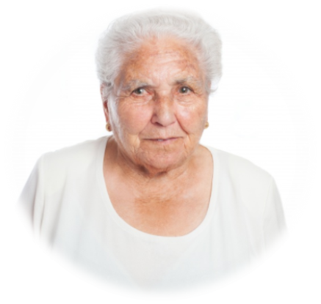
Elsie is 68 and lives on her own since her husband died 5 years ago. She is visited by Sharon her befriender on a regular basis.
Her health is generally good, but Sharon has noticed Elise has a cough which has got progressively worse over the last 4 weeks.
Elsie’s cough continues to get worse. One morning she is out shopping with Sharon when she becomes severely short of breath. She starts coughing and sees blood on her hands.

Sharon is worried and feels she needs to discuss her concerns with Elsie. Thinking about your learning so far, especially the healthy chat. Jot down some responses to the following Questions:

What could Sharon do?

How would you start the conversation with Elsie?

Had you been faced with this scenario before this session would your actions have been the same – what changes would you now make?

Simple sign posting to better health and wellbeing

Information
Key resources to help and assist you with the healthy chat initiative:

Simple sign posting to better health and wellbeing

happyandwell.me
http://www.mecclink.co.uk/
https://www.yhphnetwork.co.uk/links-and-resources/making-every-contact-count/making-every-contact-count-training/
https://eastriding.connecttosupport.org

Reflect and check in with yourself every now and again


DEVELOP
LET GO
KEEP

https://www.nhs.uk/oneyou/how-are-you-quiz



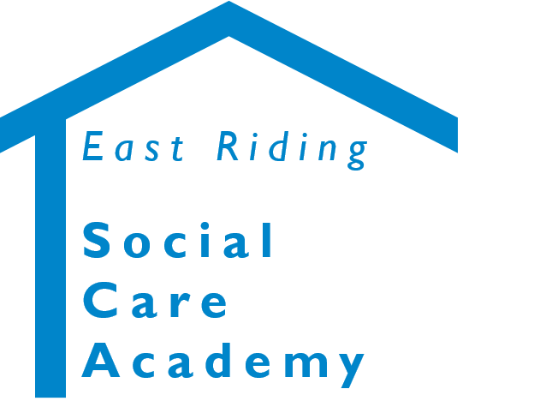

Healthy Chats (Wellbeing and You)
© 2020 – East Riding Social Care Academy (East Riding of Yorkshire Council)

All rights reserved. No part of this document may be reproduced, distributed, or transmitted in any form or by any means, including photocopying, recording, or other electronic or mechanical methods, without the prior written permission of the copyright holder.

