Getting the most out of Supervision
A tool for reflection

- Everyone has experience of being supervised and this can affect how you approach supervision now and in the future. For example, in a Research in Practice for Adults workshop on supervision with frontline staff and managers (2013), one social worker said that a supervisor once fell asleep during their supervision session. This meant that they lost respect for their supervisor and were then reluctant to attend sessions or discuss issues with them.

- Even ‘little’ things like a supervisor cancelling the session at the last minute can have an impact. Similarly, positive experiences of supervision (like receiving good support on an issue) can be built upon. Thinking about these experiences can help you identify what you are looking for from supervision in the future.

- The questions below, based on Morrison’s work on the impact of past supervision experiences (2005), are designed to help you think about your experiences of supervision and how they impact on your approach to supervision at the moment. You can think about the answers to these questions and then discuss your reactions in group or 1:1 supervision; this could enable your team to focus on getting the most out of supervision and help you build a positive supervisory relationship.

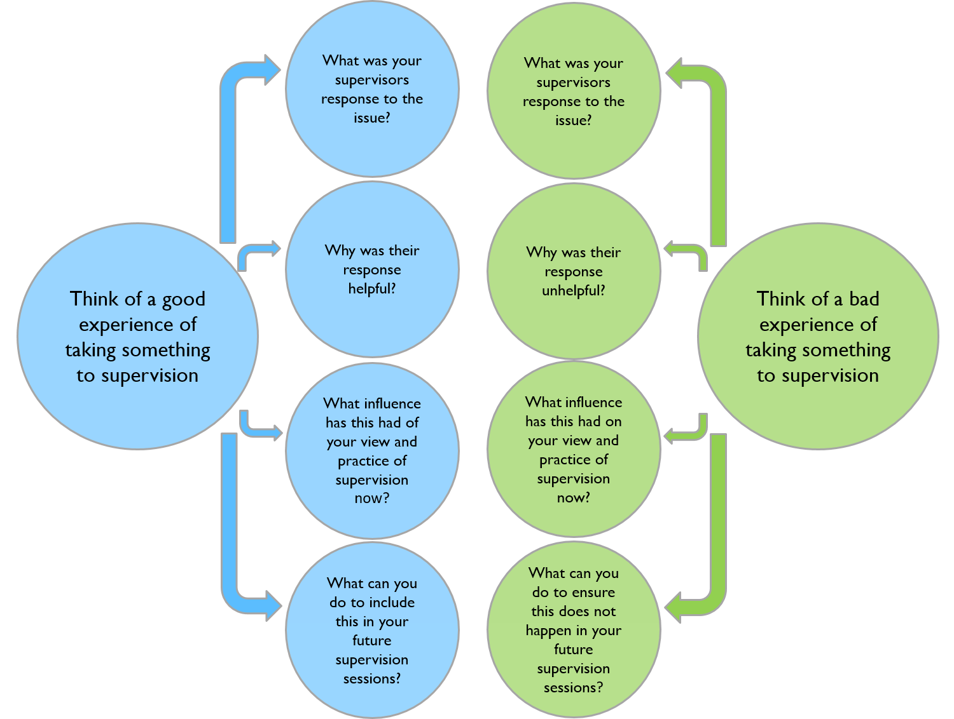

Before Supervision

This tool helps you think about how supervision is currently conducted in your organisation and how the person being supervised, the supervisor and the organisational culture impacts on supervision.

This supports you to identify what may need to change and encourages you to think about how any changes can be achieved.

- Think about and describe the current practice of supervision
(both your practice and practice in your organisation)

- Are each of the following aims or functions of supervision addressed in this practice?
Does current practice meet these aims?
- To improve the quality of decisions and interventions (through critical reflection)
- To enable effective line management and organisational accountability
- To identify and address issues related to caseload and workload management
- To help identify and achieve personal learning, career and development opportunities
- To mediate between an individual and the organisation

Consider the following three questions for each aim or function:
- What is working well?
- What could be improved?
- What is not working?

- Why are these things happening?
- What can the person being supervised control in these areas?
What do they have influence over?
What is out of their control?
- What can the supervisor control in these areas?
What do they have influence over?
What is out of their control?
- What can the organisation control in these areas?
What do they have influence over?
What is out of their control?
- How will this information impact on your future supervision practice?
- What actions will you take to address any issues identified here?

(Getting the most out of Supervision: RiPfA Practice Tool 2013)

