|  |  |
| --- | --- |
|  | ***Learner Resource*** |
| **Supervision Skills**  **for**  **Supervisors in Adult Provider Services** | |

Version 1.0 – 01/2021

**Contents**

The Learner Resource 1

Introduction 1

Structure and Layout 1

Latest Version 2

Activity 1: Hopes and Fears 3

Activity 2: What is Supervision? 3

Supervision Log Book 4

APPENDIX 2 – Supervision Logbook (Single) 4

APPENDIX 3 – Supervision Logbook (Team) 6

Positive Supervision Cycle 8

Negative Supervision Cycle 8

Activity 3: Positive and Negative 9

Getting the most out of Supervision 10

A tool for reflection 10

Before Supervision 10

Supervision Contract 12

Supervision Templates 14

Care Staff – Supervision Record 14

Domestic and Kitchen Staff – Supervision Record 16

Management – Supervision Record 18

Informal Supervision Record 21

Learning & Development Matrices 22

Format of the Matrices 23

Key to understanding matrix content: 23

Compliance Tracking Tool 24

Development of Service Matrices 24

Activity 4: People Performance - Bob 25

Learning Styles Questionnaire 26

Activity 5: 26

Scoring and Interpreting the Learning Styles Questionnaire 29

Learning Styles - General Descriptions 30

Activists 30

Reflectors 30

Theorists 30

Pragmatists 31

Learning Styles - A Further Perspective 31

Activists: 31

Reflectors: 32

Theorists: 34

Pragmatists 35

Reflecting on your own Supervision History 37

Activity 7: Self-reflection 37

Kolb Cycle to supervision 38

Applying the Kolb Cycle to Supervision 38

Questions to Enable Reflective Supervision 39

Focusing on experience 39

Focusing on Reflection 40

Focusing on Analysis 41

Focusing on Action Plans 42

Characteristics consistent with Good Recording Practice 43

Handling Difficult Conversations 45

Question Tools: 47

Direct Observations of Practice 47

Reflection for the worker on Feedback 47

Suggested Feedback Questions from Service User and Carer 47

Care Practice Observations (6-monthly) 48

CLEAR Model 50

Putting your skills into practice 51

Scenario 1: Barbara 51

Scenario 2: Shona 52

Scenario 3: Olu 53

Information 55

# The Learner Resource

## Introduction

Welcome to the Supervision Skills for supervisors in Adult Provider Services course. This course enables you to develop your knowledge, skills and confidence to apply the key elements of supervision.

This learner resource is to be used as part of the learning process. Within this learner resource you will find information, activities and direction to further help or information.

## Structure and Layout

Each guide has a common structure and layout that helps ensure consistency and maintains the quality of the materials.

The following symbols are used to highlight key information or actions:

|  |  |
| --- | --- |
|  | *Information*  This symbol highlights information on a particular point, topic or area. |
|  | *Key Point*  This symbol highlights a key point on a particular topic or area. |
|  | *Question*  This symbol indicates a question. |
|  | *Activity*  This symbol indicates a activity. |
|  | *Scenario*  This symbol indicates a scenario or case study. |
|  | *Tag*  This symbol highlights where you can find more information, help, support or a resource. |

## Latest Version

Always check you have the latest version of the learner resource. The issue number and date appear on the cover page.

If you have been given this learner resource by your Line Manager, Supervisor or Learning and Development Champion – they will have checked it is the current version. Learning and Development only provide copies of the current version of any learner resource.

## Activity 1: Hopes and Fears

|  |  |
| --- | --- |
|  | *Activity*  Related imageWhat do you want to get from today?  What do you not want to get from today? |

## Activity 2: What is Supervision?

|  |  |
| --- | --- |
|  | *Activity*  What does the word **SUPERVISION** mean to you? |

# Supervision Log Book

## APPENDIX 2 – Supervision Logbook (Single)

**Supervision Logbook**

All supervisors undertaking the formal supervision of others should maintain a supervisor’s logbook as a record of the supervisions they have undertaken. The logbook should be inspected and endorsed by the supervisor’s line manager as part of their supervision.

This logbook should be used to record all types of supervision, including: formal supervisions; informal supervisions; observation completions; EDRs; and group supervisions.

An entry should be made for each supervision session carried out. The log is intended as a record that supervision has taken place, which can be monitored within the line management system. It is not a measure of supervision quality, which will be monitored elsewhere and ultimately through the quality assurance system.

Each supervisor should only use one logbook at a time; do not use different logbooks for different staff groups. The logbook is a record of all the supervisions you have undertaken. Enter your details as supervisor below, and the date that use of the logbook commenced.

|  |  |
| --- | --- |
| Supervisor name: |  |
| Post held: |  |
| Date logbook started: |  |
| Signature: |  |

**FORMAL SUPERVISION LOG FOR NAME**

| **Month** | **Date** | **Supervision length** | **Supervisor signature** | **Employee signature** | **Supervisor’s manager** |
| --- | --- | --- | --- | --- | --- |
| **January** |  |  |  |  |  |
| **February** |  |  |  |  |  |
| **March** |  |  |  |  |  |
| **April** |  |  |  |  |  |
| **May** |  |  |  |  |  |
| **June** |  |  |  |  |  |
| **July** |  |  |  |  |  |
| **August** |  |  |  |  |  |
| **September** |  |  |  |  |  |
| **October** |  |  |  |  |  |
| **November** |  |  |  |  |  |
| **December** |  |  |  |  |  |
| **EDR** | **Date** | **Date sent to Training** | **Supervisor signature** | **Employee signature** | **Supervisor’s manager** |
| **EDR 1** |  |  |  |  |  |
| **EDR 2** |  |  |  |  |  |

## APPENDIX 3 – Supervision Logbook (Team)

Supervision Logbook

All supervisors undertaking the formal supervision of others should maintain a supervisor’s logbook as a record of the supervisions they have undertaken. The logbook should be inspected and endorsed by the supervisor’s line manager as part of their supervision.

This logbook should be used to record all types of supervision, including: formal supervisions; informal supervisions; observation completions; EDRs; and group supervisions.

An entry should be made for each supervision session carried out. The log is intended as a record that supervision has taken place, which can be monitored within the line management system. It is not a measure of supervision quality, which will be monitored elsewhere and ultimately through the quality assurance system.

Each supervisor should only use one logbook at a time; do not use different logbooks for different staff groups. The logbook is a record of all the supervisions you have undertaken. Enter your details as supervisor below, and the date that use of the logbook commenced.

|  |  |
| --- | --- |
| **Service name:** |  |
| **Supervisor/Manager name:** |  |
| **Post held:** |  |
| **Date logbook started:** |  |
| **Signature:** |  |

|  |  |  |  |  |  |  |  |  |  |  |  |  |
| --- | --- | --- | --- | --- | --- | --- | --- | --- | --- | --- | --- | --- |
| **Staff names** | **Jan** | **Feb** | **Mar** | **Apr** | **May** | **Jun** | **Jul** | **Aug** | **Sep** | **Oct** | **Nov** | **Dec** |
|  |  |  |  |  |  |  |  |  |  |  |  |  |
|  |  |  |  |  |  |  |  |  |  |  |  |  |
|  |  |  |  |  |  |  |  |  |  |  |  |  |
|  |  |  |  |  |  |  |  |  |  |  |  |  |
|  |  |  |  |  |  |  |  |  |  |  |  |  |
|  |  |  |  |  |  |  |  |  |  |  |  |  |
|  |  |  |  |  |  |  |  |  |  |  |  |  |
|  |  |  |  |  |  |  |  |  |  |  |  |  |
|  |  |  |  |  |  |  |  |  |  |  |  |  |
|  |  |  |  |  |  |  |  |  |  |  |  |  |
|  |  |  |  |  |  |  |  |  |  |  |  |  |
|  |  |  |  |  |  |  |  |  |  |  |  |  |
|  |  |  |  |  |  |  |  |  |  |  |  |  |
|  |  |  |  |  |  |  |  |  |  |  |  |  |
|  |  |  |  |  |  |  |  |  |  |  |  |  |
|  |  |  |  |  |  |  |  |  |  |  |  |  |
|  |  |  |  |  |  |  |  |  |  |  |  |  |
|  |  |  |  |  |  |  |  |  |  |  |  |  |
|  |  |  |  |  |  |  |  |  |  |  |  |  |
|  |  |  |  |  |  |  |  |  |  |  |  |  |
|  |  |  |  |  |  |  |  |  |  |  |  |  |
|  |  |  |  |  |  |  |  |  |  |  |  |  |
|  |  |  |  |  |  |  |  |  |  |  |  |  |
|  |  |  |  |  |  |  |  |  |  |  |  |  |
|  |  |  |  |  |  |  |  |  |  |  |  |  |
|  |  |  |  |  |  |  |  |  |  |  |  |  |

# Positive Supervision Cycle

1. Effective supervision: clear, safe, enabling

2. Worker clear on role and task

3. User confident in worker

4. Increased clarity, trust, sharing, partnership

5. Clearer assessment, more evidence based

6. Worker clear on next steps and expectations

7. Worker more rewarded and confident

8. More open in supervision

# Negative Supervision Cycle

**1. Poor or no supervision**

**2. Worker unclear, accountability unclear, rigid**

**3. User less confident**

**4. Increased anxiety, less open, less trust/sharing**

**5. Assessment weaker, less evidence based**

**6. Plans less shared or agreed, service less appropriate**

**7. Worker less confident**

**8. Less open or more dependent on supervision**

## Activity 3: Positive and Negative

|  |  |
| --- | --- |
|  | *Activity*  I would like you to think about your own experiences and think of 2 examples:   * Good supervision which made a positive difference * Negative supervision which made the situation worse   *Consider and reflect on the people that were affected…* |

# Getting the most out of Supervision

## A tool for reflection

Everyone has experience of being supervised and this can affect how you approach supervision now and in the future. For example, in a Research in Practice for Adults workshop on supervision with frontline staff and managers (2013), one social worker said that a supervisor once fell asleep during their supervision session. This meant that they lost respect for their supervisor and were then reluctant to attend sessions or discuss issues with them.

Even ‘little’ things like a supervisor cancelling the session at the last minute can have an impact. Similarly, positive experiences of supervision (like receiving good support on an issue) can be built upon. Thinking about these experiences can help you identify what you are looking for from supervision in the future.

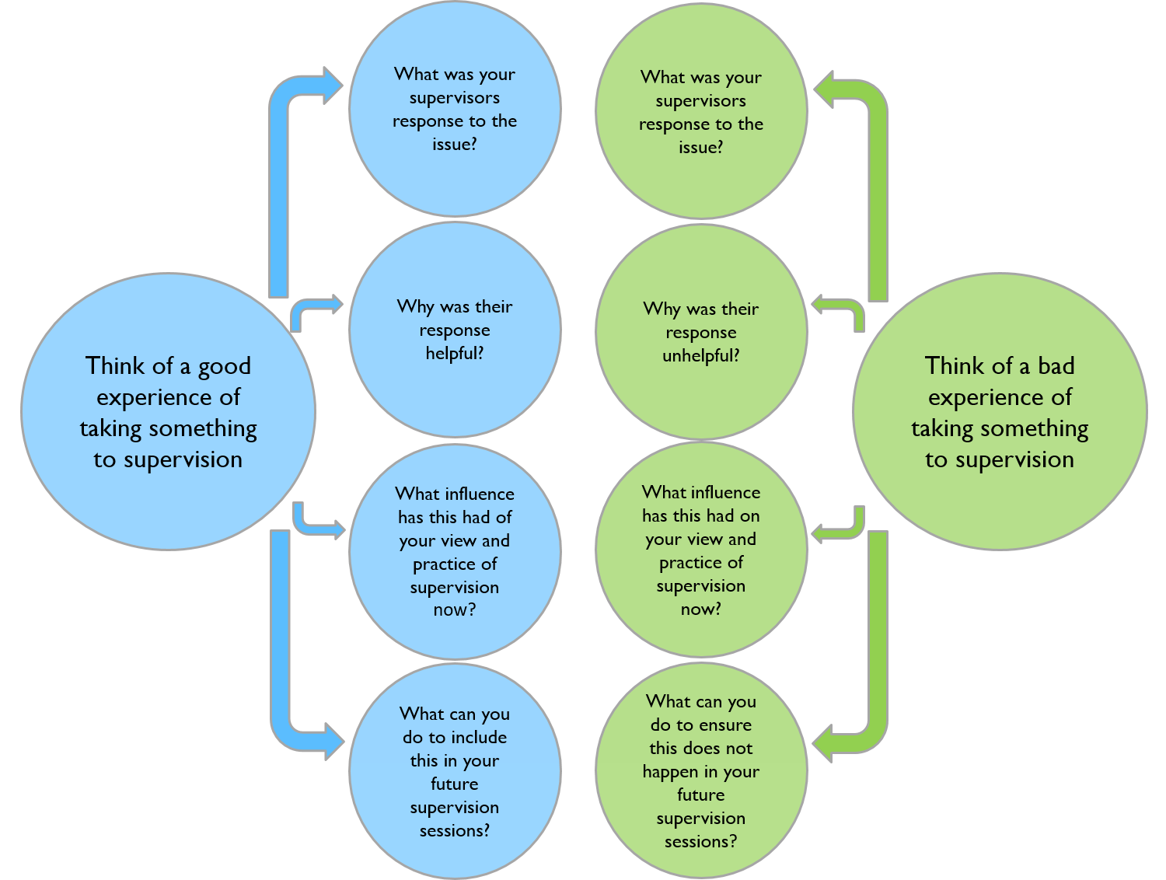The questions below, based on Morrison’s work on the impact of past supervision experiences (2005), are designed to help you think about your experiences of supervision and how they impact on your approach to supervision at the moment. You can think about the answers to these questions and then discuss your reactions in group or 1:1 supervision; this could enable your team to focus on getting the most out of supervision and help you build a positive supervisory relationship.

## Before Supervision

This tool helps you think about how supervision is currently conducted in your organisation and how the person being supervised, the supervisor and the organisational culture impacts on supervision.

This supports you to identify what may need to change and encourages you to think about how any changes can be achieved.

1. Think about and describe the current practice of supervision

(Both your practice and practice in your organisation)

1. Are each of the following aims or functions of supervision addressed in this practice?

Does current practice meet these aims?

* To improve the quality of decisions and interventions (through critical reflection)
* To enable effective line management and organisational accountability
* To identify and address issues related to caseload and workload management
* To help identify and achieve personal learning, career and development opportunities
* To mediate between an individual and the organisation

Consider the following three questions for each aim or function:

* What is working well?
* What could be improved?
* What is not working?

1. Why are these things happening?
2. What can the person being supervised control in these areas?

* What do they have influence over?
* What is out of their control?

1. What can the supervisor control in these areas?

* What do they have influence over?
* What is out of their control?

1. What can the organisation control in these areas?

* What do they have influence over?
* What is out of their control?

1. How will this information impact on your future supervision practice?
2. What actions will you take to address any issues identified here?

*(Getting the most out of Supervision: RiPfA Practice Tool 2013)*

# Supervision Contract

|  |
| --- |
| **CONTRACT FOR SUPERVISION**  **Between: (supervisor )**  **And ( supervisee: )**  This contract is to be read in conjunction with the supervision procedure and with reference to the supervision practice guide and supporting materials that can be found on the intranet  <http://insight.eastriding.gov.uk/search/?q=supervision>  Content and focus of supervision will be based on:   * Agreeing the items to be discussed under standard agenda * Reviewing your work via discussion, reports, observation * Quality Assurance of selected pieces of work (usually two) * Agreeing and monitoring action plans * Development of your skills, knowledge and value base by reflecting on your performance * Identifying your developmental needs, interests, goals and action plans * Providing space for you to reflect more generally on your experience of and feelings about the work Reviewing this supervision agreement, including your feedback about the progress of supervision   **Arrangements for recording supervision** (i.e. who will record, including whether support services will type notes)  **Storage of supervision record** ( who will have access )  **How we will agree the agenda for sessions** ( balance of key elements as stated in supervision procedure)  **Making supervision work: What each agree to contribute ( consider use of supervision supporting documents i.e. learning styles)**  **What I want from you as my supervisor:**  **­­­­­­**  **What I will contribute as the supervisee to make this work:**  **­What I want from you as a supervisee:**  **­­­­­­**  **What I will contribute as the supervisor to make this work:**  **­­**  **Permissions that we have agreed**  ***(E.g.: The supervisor does not always have an answer; OK for me as the worker to say I am stuck.)***  **­­­­­­**  **What we will do if there are difficulties working together**  **Supervisee’s areas of strengths identified at the beginning of the supervisory role**  **Supervisee’s areas to be developed identified at the beginning of the supervisory role**  **What opportunities or activity will be planned to meet the development needs**  **I.e. training, furthering knowledge or experience, or particular case work.**  ­­­  **Signed**    **Supervisor: Date:**  **Supervisee: Date:** |

**APPENDIX 4 – Care Staff Supervision Record**

# Supervision Templates

## Care Staff – Supervision Record

APPENDIX 4 –Care Staff Supervision Record (G1004 staff supervision procedure)

|  |  |  |  |
| --- | --- | --- | --- |
| **Staff member:** | **Line manager:** | **Supervision date:** | **Date of next EDR:** |
|  |  |  |  |

|  |  |
| --- | --- |
| **Core competencies:** |  |

|  |  |  |
| --- | --- | --- |
| **Update on actions from previous supervision – date:** | | |
| **Action agreed** | **Whom/Deadline** | **Update on action** |
|  |  |  |
|  |  |  |
|  |  |  |
|  |  |  |

| **Discussion** | **Action** |
| --- | --- |
| **Wellbeing** |  |
|  |
| **Workload, incl. keyworker role and lead responsibilities** |  |
|  |
| **Impact of recent learning on performance** |  |
|  |
| **Service user discussion, incl. dignity and safeguarding** |  |
|  |
| **Communication and record keeping** |  |
|  |
| **Health and safety** |  |
|  |
| **Observations undertaken** |  |
|  |
| **Customer feedback** |  |
|  |
| **Other** |  |
|  |

|  |
| --- |
| **Areas of disagreement, differences of opinion (pass to line manager for resolution)** |
|  |

|  |  |  |  |
| --- | --- | --- | --- |
| **Signature of staff member:** | | **Signature of line manager:** | |
|  | |  | |
| **Date:** |  | **Date:** |  |

## Domestic and Kitchen Staff – Supervision Record

APPENDIX 5 – Domestic and Kitchen Staff Supervision Record (G1004 staff supervision procedure)

|  |  |  |  |
| --- | --- | --- | --- |
| **Staff member:** | **Line manager:** | **Supervision date:** | **Date of next EDR:** |
|  |  |  |  |

|  |  |
| --- | --- |
| **Core competencies:** |  |

|  |  |  |
| --- | --- | --- |
| **Update on actions from previous supervision – date:** | | |
| **Action agreed** | **Whom/Deadline** | **Update on action** |
|  |  |  |
|  |  |  |
|  |  |  |
|  |  |  |

| **Discussion** | **Action** |
| --- | --- |
| **Wellbeing** |  |
|  |
| **Workload, incl. keyworker role and lead responsibilities** |  |
|  |
| **Impact of recent learning on performance** |  |
|  |
| **Service user discussion, incl. dignity and safeguarding** |  |
|  |
| **Communication and record keeping** |  |
|  |
| **Equipment and products** |  |
|  |
| **Cleaning schedule** |  |
|  |
| **Health and safety** |  |
|  |
| **Observations undertaken** |  |
|  |
| **Customer feedback** |  |
|  |
| **Catering compliance, to include menus, logbook, inspections, and actions** |  |
|  |
| **Other** |  |
|  |

|  |
| --- |
| **Areas of disagreement, differences of opinion (pass to line manager for resolution)** |
|  |

|  |  |  |  |
| --- | --- | --- | --- |
| **Signature of staff member:** | | **Signature of line manager:** | |
|  | |  | |
| **Date:** |  | **Date:** |  |

## Management – Supervision Record

APPENDIX 6 – Management Supervision Record (G1004 staff supervision procedure)

|  |  |  |  |
| --- | --- | --- | --- |
| **Staff member:** | **Line manager:** | **Supervision date:** | **Date of next EDR:** |
|  |  |  |  |

|  |  |
| --- | --- |
| **Core competencies:** |  |

|  |  |  |
| --- | --- | --- |
| **Update on actions from previous supervision – date:** | | |
| **Action agreed** | **Whom/Deadline** | **Update on action** |
|  |  |  |
|  |  |  |
|  |  |  |
|  |  |  |

| **Discussion** | **Action** |
| --- | --- |
| **Wellbeing** |  |
|  |
| **Workload, incl. keyworker role, lead responsibilities, and project work** |  |
|  |
| **Impact of recent learning on performance** |  |
|  |
| **Service plan / team plan updates** |  |
|  |
| **Service user discussion, incl. dignity and safeguarding** |  |
|  |
| **Budget monitoring / financial audits** |  |
|  |
| **Vacancy and attendance management** |  |
|  |
| **Health and safety, incl. observational walk-round, building management** |  |
|  |
| **Team issues** |  |
|  |
| **Service issues and pressures** |  |
|  |
| **Observations undertaken** |  |
|  |
| **Communication and record keeping** |  |
|  |
| **Safeguarding, CQC, and AIF reporting / audits and evaluation** |  |
|  |
| **CQC improvements and issues / performance monitoring** |  |
|  |
| **Customer feedback** |  |
|  |
| **Any other business** |  |
|  |

|  |
| --- |
| **Areas of disagreement, differences of opinion (pass to line manager for resolution)** |
|  |

|  |  |  |  |
| --- | --- | --- | --- |
| **Signature of staff member:** | | **Signature of line manager:** | |
|  | |  | |
| **Date:** |  | **Date:** |  |

# Informal Supervision Record

To be used to record informal or immediate 1:1 discussion. These discussions will be noted in formal supervision.

|  |  |  |  |
| --- | --- | --- | --- |
| **Staff member:** | **Line manager:** | **Period from:** | **Period to:** |
|  |  |  |  |

|  |  |
| --- | --- |
| **Adhoch 1 to 1** | Support and advice offered on unplanned issues |

|  |  |  |
| --- | --- | --- |
| **Date:** | **Issues discussed/raised** | **Actions/outcome agreed** |
|  |  |  |
|  |  |  |
|  |  |  |
|  |  |  |
|  |  |  |
|  |  |  |
|  |  |  |
|  |  |  |

|  |
| --- |
| **Areas of disagreement, differences of opinion (pass to line manager for resolution)** |
|  |

|  |  |  |  |
| --- | --- | --- | --- |
| **Signature of staff member:** | | **Signature of line manager:** | |
|  | |  | |
| **Date:** |  | **Date:** |  |

# Learning & Development Matrices

The Learning & Development Matrices are part of the Corporate Learning and Development process, to identify key requirements for all Posts within the Council.

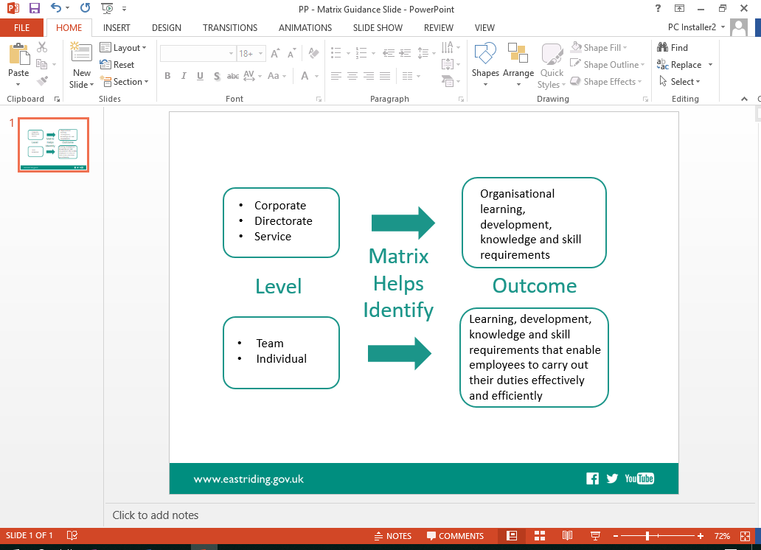About the Matrices

The Learning and Development Matrices capture the Mandatory, Essential and Developmental knowledge, skills and / or activities required by the workforce on a post-by-post basis. This enables:

Directorates to identify the knowledge and skills requirements for all Posts, based on Corporate, Directorate and Service priorities.

Managers to complete an individual learning / training needs analysis with each employee, based on the requirements of their Post (which forms part of the EDR and Supervision processes).

The formalisation of Directorate Learning and Development Plans that aid the prioritisation of limited funds.

It is important to remember that the Matrices should not simply provide a list of courses. The process of developing Service Matrices is designed to focus on the identification of required knowledge and skills. These could be met through a course, but equally by activities such as coaching, mentoring, reading, eLearning, qualifications and competency assessments etc. all of which should be included in the Service Matrix.

## Format of the Matrices

A standard template is provided for the development and updating of the Matrices.

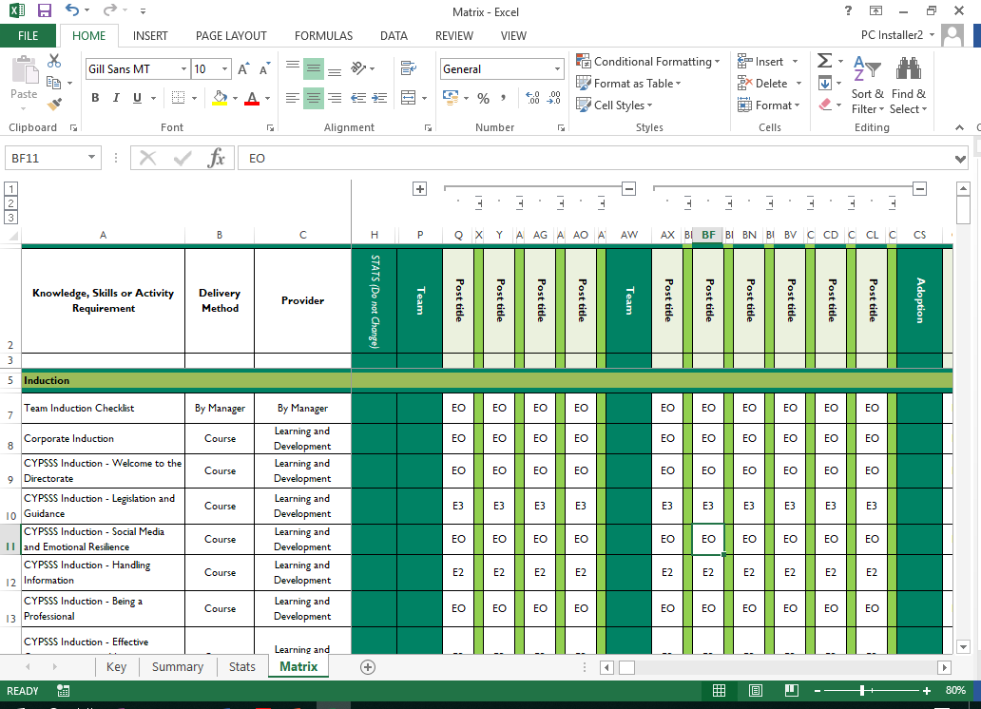

As a minimum each Matrix must identify the knowledge, skills and / or activities required by a person in each Post.

This enables Managers to compare the knowledge, skills and / or activities required by the Post against each Post Holder during Supervision and EDR discussions.

In essence, this supports the completion of an individual employee Learning / Training Needs Analysis.

The identification of knowledge, skills and / or activities at Post level is mandatory for all Services.

## Key to understanding matrix content:

|  |  |  |
| --- | --- | --- |
| M | Mandatory | Legal or inspection requirement |
| E | Essential | East Riding or Professional Body requirement |
| D | Developmental | Developmental requirement |
| NA | Not Applicable | Not applicable to the post / post holder |
| Numeric Value | Number reflects the refresh cycle requirement e.g. 1, 2, 3 = 1, 2, 3 years etc. | |
| O | No refresh cycle requirement | |

## Compliance Tracking Tool

The 2018 format has been updated to meet the additional needs of some Services that utilise the Matrices as a compliance tracking tool.

The enhanced format enables the logging of attendance / attainment of the relevant knowledge, skills and / or activities within a Post against each Employee within the relevant Post.

This provides an end-to-end summary of the requirements and achievements of each Employee.

The Service is responsible for inputting and maintaining the tracking aspects of the Matrices

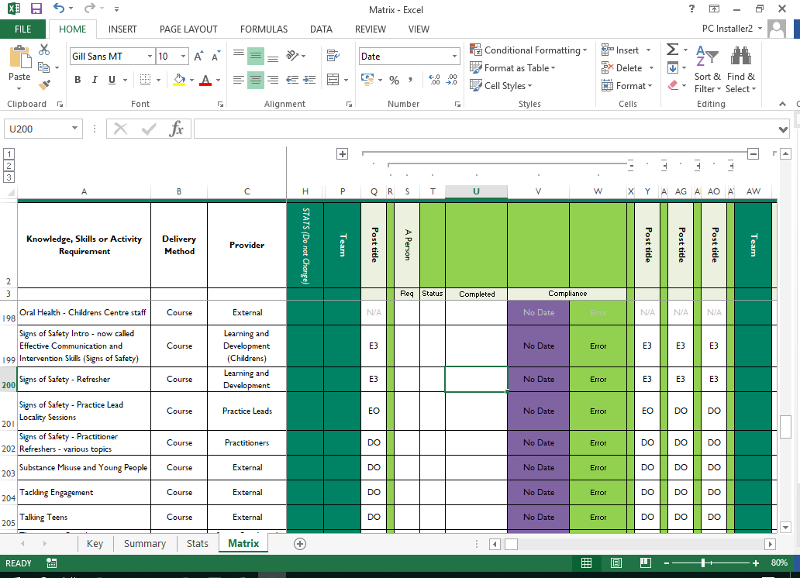

## Development of Service Matrices

This is a staged process as follows;

Structure of the Service – identifying all the teams that fall within its remit, to ensure that every team has a Matrix developed for them.

Service learning, development, knowledge and skill requirements - establishing what learning and development requirements apply across the Service.

Meeting with the Managers;

Post titles – meeting with a representative from each team to confirm all post titles within each team to ensure that every post in the Service is captured in the matrix.

Learning, development, knowledge and skill requirements - meeting with a representative from each team to establish what the learning and development requirements are for each post within their team.

Draft Matrices;

* Sent to the representative from each team to check, amend and approve.
* Sent to Head of Service for consideration / amendment / final approval for use.

Approved Matrices - made available for all managers and staff within the Service to access and use as part of Supervision and EDR discussions.

## Activity 4: People Performance - Bob

|  |  |
| --- | --- |
|  | *Activity*    Claude has arrived from another land and you need to teach him some basic life skills.  Take 5 minutes to decide how you would teach Claude to make a ham and cheese sandwich– noting how you would do it in the space provided. |

# Learning Styles Questionnaire

## Activity 5:

**Name: _______________________________________**

This questionnaire is designed to find out your preferred learning style(s). Over the years you have probably developed learning "habits" that help you benefit more from some experiences than from others. Since you are probably unaware of this, this questionnaire will help you pinpoint your learning preferences so that you are in a better position to select learning experiences that suit your style and having a greater understanding of those that suit the style of others.

This is an internationally proven tool designed by Peter Honey and Alan Mumford.

There is no time limit to this questionnaire. It will probably take you 10-15 minutes. The accuracy of the results depends on how honest you can be. There are no right or wrong answers.

If you agree more than you disagree with a statement put a tick by it.

If you disagree more than you agree put a cross by it.

Be sure to mark each item with either a tick or cross.

|  |  |  |
| --- | --- | --- |
| **🞏** | | 1. I have strong beliefs about what is right and wrong, good and bad. |
| **🞏** | | 1. I often act without considering the possible consequences |
| **🞏** | | 1. I tend to solve problems using a step-by-step approach |
| **🞏** | | 1. I believe that formal procedures and policies restrict people |
| **🞏** | | 1. I have a reputation for saying what I think, simply and directly |
| **🞏** | | 1. I often find that actions based on feelings are as sound as those based on careful thought and analysis |
| **🞏** | | 1. I like the sort of work where I have time for thorough preparation and implementation |
| **🞏** | | 1. I regularly question people about their basic assumptions |
| **🞏** | | 1. What matters most is whether something works in practice |
| **🞏** | | 1. I actively seek out new experiences |
| **🞏** | | 1. When I hear about a new idea or approach I immediately start working out how to apply it in practice |
| **🞏** | | 1. I am keen on self-discipline such as watching my diet, taking regular exercise, sticking to a fixed routine, etc. |
| **🞏** | | 1. I take pride in doing a thorough job |
| **🞏** | | 1. I get on best with logical, analytical people and less well with spontaneous, "irrational" |
| **🞏** | | 1. I take care over the interpretation of data available to me and avoid jumping to conclusions |
| **🞏** | | 1. I like to reach a decision carefully after weighing up many alternatives |
| **🞏** | | 1. I'm attracted more to novel, unusual ideas than to practical ones |
| **🞏** | | 1. I don't like disorganised things and prefer to fit things into a coherent pattern |
| **🞏** | | 1. I accept and stick to laid down procedures and policies so long as I regard them as an efficient way of getting the job done |
| **🞏** | | 1. I like to relate my actions to a general principle |
| **🞏** | | 1. In discussions I like to get straight to the point |
| **🞏** | | 1. 1 tend to have distant, rather formal relationships with people at work |
| **🞏** | 1. I thrive on the challenge of tackling something new and different | | |
| **🞏** | 1. I enjoy fun-loving, spontaneous people | | |
| **🞏** | 1. I pay meticulous attention to detail before coming to a conclusion | | |
| **🞏** | 1. I find it difficult to produce ideas on impulse | | |
| **🞏** | 1. I believe in coming to the point immediately | | |
| **🞏** | 1. I am careful not to jump to conclusions too quickly | | |
| **🞏** | 1. I prefer to have as many resources of information as possible - the more data to think over the better | | |
| **🞏** | 1. Flippant people who don't take things seriously enough usually irritate me | | |
| **🞏** | 1. I listen to other people's points of view before putting my own forward | | |
| **🞏** | 1. I tend to be open about how I'm feeling | | |
| **🞏** | 1. In discussions I enjoy watching the manoeuvrings of the other participants | | |
| **🞏** | 1. I prefer to respond to events on a spontaneous, flexible basis rather than plan things out in advance | | |
| **🞏** | 1. I tend to be attracted to techniques such as network analysis, flow charts, branching programs, contingency planning, etc. | | |
| **🞏** | 1. It worries me if I have to rush out a piece of work to meet a tight deadline | | |
| **🞏** | 1. I tend to judge people's ideas on their practical merits | | |
| **🞏** | 1. Quiet, thoughtful people tend to make me feel uneasy | | |
| **🞏** | 1. I often get irritated by people who want to rush things | | |
| **🞏** | 1. It is more important to enjoy the present moment than to think about the past or future | | |
| **🞏** | 1. I think that decisions based on a thorough analysis of all the information are sounder than those based on intuition | | |
| **🞏** | 1. I tend to be a perfectionist | | |
| **🞏** | 1. In discussions I usually produce lots of spontaneous ideas | | |
| **🞏** | 1. In meetings I put forward practical realistic ideas | | |
| **🞏** | 1. More often than not, rules are there to be broken | | |
| **🞏** | 1. I prefer to stand back from a situation | | |
| **🞏** | 1. I can often see inconsistencies and weaknesses in other people's arguments | | |
| **🞏** | 1. On balance I talk more than I listen | | |
| **🞏** | 1. I can often see better, more practical ways to get things done | | |
| **🞏** | 1. I think written reports should be short and to the point | | |
| **🞏** | 1. I believe that rational, logical thinking should win the day | | |

|  |  |
| --- | --- |
| **🞏** | 1. I tend to discuss specific things with people rather than engaging in social discussion |
| **🞏** | 1. I like people who approach things realistically rather than theoretically |
| **🞏** | 1. In discussions I get impatient with irrelevancies and digressions |
| **🞏** | 1. If I have a report to write I tend to produce lots of drafts before settling on the final version |
| **🞏** | 1. 1 am keen to try things out to see if they work in practice |
| **🞏** | 1. I am keen to reach answers via a logical approach |
| **🞏** | 1. I enjoy being the one that talks a lot |
| **🞏** | 1. In discussions I often find I am the realist, keeping people to the point and avoiding wild speculations |
| **🞏** | 1. I like to ponder many alternatives before making up my mind |
| **🞏** | 1. In discussions with people I often find I am the most dispassionate and objective |
| **🞏** | 1. In discussions I'm more likely to adopt a "low profile" than to take the lead and do most of the talking |
| **🞏** | 1. I like to be able to relate current actions to a longer term bigger picture |
| **🞏** | 1. When things go wrong I am happy to shrug it off and "put it down to experience" |
| **🞏** | 1. I tend to reject wild, spontaneous ideas as being impractical |
| **🞏** | 1. It's best to think carefully before taking action |
| **🞏** | 1. On balance I do the listening rather than the talking |
| **🞏** | 1. I tend to be tough on people who find it difficult to adopt a logical approach |
| **🞏** | 1. Most times I believe the end justifies the means |
| **🞏** | 70. I don't mind hurting people's feelings so long as the job gets done |
| **🞏** | 71. I find the formality of having specific objectives and plans stifling |
| **🞏** | 72. I'm usually one of the people who puts life into a party |
| **🞏** | 73. I do whatever is expedient to get the job done |
| **🞏** | 74. I quickly get bored with methodical, detailed work |
| **🞏** | 75. I am keen on exploring the basic assumptions, principles and theories underpinning things and events |
| **🞏** | 76. I'm always interested to find out what people think |
| **🞏** | 77. I like meetings to be run on methodical lines, sticking to laid down agenda, etc. |
| **🞏** | 78. I steer clear of subjective or ambiguous topics |
| **🞏** | 79. I enjoy the drama and excitement of a crisis situation |
| **🞏** | 80. People often find me insensitive to their feelings |

## Scoring and Interpreting the Learning Styles Questionnaire

The Questionnaire is scored by awarding one point for each ticked item. There are no points for crossed items. Simply indicate on the lists below which items were ticked by circling the appropriate question number.

|  |  |  |  |
| --- | --- | --- | --- |
| 2 | 7 | 1 | 5 |
| 4 | 13 | 3 | 9 |
| 6 | 15 | 8 | 11 |
| 10 | 16 | 12 | 19 |
| 17 | 25 | 14 | 21 |
| 23 | 28 | 18 | 27 |
| 24 | 29 | 20 | 35 |
| 32 | 31 | 22 | 37 |
| 34 | 33 | 26 | 44 |
| 38 | 36 | 30 | 49 |
| 40 | 39 | 42 | 50 |
| 43 | 41 | 47 | 53 |
| 45 | 46 | 51 | 54 |
| 48 | 52 | 57 | 56 |
| 58 | 55 | 61 | 59 |
| 64 | 60 | 63 | 65 |
| 71 | 62 | 68 | 69 |
| 72 | 66 | 75 | 70 |
| 74 | 67 | 77 | 73 |
| 79 | 76 | 78 | 80 |
|  |  |  |  |

**TOTALS**

**Activist Reflector Theorist**  **Pragmatist**

# Learning Styles - General Descriptions

## Activists

Activists involve themselves fully and without bias in new experiences. They enjoy the here and now and are happy to be dominated by immediate experiences. They are open-minded, not sceptical, and this tends to make them enthusiastic about anything new. Their philosophy is: "I'll try anything once". They tend to act first and consider the consequences afterwards. Their days are filled with activity. They tackle problems by brainstorming. As soon as the excitement from one activity has died down they are busy looking for the next. They tend to thrive on the challenge of new experiences but are bored with implementation and longer-term consolidation. They are gregarious people constantly involving themselves with others but in doing so; they seek to centre all activities on themselves.

## Reflectors

Reflectors like to stand back to ponder experiences and observe them from many different perspectives. They collect data, both first hand and from others, and prefer to think about it thoroughly before coming to any conclusion. The thorough collection and analysis of data about experiences and events is what counts so they tend to postpone reaching definitive conclusions for as long as possible. Their philosophy is to be cautious. They are thoughtful people who like to consider all possible angles and implications before making a move. They prefer to take a back seat in meetings and discussions. They enjoy observing other people in action. They listen to others and get the drift of the discussion before making their own points. They tend to adopt a low profile and have a slightly distant, tolerant unruffled air about them. When they act it is part of a wide picture which includes the past as well as the present and others' observations as well as their own.

## Theorists

Theorists adapt and integrate observations into complex but logically sound theories. They think problems through in a vertical, step-by-step logical way. They assimilate disparate facts into coherent theories. They tend to be perfectionists who won't rest easy until things are tidy and fit into a rational scheme. They like to analyse and synthesise. They are keen on basic assumptions, principles, theories models and systems thinking. Their philosophy prizes rationality and logic. "If it's logical it's good". Questions they frequently ask are: "Does it make sense?" "How does this fit with that?" "What are the basic assumptions?" They tend to be detached, analytical and dedicated to rational objectivity rather than anything subjective or ambiguous. Their approach to problems is consistently logical. This is their "mental set" and they rigidly reject anything that doesn't fit with it. They prefer to maximise certainty and feel uncomfortable with subjective judgments, lateral thinking and anything flippant.

## Pragmatists

Pragmatists are keen on trying out ideas, theories and techniques to see if they work in practice. They positively search out new ideas and take the first opportunity to experiment with applications. They are the sorts of people who return from management courses brimming with new ideas that they want to try out in practice. They like to get on with things and act quickly and confidently on ideas that attract them. They tend to be impatient with ruminating and open-ended discussions. They are essentially practical, down to earth people who like making practical decisions and solving problems. They respond to problems and opportunities "as a challenge". Their philosophy is: "There is always a better way" and "if it works its good".

# Learning Styles - A Further Perspective

## Activists:

**Activists** learn best from activities where: ­

* There are new experiences/problems/opportunities from which to learn.
* They can engross themselves in short "here and now" activities such as business games, competitive teamwork tasks, role-playing exercises.
* There is excitement/drama/crisis and things chop and change with a range of diverse activities to tackle
* They have a lot of the limelight/high visibility, i.e. they can "chair" meetings, lead discussions, and give presentations.
* They are allowed to generate ideas without constraints of policy or structure or feasibility.
* They are thrown in at the deep end with a task they think is difficult, i.e. when set a challenge with inadequate resources and adverse conditions.
* They are involved with other people, i.e. bouncing ideas off them, solving problems as part of a team.
* It is appropriate to "have a go".

**Activists** learn least from, and may react against, activities where: ­

* Learning involves a passive role, i.e. listening to lectures, monologues, explanations, statements of how things should be done, reading, and watching.
* They are asked to stand back and not be involved.
* They are required to assimilate, analyse and interpret lots of "messy" data.
* They are required to engage in solitary work, i.e. reading, writing, thinking on their own.
* They are asked to assess beforehand what they will learn, and to appraise afterwards what they have learned.
* They are offered statements they see as "theoretical", i.e. explanation of cause or background
* They are asked to repeat essentially the same activity over and over again, i.e. when practicing.
* They have precise instructions to follow with little room for manoeuvre.
* They are asked to do a thorough job, i.e. attend to detail, tie up loose ends, dot the i's, cross t's.

**Summary of Strengths:**

* Flexible and open minded
* Happy to have a go
* Happy to be exposed to new situations
* Optimistic about anything new and therefore unlikely to resist change

**Summary of Weaknesses:**

* Tendency to take the immediately obvious action without thinking
* Often take unnecessary risks
* Tendency to do too much themselves and hog the limelight
* Rush into action without sufficient preparation
* Get bored with implementation/consolidation

**Key Questions for Activists:**

* Shall I learn something new, i.e. that I didn't know/couldn't do before?
* Will there be a wide variety of different activities? (I don't want to sit and listen for more than an hour at a stretch!)
* Will it be OK to have a go/let my hair down/make mistakes/have fun?
* Shall 1 encounter some tough problems and challenges?
* Will there be other like-minded people to mix with?

## Reflectors:

**Reflectors** learn best from activities where: ­

* They are allowed or encouraged to watch/think/chew over activities.
* They are able to stand back from events and listen/observe, i.e. observing a group at work, taking a back seat in a meeting, watching a film or video.
* They are allowed to think before acting, to assimilate before commencing, i.e. time to prepare, a chance to read in advance a brief giving background data.
* They can carry out some painstaking research, i.e. investigate, assemble information, and probe to get to the bottom of things.
* They have the opportunity to review what has happened, what they have learned.
* They are asked to produce carefully considered analyses and reports.
* They are helped to exchange views with other people without danger, i.e. by prior agreement, within a structured learning experience.
* They can reach a decision in their own time without pressure and tight deadlines.

**Reflectors** learn least from, and may react against, activities where: ­

* They are "forced" into the limelight, i.e. to act as leader/chairman, to role-play in front of on-lookers.
* They are involved in situations which require action without planning.
* They are pitched into doing something without warning, i.e. to produce an instant reaction, to produce an off-the-top-of-the-head idea.
* They are given insufficient data on which to base a conclusion.
* They are given cut and dried instructions of how things should be done.
* They are worried by time pressures or rushed from one activity to another.
* In the interests of expediency they have to make short cuts or do a superficial job.

**Summary of Strengths:**

* Careful
* Thorough and methodical
* Thoughtful
* Good at listening to others and assimilating information
* Rarely jump to conclusions

**Summary of Weaknesses:**

* Tendency to hold back from direct participation.
* Slow to make up their minds and reach a decision.
* Tendency to be too cautious and not take enough risks.
* Not assertive - they aren't particularly forthcoming and have no "small talk".

**Key questions for Reflectors:**

* Shall I be given adequate time to consider, assimilate and prepare?
* Will there be opportunities/facilities to assemble relevant information?
* Will there be opportunities to listen to other people's points of view - preferably a wide cross section of people with a variety of views?
* Shall I be under pressure to be slapdash or to extemporise?

## Theorists:

**Theorists learn best from activities where: ­**

* What is being offered is part of a system, model, concept, theory
* The have time to explore methodically the associations and inter-relationships between ideas, events andsituations.
* They have the chance to question and probe the basic methodology, assumptions or logic behind something, i.e. by taking part in a question and answer session, by checking a paper for inconsistencies.
* They are intellectually stretched, i.e. by analysing a complex situation, being tested in a tutorial session, by teaching high calibre people who ask searching questions.
* They are in structured situations with a clear purpose.
* They can listen to or read about ideas and concepts that emphasise rationality or logic and are well argued/elegant/watertight.
* They can analyse and then generalise the reasons for success or failure.
* They are offered interesting ideas and concepts even though they are not immediately relevant.
* They are required to understand and participate in complex situations.

**Theorists** learn least from, and may react against, activities where: ­

* They are pitch-forked into doing something without a context or apparent purpose.
* They have to participate in situations emphasising emotions and feelings.
* They are involved in unstructured activities where ambiguity and uncertainty are high, i.e. with open-ended problems, on sensitivity training.
* They are asked to act or decide without a basis in policy, principle or concept.
* They are faced with a hotchpotch of alternative/contradictory techniques/methods without exploring any in depth, i.e. as on a "once over lightly" course.
* They find the subject matter platitudinous, shallow or gimmicky.
* They feel themselves out of tune with other participants, i.e. when with lots of Activists or people of lower intellectual calibre.

**Summary of Strengths:**

* Logical "vertical" thinkers
* Rational and objective
* Good at asking probing questions
* Disciplined approach

**Summary of weaknesses:**

* Restricted in lateral thinking
* low tolerance for uncertainty, disorder and ambiguity
* Intolerant of anything subjective or intuitive
* Full of "shoulds, oughts and musts"

**Key questions for theorists:**

* Will there be lots of opportunities to question?
* Do the objectives and program of events indicate a clear structure and purpose?
* Shall I encounter complex ideas and concepts that are likely to stretch me?
* Are the approaches to be used and concepts to be explored "respectable", i.e. sound and valid?
* Shall I be with people of similar calibre to myself?

## Pragmatists

**Pragmatists** learn best from activities where: ­

* There is an obvious link between the subject matter and a problem or opportunity on the job.
* They are shown techniques for doing things with obvious practical advantages, i.e. how to save time, how to make a good first impression, how to deal with awkward people.
* They have the chance to try out and practice techniques with coaching/feedback from a credible expert, i.e. someone who is successful and can do the techniques themselves.
* They are exposed to a model they can emulate, i.e. a respected boss, a demonstration from someone with a proven track record, lots of examples/anecdotes, and a film showing how it’s done.
* They are given techniques currently applicable to their own job.
* They are given immediate opportunities to implement what they have learned.
* There is high face validity in the learning activity, i.e. a good simulation, 'real" problems.
* They can concentrate on practical issues, i.e. drawing up action plans with an obvious end product, suggesting short cuts, giving tips.

**Pragmatists** learn least from, and may react against, activities where: **­**

* The learning is not related to an immediate need they recognise/they cannot see an immediate relevance/practical benefit.
* Organisers of the learning, or the event itself, seems distant from reality, i.e. "ivory towered", all theory and general principles, pure "chalk and talk".
* There is no practice or clear guidelines on how to do it.
* They feel that people are going round in circles and not getting anywhere fast enough.
* There are political, managerialor personal obstacles to implementation.
* There is no apparent reward from the learning activity, i.e. more sales, shorter meetings, higher bonus, promotion.

**Summary of Strengths:**

* Keen to test things out in practice
* Practical, down to earth, realistic
* Businesslike - gets straight to the point
* Technique oriented

**Summary of Weaknesses:**

* Tendency to reject anything without an obvious application
* Not very interested in theory or basic principles
* Tendency to seize on the first expedient solution to a problem
* Impatient with waffle
* On balance, task oriented not people oriented

**Key Questions for Pragmatists:**

* Will there be ample opportunities to practice and experiment?
* Will there be lots of practical tips and techniques?
* Shall we be addressing real problems and will it result in action plans to tackle some of my current problems?
* Shall we be exposed to experts who know how to/can do it themselves?

# Reflecting on your own Supervision History

## Activity 7: Self-reflection

|  |  |
| --- | --- |
| **Previous Supervisor** |  |
| **What helped?** |  |
| **What hindered?** |  |
| **Response at time** |  |
| **Influence on me now** |  |

|  |  |
| --- | --- |
| **Previous Supervisor** |  |
| **What helped?** |  |
| **What hindered?** |  |
| **Response at time** |  |
| **Influence on me now** |  |

# Kolb Cycle to supervision

**Kolb’s Experiential Learning Theory**

Kolb’s learning theory sets out a four stage learning cycle;

**Concrete Experience** – Feeling e.g. interviewing a service user for the first time, learning from specific experiences and relating to people and feeling.

**Reflective Observation** – Watching e.g. reflecting on what they did, making observations, discussing, looking for the meaning.

**Abstract Conceptualisation** – Thinking e.g. making links with previous experiences and any theories or knowledge they can apply; logical analysis.

**Active Experimentation** – Doing e.g. considering ways to improve and trying out methods and strategies; taking risks.

## Applying the Kolb Cycle to Supervision

This process involves asking open, reflective questions targeted at each stage of the learning cycle. The aim is to encourage reflection and a ‘problem solving’ approach to issues raised in supervision:

**Focusing on Experience** – The emphasis is on facilitating an accurate and detailed recall of events. A partial description of the situation would undermine the rest of the cycle.

**Focusing on Reflection** – The emphasis is on eliciting feelings and patterns. This may bring out further information or reveal the supervisee’s underlying attitudes. It may also give clues to other personal factors complicating the supervisee’s experience. Helping the supervisee make links between the current situation and his/her prior experiences, skills or knowledge.

**Focusing on Analysis** - The emphasis is on analysis and explanation, probing the meanings that the supervisee (and others) attribute to the situation. This includes consideration of other possible explanations, the identification of what is not known or understood, and areas for further exploration or assessment.

**Focusing on Strategies and Action Plans** – The emphasis is on translating the analysis into planning, preparation and action. This includes the identification of outcomes and success criteria as well as consideration of potential complications and contingency plans.

## Questions to Enable Reflective Supervision

## Focusing on experience

These questions aim to support accurate and detailed recall of events. A partial description of the situation will cause problems later in the cycle, but the right questions can help workers recall more detail, more accurately. In these lists ‘you’ refers to the supervisee.

* What was your aim? What planning did you do?
* What happened before the interview/visit?
* What was your role?
* What did you expect to happen?
* What happened?
* Identify different perceptions of co-workers.
* What did you say and do?
* What methods or interventions did you try?
* What did the user say or show?
* What reactions did you notice to what you said/did?
* What surprised or puzzled you?
* Who behaved differently
* What stuck out for you?
* What were the key moments?
* What did you notice about yourself, the user, your co-worker?
* What words, non-verbal signals, interactions, sounds, images or smell struck you?
* What do you think the service user would have noticed about you?
* What or who was hard to observe?
* What observations or concerns do other agencies have?
* What went according to plan?
* What didn’t happen?
* What changes to your plan or choices did you make?
* What did you say, notice or do immediately after the session?

Use other methods to support these questions, such as video or audio recording, observation by a co-worker, live supervision, learning diaries, incident logs and process recording.

## Focusing on Reflection

The questions aim to draw out feelings, partly because they may bring out further information or may reveal the worker’s underlying attitudes. They may also give clues about other personal factors complicating the worker’s responses.

Reflection helps the worker make links between the current situation and his/her prior experiences, skills or knowledge.

* What did you feel at the start of the interview/visit?
* What feelings did you bring to the interview/visit?
* Describe the range of feelings you had during the session.
* What did the session remind you of?
* What patterns did you see in this visit? Are these familiar?
* Where have you encountered similar processes?
* Describe a time when you last experienced this process. What happened?
* Who/what does this service user remind you of?
* What do you think the service user was feeling? Based on what?
* What feelings might you or your co-worker be carrying on behalf of the user/victim/other workers? What projection of feelings or emotions might be occurring?
* What other factors might influence how you, the user or the co-worker felt or reacted, for example, in relation to gender or race?
* Where and when did you feel most or least comfortable?
* Who seemed least or most comfortable? At what points?
* Who found it hardest to express their feelings?
* What thoughts/ideas went through your mind during the session?
* What are the similarities/differences between this contact and your previous contact with the service user?
* What did you tell yourself about what was happening, or about your feelings?
* What metaphor or analogy would describe your experience of working with this situation?
* What was left unfinished?

Other methods to help reflection are role play, sculpting, art work to draw feelings and perceptions, and genograms to draw out patterns, context and roles.

## Focusing on Analysis

These questions help with analysis by probing the meanings given to situations by the supervisee and user, prompting consideration of other explanations. They may help you identify what is known or understood and lead to areas for further assessment.

* List three assumptions you, the co-worker or the user brought to the session.
* How do you define your role in this situation?
* How does ‘x’ agency define your role in this situation?
* How do the user and their family define your role?
* What aims/outcomes for this session were or were not achieved?
* What went well, or not well, and why?
* What family or community behaviours in this situation are acceptable to you?
* What behaviours or norms in this situation are acceptable to the family or community?
* What norms/standards do other agencies expect in this situation, and why?
* What do you understand this agency’s standards/norms to be in this situation?
* What other, possibly unexpected outcomes, did the session produce?
* How would the user explain what was happening in that session?
* How else could you explain what happened?
* How would you describe the power relationship during this session?
* Did power shift during the session? If so, why? What might this tell you about assumptions around gender, race, and sexuality and so on?
* How far did this session confirm or challenge your previous understanding or hypothesis about this situation?
* What new information emerged? What was the critical moment?
* What bits of theory, training, research, policy or values might help you make sense of what was happening in this session?
* How else might you have managed the session?
* What are the current strengths, needs, risks for the different users?
* What is not known?
* What areas of further assessment are required?
* What conclusion are you drawing from this work so far?

Other methods to assist analysis are sharing articles, references, identifying resources from the web, case presentations, external speakers, attending training as a team, presentations by staff who have been on training, group supervision and action learning sets.

## Focusing on Action Plans

These questions help translate the analysis into planning, preparation and action by identifying outcomes and success criteria as well as considering potential complications and contingency plans.

* In the light of the reflection and analysis we’ve done, what’s your overall summary of the needs, strengths and risks for the service users in this situation?
* What are you responsible for in managing this situation?
* What training, supervisory, co-work and support needs have been raised for you
* What information needs to be obtained before proceeding?
* What are your aims in the next phase of work?
* What is urgent and essential?
* What would be desirable?
* What is negotiable and what is non-negotiable in this situation?
* What would be a successful outcome of the next session from your perspective
* What would be a successful outcome of the next session from the user’s perspective?
* What are the different ways in which you could approach this?
* What might be your strategy for the next session?
* What are the possible best or worst responses from the user?
* How can the user be engaged? What does he/she need from you?
* What contingency plans do you need? What is the bottom line?
* Who else needs to be involved (co-worker, supervisor, other agency)?
* What would you like from them?
* On a scale of 0-5, where 5 is total confidence, how confident are you with this case?
* How can you prepare for this? Mental rehearsal, planning, reading?
* What can I do that would be helpful at this stage?
* What and when does feedback and debriefing need to take place?
* Are there any safety issues for you or others?
* What can be done to minimise any dangers?

Other methods include role play, co-work planning, case planning and contacting other professionals involved.

# Characteristics consistent with Good Recording Practice

**Ethical**

Non-judgemental in tone; uses respectful language; considers the person’s rights, consent and confidentiality as well as that of other people or professionals involved or referred to within it; doesn’t label, stereotype or put people into boxes.

**Lawful**

Adheres to the requirements of the Care Act 2014; takes account of other relevant legislation such as that around mental capacity, mental health, equalities and human rights; follows relevant national and local guidance, policy and/or procedures.

**Person-centred**

Accurately reflects the persons circumstances, tells their story; shows the person was fully involved as they wanted to be/as possible; considers capacity; clearly states the person’s views, wishes, feelings, beliefs and their desired outcomes.

**Strengths-based**

Looks at the person’s individual strengths, resilience, capacity and networks, as well as needs and risks; takes account of strengths and assets which may be available via the person’s immediate network, family, friends, neighbours and those available in the wider community.

**Appropriate**

Information is gathered and recorded in a way which is suited to the person’s circumstances in terms of their needs and preferences; involves the person as much as they want to be involved and allows them to lead the process as much as possible.

**Holistic**

Looks at the person’s life as a whole, all areas of their wellbeing, and any interdependence between different areas of this; considers whether, and to what extent, the person’s needs impact on their wider support network – for example, family and friends.

**Joined-up**

Involves other relevant people, for example, professionals where appropriate; takes account of, and references, other relevant assessments, reports and information which may be available.

**Proportionate**

Reflects the person’s view of what’s important and what is needed; the number of needs and people involved; the complexity of the situation; the likelihood of change; the likelihood and consequence of risk; the likelihood of dispute and how unusual the situation is.

**Accountable**

Is clear about what is fact, opinion, hearsay and where these originate from; explains rationale behind opinions, decisions and action/inaction; states what was done, by whom and why; is signed and dated.

**Analytical**

Weighs up information; is informed by evidence; explains meaning; identifies gaps; includes professional judgements, reasoned decisions and recommendations; avoids irrelevant speculation, subjective comments or personal opinions – for example, comments about the person’s life choices or character.

**Useful**

Includes clear outcomes for the person; reaches a conclusion about needs and eligibility, ensures links between need, impact, outcome and eligibility rationales are clear; includes actions and is clear about what will happen next – the ‘what’, ‘who’, ‘when’ and ‘why’; contains only relevant information.

**Well-written**

Is written in clear, correct English; logical and concise; uses empowering language; avoids repetition or duplication; uses plain English; reflects the principles of professional writing.

*RiPfA: Good Recording Practice Tool (Nosowska 2014)*

# Handling Difficult Conversations

The following stages are intended to give supervisors a framework for discussing potential concerns regarding performance with the worker concerned.

**State the Problem**

Stick to the specific behaviour you want to change.

***“As I understand it you were going to have the new rota set up by 1st November. Was that your understanding?”***

Don’t make judgements. You are trying to solve a problem, not run a courtroom! Don’t proceed beyond this point without an agreement that you both have something to talk about.

If there is disagreement at this point:

Provide more detail

Ask the worker to describe the situation as s/he sees it

***The interview/conversation doesn’t have to stop if you don’t agree on the obvious problem. You have an issue. You have different perceptions of an important issue. You have to work on that.***

**Listen**

Don’t interrupt. Listening is not the same as endorsing a negative response. It is acceptance of their feelings and an exploration of their perceptions.

**Consider Extenuating Circumstances**

Examples

* Has there been any change in working conditions since the standard was set?
* Has it become clear that more training is required?
* Is the person in the right post?
* Has their workload become disproportionate to their responsibility?
* Has there been, or is there now, any conflict within or between this team and the agency/other agencies which is interfering?
* Are there personal problems?

Decide where the source of the poor performance lies. It is possible that at this point some things need checking on before you know how to proceed.

**Look for the Desired Alternative**

***If it’s a ‘capability’ problem:***

* Change systems or targets
* Provide time, technical assistance, etc.
* Provide training or counselling
* Refer to East Riding of Yorkshire Council Disciplinary and Grievance policies and procedures, which can be viewed on the corporate intranet

***If it’s a ‘disinclination’ problem:***

* Provide feedback on consequences
* Provide positive ‘payoffs’ for improved performance
* Remove positive’ payoffs’ for poor performance

**Design Action Plan**

Ensure that this is concrete, visible and within a set timescale with a review date. Clarify what each of you will do.

**Check the Worker’s Perception of the Agreement**

Don’t assume understanding unless you have thoroughly checked. Ask the worker to state what has been agreed.

**Follow Through: Improving Performance Takes Time**

The purpose of the process is to change the unwanted behaviour. Therefore, there needs to be a systematic follow-up, otherwise the process is devalued. If the targets have been met, celebrate the success. You have both succeeded. If the targets have not been achieved, discipline may be a necessary step.

# Question Tools:

## Direct Observations of Practice

* Did the service user understand what to expect during the session?
* What went well during the observation?
* What could have gone better?
* What difference do you think being involved in providing feedback made to the service user/carer?

## Reflection for the worker on Feedback

* What surprised you about the feedback?
* What has been most positive for you about the feedback?
* How did you feel about the service users/ carers views?
* What might you do about these feelings? How might they impact on your work with these people?
* What might you do differently as a result of the feedback?

## Suggested Feedback Questions from Service User and Carer

* What have you found useful about your work with this worker?
* What do you think they might do differently?
* What positive things do you hope your next worker might do?
* Was the worker always on time / sometimes on time/ never on time?
* If a problem cropped up that made them late, did someone let you know?
* Did you feel they listened to you?
* Did you feel they understood your point of view?
* Did they help you to understand the options available to you?
* Did they help you to understand what might be expected of you?
* Did they help you to understand how you could take more control of the situation?
* Do you feel your situation has improved since being involved with this worker?
* Do you feel safer?
* Do you feel more in control of your life having worked with this worker?

**APPENDIX 1 – Care Practice Observation Form**

# Care Practice Observations (6-monthly)

APPENDIX 1 – Care Practice observations (G1004 staff supervision procedure)

|  |  |
| --- | --- |
| **Staff name** |  |
| **Observation date** |  |
| **Line manager** |  |

| **Task observed** | **Observed?** | **Evidence** | **Competency** |
| --- | --- | --- | --- |
| Communication | Y/N |  |  |
| Moving and handling | Y/N |  |  |
| Dignity | Y/N |  |  |
| Personal care | Y/N |  |  |
| Medication | Y/N |  |  |
| Meal assistance | Y/N |  |  |
| Service user interaction | Y/N |  |  |
| Reablement ethos  (if applicable) | Y/N |  |  |
| Any action  to be taken | Y/N |  |  |
| Competency feedback | Y/N |  | |

|  |
| --- |
| **Follow-up training or developmental needs identified** |
| **Training** |
|  |
| **Development links to EDR** |
|  |

|  |  |  |
| --- | --- | --- |
| **Signature (CA)** |  | **Date** |
|  |
| **Signature (SCO)** |  | **Date** |
|  |

# CLEAR Model

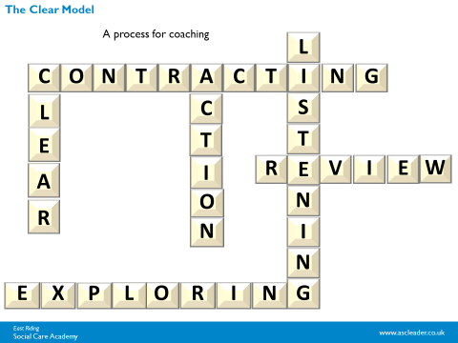The CLEAR model was developed by Peter Hawkins in the early 80’s as a process for coaching. It is also applicable and well-tried within a supervision environment. CLEAR an acronym for Contracting; Listening; Exploring; Action; Review. It is not dissimilar to the GROW model (another well-known coaching model) although it includes additional elements.

**Contracting** is an opportunity to set the ground rules for working together and establishing the outcomes and priorities wanted by both supervisor and supervisee. If this is an initial meeting this step will be probably be extended to ensure the understanding and signing of a written supervision agreement or contract and explanation of the standard agenda (if used).

**Listening.** This stage is all about actively listening to your supervisee. Helping them to gain an understanding of their situation in relation to the standards, priorities and tasks required.

**Exploring.** This stage comprises two elements:

* Exploring 1: Helping the supervisee to understand the impact of their performance, both positive and negative, and the effects on themselves, both personally and professionally.
* Exploring 2: Challenging the supervisee to think through possibilities for future action in resolving the situation or developing their practice.

**Action.** At this stage you are supporting the supervisee to choose a way ahead, and decide the next steps within the context of the standards, priorities and plans which inform their role.

**Review.** Finally this is about closing the session, reinforcing ground covered, decisions made and value added. As a supervisor you are also encouraging feedback from your supervisee on what was helpful about the supervision process or session, what was difficult and what they would might be helpful in future sessions.

# Putting your skills into practice

## Scenario 1: Barbara

|  |  |
| --- | --- |
|  | *Scenario*  Barbara had been in post for a number of years when a new manager was assigned to the department. The manager found Barbara had, for a long time, been left to her own devices. Barbara was not meeting her objectives and had been spoken to on a number of occasions about her not completing routine duties. Other performance concerns included not being polite or helpful to relatives and visitors. There were also a number of low level complaints about her attitude over a number of years. Her colleagues often said “That’s just how Barbara is, she is grumpy by nature.”  **How do you manage an employee like Barbara?**  Don’t delay - start taking action Use your observations to make a list of the specific problems that are evident from Barbara’s performance at work, and the reasons why they are not acceptable.  **Ask yourself:**   * How serious is the problem? * How long has the problem existed? * How significant is the difference between what is expected of the role and what is being done by the employee?   **What actions would you take?** |

## Scenario 2: Shona

|  |  |
| --- | --- |
|  | *Scenario*  You manage a long-serving support worker called Shona. Up until two years ago Shona had been a very dedicated and trustworthy employee. However, over the last two years Shona has become a very difficult employee to manage. If you ask Shona to undertake tasks that she considers to be beneath her, such as cleaning, she refuses stating that it is not in her job description. Shona will do only the absolute minimum amount of work necessary; you often find her sitting down flicking through the pages of gossip magazines when she is on duty. Shona has recently decided to become a vegetarian and has started to tell people being supported by the service that they “should not be eating dead animals”. You also notice that Shona is swapping shifts with other staff members and that she prefers to work later in the day. On a couple of occasions when she was on the early shift Shona was half an hour late for work and the night staff had to stay on after a busy night for her to arrive.  **How would you manage Shona?**  **The questions you need to ask yourself** Has anything happened at work or home that could explain or partly explain Shona’s failing performance at work? For example:   * Has the content of Shona’s job changed in the last two years? * Have the needs of the people being supported by the service changed in the last two years; for example, more acute or more complex needs? * Are you aware of anything outside work that might affect Shona’s ability to do her job? * Does her sickness absence reveal an underlying health problem? * Look back over the period when Shona’s attitude and performance started to decline and read supervisions and appraisals: are there any clues there? * Is Shona adequately supported to deliver her role? * Has she had the appropriate training? * How are Shona’s working relationships? * Is there any indication of bullying or harassing behaviour?   **What actions would you take?** |

## Scenario 3: Olu

|  |  |
| --- | --- |
|  | *Scenario*  Olu had been recently recruited and confirmed in post as a care assistant. When his manager returned from maternity leave she found he had been left to his own devices for a long time. He often failed to attend training and cancelled supervisions. His written communication was poor and his willingness to go beyond his job description was limited to say in the least. Other performance concerns included not being proactive enough to order maintenance to attend the service, support plans not being read and the communication book not updated with information on the people he supported except when he could remember to do so.  **How do you manage an employee like Olu?**  **Don’t delay - start taking action** Compile a list of the three to five most common examples of Olu’s performance that are giving you cause for concern, investigate them as far as possible to discover what happened and why.  **What actions would you take?** |

# Information

|  |  |
| --- | --- |
|  | *Information*  Further information can be found by following the links below:  Supervision:  <http://insight.eastriding.gov.uk/search/?q=supervision>  <https://www.skillsforcare.org.uk/Documents/Leadership-and-management/People-Performance-Management-Toolkit/People-Performance-Management-Toolkit.pdf>  https://www.skillsforcare.org.uk/Leadership-management/managing-people/supervision/Supervision.aspx  <https://www.skillsforcare.org.uk/Documents/Leadership-and-management/Registered-managers/Effective-supervision-What-to-look-for-in-a-good-supervisor-checklist.pdf>  <https://www.skillsforcare.org.uk/Documents/Learning-and-development/Effective-supervision/Effective-supervision-guide-ONLINE.pdf>  Health and Well-being:  <https://www.communitycare.co.uk/2020/12/03/recognise-manage-secondary-trauma-pandemic/>  <http://insight.eastriding.gov.uk/health-and-wellbeing/> |

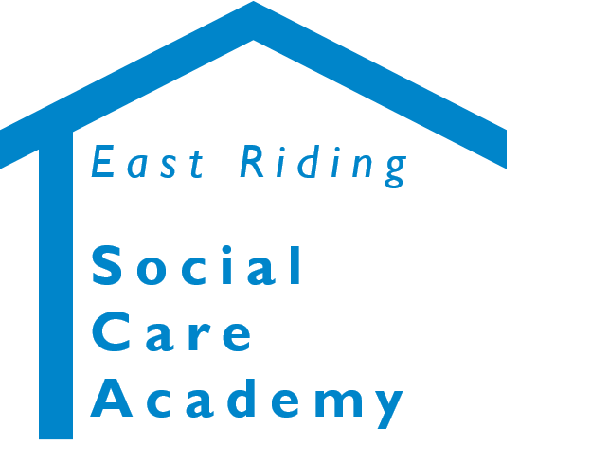

**Supervision Skills for Supervisors and Managers in Adult Provider Services** © 2020 – East Riding Social Care Academy (East Riding of Yorkshire Council)

All rights reserved. No part of this document may be reproduced, distributed, or transmitted in any form or by any means, including photocopying, recording, or other electronic or mechanical methods, without the prior written permission of the copyright holder.