Learner Resource Book

Covid 19 Aftercare and Support

Version 1.0 – 01/2021

Contents
The Learner Resource 1
Introduction 1
Structure and Layout 1
Latest Version 2
Discharge to Assess (D2A 3
Scenario 1 5
Scenario 2 6
Information 7

The Learner Resource

Introduction
Welcome to the Covid 19 Aftercare and Support. This module will provide you with an overview of why it is important to support the aftercare of people who have received treatment for Covid 19 in an integrated holistic way. It will also give you practical help by means of appropriate information sources, which will also assist with and promote self-care for individuals following discharge from hospital.

This learner resource is to be used as part of the leaning process. Within this learner resource you will find information, activities and direction to further help or information.

Structure and Layout
Each guide has a common structure and layout that helps ensure consistency and maintains the quality of the materials.

The following symbols are used to highlight key information or actions:

Information
This symbol highlights information on a particular point, topic or area.
Key Point
This symbol highlights a key point on a particular topic or area.
Question
This symbol indicates a question.
Activity
This symbol indicates an activity.
Scenario
This symbol indicates a scenario or case study.
Tag
This symbol highlights where you can find more information, help, support or a resource.

Latest Version
Always check you have the latest version of the learner resource. The issue number and date appear on the cover page.

If you have been given this learner resource by your Line Manager, Supervisor or Learning and Development Champion – they will have checked it is the current version. Learning and Development only provide copies of the current version of any learner resource.

Discharge to Assess (D2A)
MDT decides Pathway for patient
ASC WORKER
(SW/ SSW/ TM/) Has input into pathway decision
OT may have input to support reductions or consider alternative care and support requirements
ALL ACUTE TRUST WARDS IDENTIFY MED FIT AND UNDERTAKE TRUSTED ASSESSOR ASSESSMENT
Pathway 1a:
HOME with POC
CSS provision
Capacity known ASAP
Pathway 1b:
HOME with POC
Private Provider
Capacity known within 30 minutes
ASC OUT OF HOSPITAL HUB (Virtual) Wards Trusted Assessor forms received and actioned by CSS TA/HSW – 2 hours timeframe to mobilise care and support ready for hospital discharge.

PATIENT MOVED TO ACUTE DISCHARGE SETTING within 1 HOUR OF MED FIT and to be DISCHARGED within 2 HOURS AFTER CONFIRMATION OF PROVISION. lounge until provision is confirmed
CHANGE
Out of Hospital Hub - KEY ACTIONS:
- Checking CSS capacity, if none, Call Out to private Providers – 30 minutes response time
- ASC worker to check Community bed capacity as Plan B if private provider has no capacity.
- POC outcome identified – notify relevant Acute Trust Discharge Hub
- OT involvement considered at LTA, refer if necessary

Pathway 1c:
HOME via Community Bed if POC unavailable
CSS TA or ASC worker to inform Discharge Hub of need for bed
(CHCP organise for HUTHT 01482 247111 and EHT/ASC workers organise for other Acute Trusts)

Pathway 3 (including Pathway 4 for York Teaching Hospital)
ERYC hospital SWs source basic residential/nursing beds and have oversight of all restarts.
Pathway 4/York for EOL/CHC
Pathway 2: Acute bed
Straight to Discharge to assess bed - with ERYC hospital SW oversight

WITHIN 24 – 48 HOURS
CSS AO’s UTILISE D2A ASSESSMENT (LTA Form) TO REVIEW INITIAL TA CARE AND SUPPORT

YES:
NOTIFY C&RT/CLOSE INITIAL D2A ASSESSMENT
RAISE CONTACT TO CWT

NO: NOTIFY DESIGNATED SW TO RAISE CONTACT TO CWT FOR REVIEW
CWT FOLLOW UP/REVIEW within max. 12 weeks after NEW D2A CONTACT RECEIVED
INITIATE ASC FINANCIAL ASSESSMENT CONTACT PROCESS

Key: Discharge to Assess flow chart
ASC worker | Could be team manager/senior social work/social work or care co-ordinator in either hospital or community teams
BMC | Business Management and Commissioning (ERYC)
POC | Package of care (in the community)
CSS | Community Support Service (ERYC in-house home care)
CSS TA | Community Support Service technical assistant
CSS AO | Community Support Service assessment officer
C&RT | Contract and Review Team (ERYC)
CWT | Community Wellbeing Team (ERYC)
D2A | Discharge to Assess Pathway
D2A Assessment | Discharge to Assess Assessment (AIS)
D2A Care and Support Plan | Discharge to Assess Care and Support Plan (Care and Support Plan on AIS)
D2A LTA Form | Discharge to Assess Light Touch Assessment Form (paper document)
Bedded setting | see Community Bed capacity lists for details

Scenario 1

Scenario Gloria
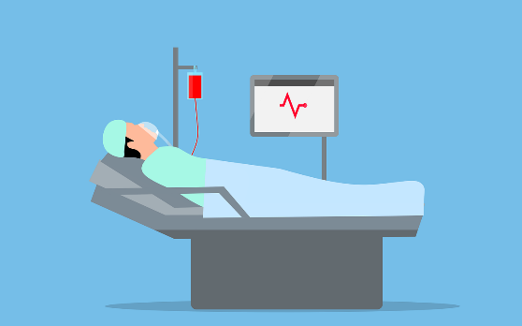
Gloria is 67 years old and has been in hospital for 9 weeks.
Gloria was admitted with breathing difficulties, not having had these difficulties previously, and after tests was diagnosed with Covid 19.

Gloria’s condition worsened rapidly and it was necessary for Gloria to be taken to Intensive Care Unit to be treated.

Gloria is now experiencing post intensive care syndrome (PICS).

Gloria is ready for discharge what might Gloria be experiencing Physically and how can Gloria be supported?

Scenario 2

Scenario Ken
Ken is 74 years old and has been in hospital for 6 weeks.
Ken was admitted after having a positive Covid test result and being unable to manage his symptoms at home.

A contributory factor to this was that Ken lives alone.

Ken has experienced some intensive treatment whilst in hospital. As a result of Ken’s treatment regime in hospital he is experiencing psychological difficulties.

What might these be and how can Ken be supported?

Information

Information

Further information on the discharge process can be found by visiting
https://www.england.nhs.uk/coronavirus/publication/covid-19-hospital-discharge-service-requirements/

http://insight.eastriding.gov.uk/directorates/ahcs/adult-services/covid-19-coronavirus/discharge-to-assess-d2a/

Further information on the recovery process can be found by visiting
Self-care guide: Your Covid Recovery Cough
https://www.yourcovidrecovery.nhs.uk/managing-the-effects/effects-on-your-body/cough/

Self-care guide: Your Covid Recovery
https://www.yourcovidrecovery.nhs.uk/managing-the-effects/other-conditions/respiratory/

Self-care guide: Your Covid Recovery Breathlessness https://www.yourcovidrecovery.nhs.uk/managing-the-effects/effects-on-your-body/breathlessness/

Self-care guide: Your Covid Recovery Managing your Oxygen
https://www.yourcovidrecovery.nhs.uk/managing-the-effects/effects-on-your-body/managing-your-oxygen/

Self-care guide: Your Covid Recovery https://www.yourcovidrecovery.nhs.uk/managing-the-effects/other-conditions/cardiovascular/

Self-care guide: Your Covid Recovery https://www.yourcovidrecovery.nhs.uk/managing-the-effects/other-conditions/diabetes/

Self-care guide: Your Covid Recovery
https://www.yourcovidrecovery.nhs.uk/your-wellbeing/eating-well/

Self-care guide: Your Covid Recovery https://www.yourcovidrecovery.nhs.uk/managing-the-effects/effects-on-your-body/taste-and-smell/

Self-care guide: Your Covid Recovery https://www.yourcovidrecovery.nhs.uk/managing-the-effects/effects-on-your-body/voice-and-swallowing/

Further information about eating well, food textures and guidelines can be found by visiting:
https://www.nhs.uk/live-well/eat-well/the-eatwell-guide/
https://iddsi.org/

Nutrition training for social care can be found @ https://www.ascleader.co.uk/

Further guidance about pressure sore care can be found:
http://www.reacttoredskin.co.uk/

Moving and Handling of People training can be found @ https://www.ascleader.co.uk/

Self-care guide: Your Covid Recovery https://www.yourcovidrecovery.nhs.uk/managing-the-effects/effects-on-your-body/musculoskeletal-shoulder-and-back-pain/

Self-care guide: Your Covid Recovery
https://www.yourcovidrecovery.nhs.uk/your-wellbeing/getting-moving-again/

Self-care guide: Your Covid Recovery
https://www.yourcovidrecovery.nhs.uk/your-wellbeing/sleeping-well/

Self-care guide: Your Covid Recovery https://www.yourcovidrecovery.nhs.uk/managing-the-effects/effects-on-your-body/fatigue/

Self-care guide: Your Covid Recovery https://www.yourcovidrecovery.nhs.uk/managing-the-effects/effects-on-your-mind/memory-and-concentration/

Self-care guide: Your Covid Recovery https://www.yourcovidrecovery.nhs.uk/managing-the-effects/effects-on-your-mind/managing-fear-and-anxiety/

Self-care guide: Your Covid Recovery https://www.yourcovidrecovery.nhs.uk/managing-the-effects/effects-on-your-mind/managing-your-mood-and-coping-with-frustration/

https://www.mind.org.uk/

Covid 19: psychological First Aid Training
https://www.futurelearn.com/courses/psychological-first-aid-covid-19

There are lots of training resources that can be found on the wellbeing hub by visiting https://www.ascleader.co.uk/

Mental Capacity Act training for social care can be found @ https://www.ascleader.co.uk/

Self-care guide: Your Covid Recovery
https://www.yourcovidrecovery.nhs.uk/your-road-to-recovery/coming-home-from-hospital/

Self-care guide: Your Covid Recovery
https://www.yourcovidrecovery.nhs.uk/your-road-to-recovery/managing-daily-activities/

https://eastriding.connecttosupport.org/

Further guidance can be found:
https://www.eastriding.gov.uk/living/care-and-support-for-adults/carers/support-for-carers/

Tel: 0800 917 6844 (Freephone)
Email: ERCarers@eastriding.gov.uk

Self-care guide: Your Covid Recovery
https://www.yourcovidrecovery.nhs.uk/your-wellbeing/family-friends-and-carers/

The British Psychological Society document can be accessed by following this link:
https://www.yourcovidrecovery.nhs.uk/wp-content/uploads/2020/07/supporting-yourself-and-others.pdf

Self-care guide: Your Covid Recovery
https://www.yourcovidrecovery.nhs.uk/your-wellbeing/grief-and-bereavement/

Infection, prevention and control elearning training can be found @ https://www.ascleader.co.uk/

Further guidance can be found
https://www.gov.uk/government/publications/covid-19-how-to-work-safely-in-domiciliary-care

Other self-care guides in Your Covid Recovery Series:
https://www.yourcovidrecovery.nhs.uk/your-road-to-recovery/when-do-i-need-to-seek-help/

https://www.yourcovidrecovery.nhs.uk/your-road-to-recovery/what-next/

https://www.yourcovidrecovery.nhs.uk/your-road-to-recovery/returning-to-work/

https://covid19.eastriding.gov.uk/local-restrictions/

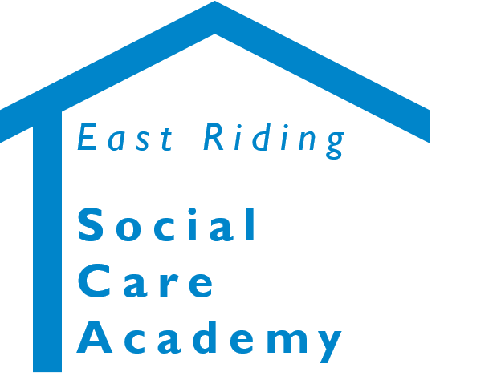

Covid 19 Aftercare and Support © 2021 – East Riding Social Care Academy (East Riding of Yorkshire Council)

All rights reserved. No part of this document may be reproduced, distributed, or transmitted in any form or by any means, including photocopying, recording, or other electronic or mechanical methods, without the prior written permission of the copyright holder.

