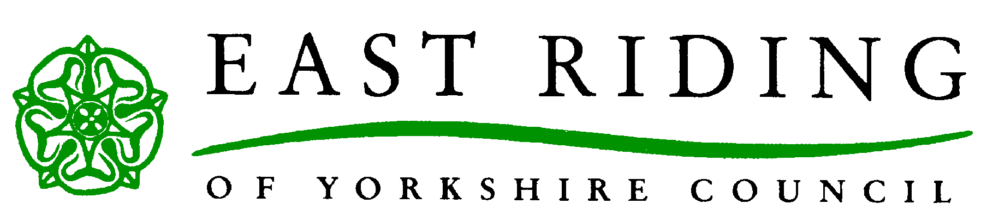

Agreement to Care and Support Plan

To be signed by Service User
Personal Budget Agreement: for commissioned/virtual care and support only (delete if not applicable)
- I agree to pay my assessed contribution (if any) to the local authority on request
- I agree to give 7 days’ notice to the council of any changes of circumstances including change in service required, hospital stays, financial changes etc.

Personal Budget Agreement: Cash via Direct payments or Mixed (delete if not applicable)
I confirm that I have received the booklet “User Guide to Direct Payments” from my care coordinator or social worker. I will read this booklet and I will have the opportunity to go through the content of it and ask questions from the direct payment support officer when they visit

Signature: |  | Date:

Role
(if not signed by individual)

Note: The can only be signed by the service user and their authorised person if they have one of the nominated person if using direct payments

For Local Authority Use
- The Personal Budget/Care & Support Plan has been agreed by the local authority
- The Care and Support Plan delivers an appropriate package of support to meet the eligible needs of the individual
- Any identified risks including contingencies are covered within the plan
- The Care and Support Plan will be reviewed within 6 – 8 weeks/annually and then at least annually unless a change in circumstance requires one sooner than this

Details of the Worker assisting you with your support plan is below:

Workers Name: |  | Phone Number:

Workers Signature: |  | Date:

Review Details
Date of Review/approximate date if not agreed:

Please note: A review can take place sooner if circumstances change of if you would like to request a review.

