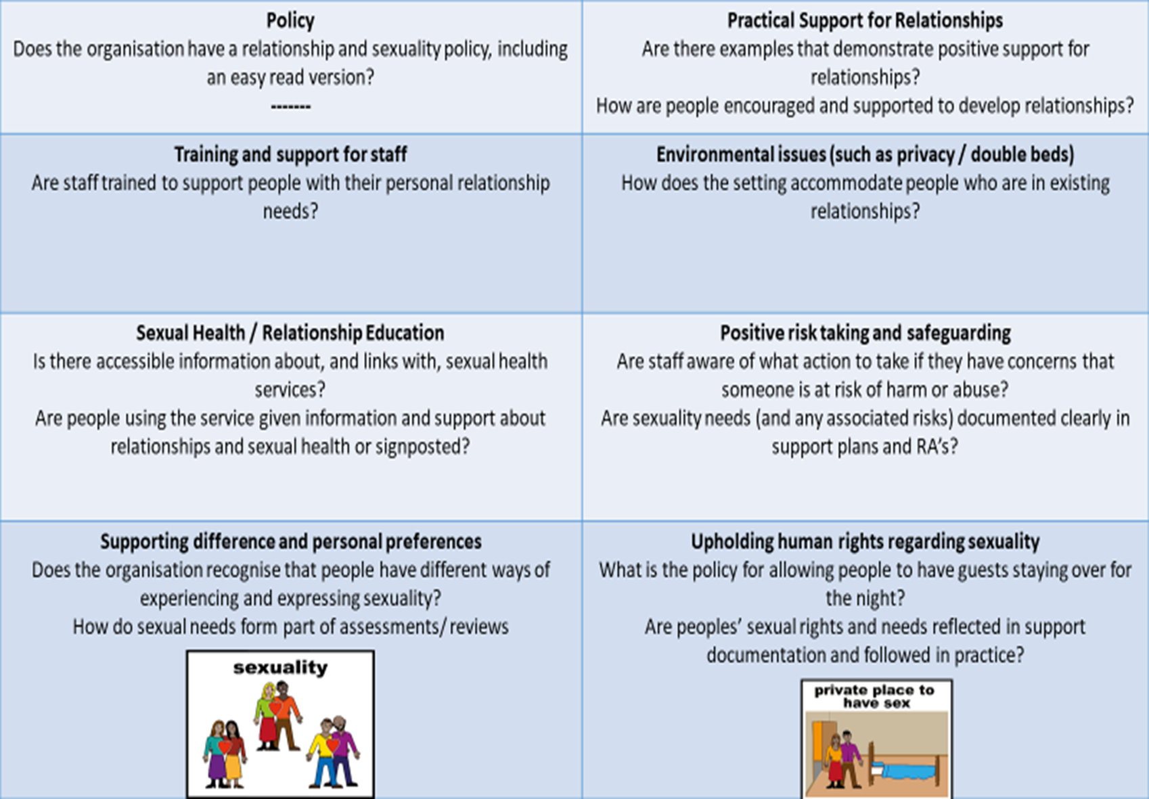

/10

/10

/10

/10

/10

/10

1

166

RELATIONSHIPS AND PLANNING

SOMETIMES WHEN PEOPLE ARE MAKING DECISIONS ABOUT THEIR LIFE, RELATIONSHIPS ARE NOT SEEN TO BE VERY IMPORTANT and SEXUAL NEEDS ARE IGNORED.   
THIS DOCUMENT WILL HELP YOU AND YOUR SUPPORTERS TO THINK ABOUT RELATIONSHIPS AND SEX BEFORE YOU START PLANNING. THIS SHOULD MAKE IT EASIER AND MORE COMFORTABLE TO INCLUDE THESE THINGS IN DISCUSSIONS OR MEETINGS, WHEN YOU ARE DEVELOPING:

* **PERSON CENTRED PLANS** 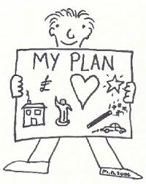
* **CARE PLANS**
* **SUPPORT PLANS**
* **health action plans**

 

|  |  |  |  |  |  |  |
| --- | --- | --- | --- | --- | --- | --- |
|  | **RELATIONSHIPS** | **YES** | NO | WHAT SUPPORT DO I NEED | WHO MIGHT HELP ME | WHEN WILL THIS HAPPEN |
|  | I AM IN A RELATIONSHIP |  |  |  |  |  |
|  | I WOULD LIKE TO HAVE A RELATIONSHIP |  |  |  |  |  |
|  | I WOULD LIKE TO FIND OUT MORE ABOUT GETTING AND MAINTAING A RELATIONSHIP |  |  |  |  |  |
|  | I WOULD LIKE TO TALK TO SOMEBODY ABOUT RELATIONSHIPS |  |  |  |  |  |
|  | I WOULD LIKE TO HAVE A CHANCE TO MEET MORE PEOPLE AND MAKE FRIENDS |  |  |  |  |  |

|  |  |  |  |  |  |
| --- | --- | --- | --- | --- | --- |
| **SEXUAL RELATIONSHIPS** | YES | NO | WHAT SUPPORT DO I NEED | WHO MIGHT HELP ME | WHEN WILL THIS HAPPEN |
| I HAVE HAD SEX EDUCATION AND FEEL CONFIDENT ABOUT MY KNOWLEDGE |  |  |  |  |  |
| I WOULD LIKE TO FIND OUT MORE ABOUT SEX AND SEXUAL RELATIONSHIPS |  |  |  |  |  |
| I KNOW WHAT SAFE SEX IS |  |  |  |  |  |
| I WOULD LIKE TO TALK TO SOMEONE ABOUT SAFE SEX |  |  |  |  |  |
| I WOULD LIKE TO TALK TO SOMEONE ABOUT A PARTICULAR ISSUE |  |  |  |  |  |

|  |  |  |  |  |  |
| --- | --- | --- | --- | --- | --- |
| SEXUAL HEALTH | YES | NO | WHAT SUPPORT DO I NEED | WHO MIGHT HELP ME | WHEN WILL THIS HAPPEN |
| I KNOW HOW TO CHECK MY TESTICLES (MALE) |  |  |  |  |  |
| I KNOW HOW TO CHECK MY BREASTS (FEMALE) |  |  |  |  |  |
| I KNOW HOW TO ACCESS LOCAL SEXUAL HEALTH SERVICES |  |  |  |  |  |
| I KNOW WHERE TO GO FOR CONTRACEPTIVE ADVICE |  |  |  |  |  |
| I WOULD LIKE TO TALK TO SOMEBODY ABOUT SEXUAL HEALTH |  |  |  |  |  |

|  |  |  |  |  |  |
| --- | --- | --- | --- | --- | --- |
| RIGHTS AND RESPONSIBILITIES | YES | NO | WHAT SUPPORT DO I NEED | WHO MIGHT HELP ME | WHEN WILL THIS HAPPEN |
| I UNDERSTAND WHAT THE LAW SAYS ABOUT SEXUALITY AND RELATIONSHIPS |  |  |  |  |  |
| I UNDERSTAND WHAT THE MENTAL CAPACITY ACT SAYS ABOUT CONSENT AND CAPACITY |  |  |  |  |  |
| I KNOW THAT I MAY CONTACT AN ADVOCATE TO ASSIST ME TO ACCESS APPROPRIATE SUPPORT |  |  |  |  |  |
| I HAVE ACCESS TO MY SUPPORT AGENCIES POLICY ABOUT SEXUALITY AND RELATIONSHIPS |  |  |  |  |  |

|  |  |  |  |  |
| --- | --- | --- | --- | --- |
| **ACTIONS-THINGS I WANT TO BE INCLUDED IN THE PLAN OR DISCUSSED AT THE MEETING** | | | | |
| ACTION No. | WHAT I WANT TO HAPPEN | WHO I WANT TO HELP ME/SUPPORT | WILL ANYONE ELSE NEED TO BE INVOLVED | WHEN WILL THIS BE ACHEIVED |
| 1 |  |  |  |  |
| 2 |  |  |  |  |
| 3 |  |  |  |  |
| 4 |  |  |  |  |
| 5 |  |  |  |  |
| 6 |  |  |  |  |



THIS FORM HAS BEEN DESIGNED BY Y TRAINING-NOT TO BE COPIED WITHOUT CONSULTATION  
Contact: Sue Sharples-Sue@ytraining.co.uk Tel:07834695606

**Training  
and  
Consultancy**

**13.Sexual behaviour and sex education care plan**

**TRAINING AND CONSULTANCY**

**Name:**

**Date of birth:**

**Written by: Date: Review date:**

|  |  |
| --- | --- |
| **My sexual behaviour** | I am currently experiencing erections around female members of staff. I will try to touch them when I can, usually on their bottoms or in between their legs. I frequently get erections when I have personal care. I will try to guide staff’s hands to my erect penis. My erections are frequent and as far as staff know I do not masturbate to the point of ejaculation. Staff are not sure why this is but think it might be because I do not know how to. |
| **Relationships and sex education** |  |
| **Growing up** |  |
| Mental Capacity Act**The law** |  |
| Bedroom**Where I live** |  |
| **Sexual behaviour care plan**  Plan-1 |  |
| Co-Training 2**Sex education plan**  Plan-1 |  |

**SDS Reviewed July 2020**

**15**.STAGES OF CHANGE (Prochaska and Norcross 1994)

|  |  |  |  |
| --- | --- | --- | --- |
| **Stage** | **Information** | **Strategy** | **Outcome** |
| Precontemplation | Reluctant to change entrenched behaviour | Listen intently  Reflect back  Open ended questions  To help move to contemplation stage | Person begins to consider that an issue exists |
| Contemplation | Aware problem exists.Considering change but have not made a commitment to action | Provide ‘pros and cons’  Explore options and concerns  Information | Tentative commitment to change |
| Preparation | Firm commitment to change, with ambivalence | Consider barriers and how to overcome them  ‘What do you think you will do?’  ‘Whats the next step?’  Education | Making clear change statements and an action plan is in place |
| Action | Active modification of behaviour.  Commitment is clear | Focus on successful activity  Reaffirm commitment | New behaviour patterns apparant |
| Maintenance | Sustained behavioural and attitudinal change  Low threat of relapse  Be aware that trauma or crisis might precipitate a relapse | Feedback about change  Reassure and reinforce  Empathy | Behaviour stage process complete and successful.  Lapses due to stress/crisis may create the need to start again at pre contemplative or contemplative stages |

