|  |  |
| --- | --- |
|  | ***Learner Resource*** |
| **Learning Disability Awareness for Adult Social Care** | |

|  |  |
| --- | --- |
|  |  |
|  |  |

Version 1.0 – 10/2020

**Contents**

The Learner Resource 1

Introduction 1

Structure and Layout 1

Latest Version 2

Activity 1: What is a Learning Disability 3

Activity 2: What is a Learning Difficulty? 3

Activity 3: Fact or Fiction 4

Activity 4: Ben 5

Legislation and Policies 6

Strategic Plan on a Page 7

Activity 5: Change 8

Activity 6: Choice and Control 9

# The Learner Resource

## Introduction

Welcome to the Learning Disability Awareness for Social Care course. This course enables you to develop your knowledge and skills about learning disabilities and promote a positive approach when working with people living with learning disabilities.

This learner resource is to be used as part of the learning process. Within this learner resource you will find information, activities and direction to further help or information.

## Structure and Layout

Each guide has a common structure and layout that helps ensure consistency and maintains the quality of the materials.

The following symbols are used to highlight key information or actions:

|  |  |
| --- | --- |
|  | *Information*  This symbol highlights information on a particular point, topic or area. |
|  | *Key Point*  This symbol highlights a key point on a particular topic or area. |
|  | *Question*  This symbol indicates a question. |
|  | *Activity*  This symbol indicates a activity. |
|  | *Scenario*  This symbol indicates a scenario or case study. |
|  | *Tag*  This symbol highlights where you can find more information, help, support or a resource. |

## Latest Version

Always check you have the latest version of the learner resource. The issue number and date appear on the cover page.

If you have been given this learner resource by your Line Manager, Supervisor or Learning and Development Champion – they will have checked it is the current version. Learning and Development only provide copies of the current version of any learner resource.

## Activity 1: What is a Learning Disability

Please take a few moments and answer the following question:

|  |  |
| --- | --- |
|  | *Activity*  What is a learning Disability? |

## Activity 2: What is a Learning Difficulty?

Thinking about your answer in Activity 1, can you now answer the question below. When doing so please ask yourself:

Is it different to a learning disability?

If so, in what way?

|  |  |
| --- | --- |
|  | *Activity*  What is a learning Difficulty? |

## Activity 3: Fact or Fiction

Look at the table below. You will find 10 statements, some are factual and some are fiction, can you see if you can match up the facts with the fiction.

|  |  |  |  |  |  |  |  |  |  |  |  |  |  |
| --- | --- | --- | --- | --- | --- | --- | --- | --- | --- | --- | --- | --- | --- |
|  | *Activity*   |  |  | | --- | --- | | 1  People with Downs Syndrome do not live long | A  We are all different and therefore people with Downs Syndrome will have their own traits and varying moods. | | 2  Only older mothers have babies born with Downs Syndrome | B  Today people with Downs Syndrome are living into their 50s,60s,70s and beyond | | 3  People with Downs Syndrome cannot achieve normal life goals | C  There are certain physical characteristics that can occur but everyone is unique. | | 4  People with Downs Syndrome all look the same | D  Although they have a higher chance, more are born to younger mothers | | 5  People with Downs Syndrome are always happy and affectionate | E  With the right support…Yes they can. More are leaving home, living independently, gaining employment, meeting partners and leading a good life | | Answers:  1  2  3  4  5 | | |

## Activity 4: Ben

|  |  |
| --- | --- |
|  | *Scenario*  Ben has learning disabilities and Prader-Willi syndrome. There are concerns about his health because his weight has been increasing steadily and now stands at 120kg.  Staff in his residential home have tried to support Ben to limit what he eats and to make healthy choices but with little effect.  Ben has been assessed as lacking capacity to make decisions about the amount and type of food he eats, which is common among people living with Prader-Willi Syndrome. It has been proposed that it is in Ben’s best interests to stop him going into the kitchen, and always supervising him when out, to prevent him spending all his money on, or stealing, food.  What should happen next?  What should the manager of the home do?  What are the key messages for the home and the staff in respect of this situation? |

## Legislation and Policies

|  |  |
| --- | --- |
|  | *Key Point*  Key pieces of Legislation and Policies that support the Human Rights and Inclusion of people with learning Disabilities.  **Legislation** – a law or set of laws suggested by a government and made official by a parliament.  **White Papers** - government policy initiatives and proposals for legislation.  **Green Papers** - government consultation documents. |

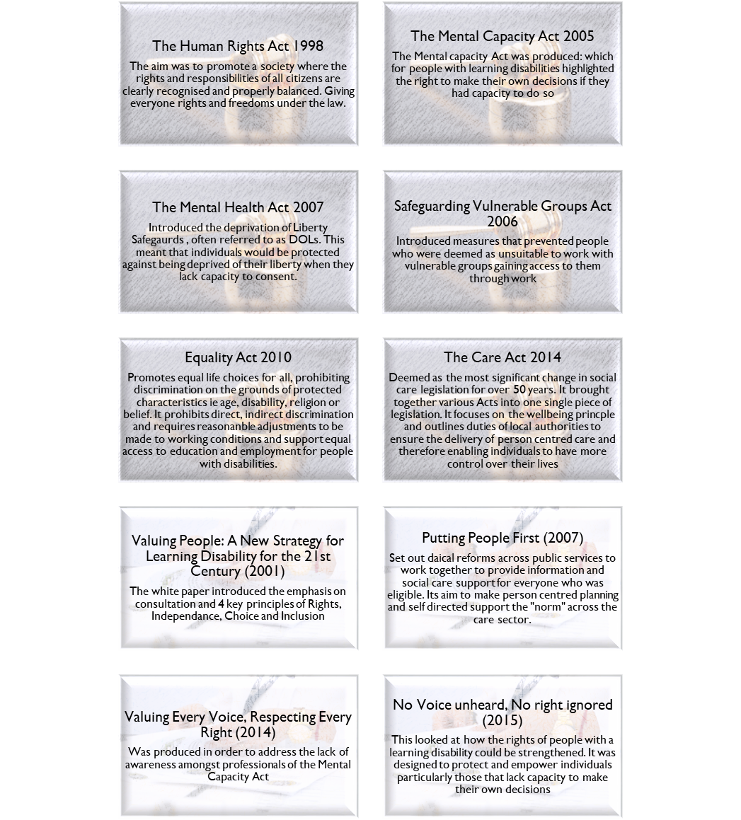

White / Green Papers



Legislation



## Strategic Plan on a Page

*Strategic Plan on a Page, Learning Disability Strategy for Adults (including those transitioning to Adulthood) 2019 2024*

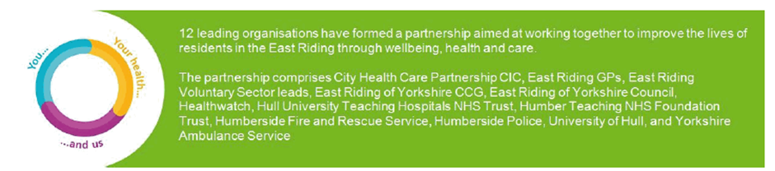 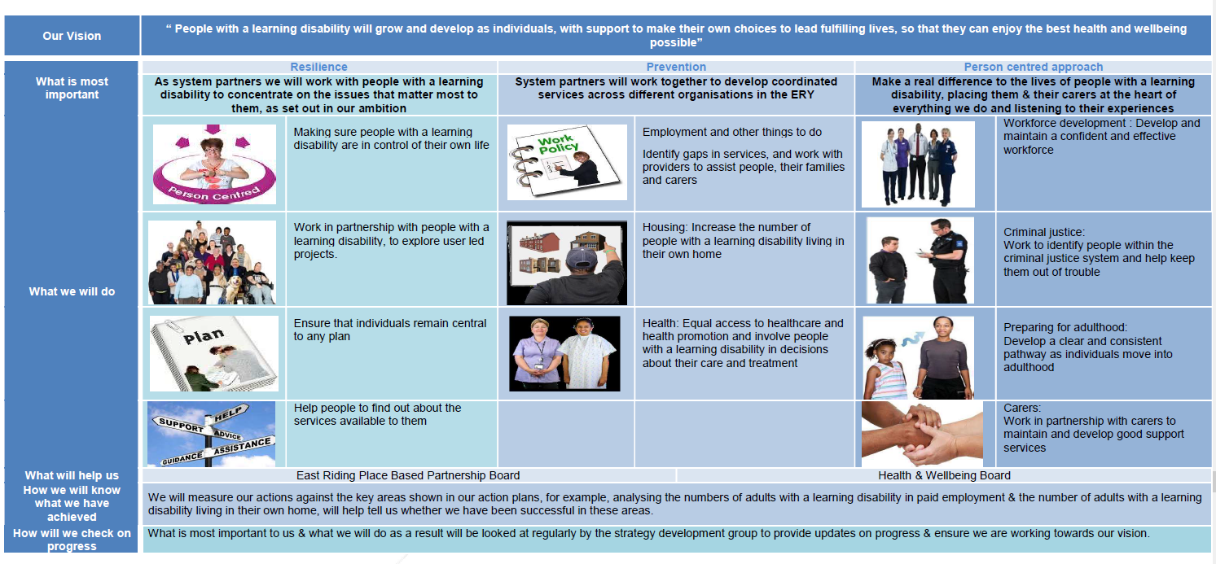

## Activity 5: Change

|  |  |  |  |  |  |  |  |  |  |  |  |
| --- | --- | --- | --- | --- | --- | --- | --- | --- | --- | --- | --- |
|  | *Activity*  Think about the key legislation, policies and events that over the years have influenced the social care system. In groups / or individually can you answer the following question.  *How can others change attitudes, influence policies and provide good quality care and support for people with learning disabilities?*  *Note your answers in the grid provided.*   |  |  | | --- | --- | | The Individual with Learning Disabilities |  | | Colleagues |  | | Families and Carers |  | | Friends |  | | Members of the Public |  | |

## Activity 6: Choice and Control

|  |  |
| --- | --- |
|  | *Activity*  Think about the Covid 19 situation. You are cut off from your family and friends. How does that make you feel?  Ask yourselves the following questions…be honest and make a note of your responses:   * Do you feel lonely and unloved? * Think about how you felt by being told what you could or couldn’t do. * Did you feel angry, confused, and sad?What impact did this have on you? * What impact did this have on your mental health and your behaviour?Can you imagine living the rest of your life like this? * Imagine not having choices. |

|  |  |
| --- | --- |
|  | *Tag*  Key resources to help and assist you with additional reading:  Downs syndrome Association <http://www.downs-syndrome.org.uk/about/>  <https://www.downs-syndrome.org.uk/for-professionals/social-care/>  <https://www.pwsa.co.uk/>  <https://www.nhs.uk/conditions/prader-willi-syndrome/>  <https://www.scie.org.uk/mca/dols/at-a-glance> (MCA directory)  <https://www.fragilex.org.uk/>  <https://www.nhs.uk/conditions/rett-syndrome/>  <https://www.mencap.org.uk>  <https://williams-syndrome.org.uk>  Learning disability England  **social model of disability**  <https://www.scie.org.uk/strengths-based-approaches/guidance>  Nice <https://www.nice.org.uk/>  <https://www.nice.org.uk/about/nice-communities/social-care/quick-guides/enabling-positive-lives-for-autistic-adults>  <https://www.nice.org.uk/guidance/cg142>  Scie social care of excellence <https://www.scie.org.uk/>  Skills for care <https://www.skillsforcare.org.uk/Home.aspx>  Skills for health <https://www.skillsforhealth.org.uk/>  NHS England Learning disabilities  PBS academy <http://pbsacademy.org.uk/>  Scope <https://www.scope.org.uk/> ( equality for disabled people) |

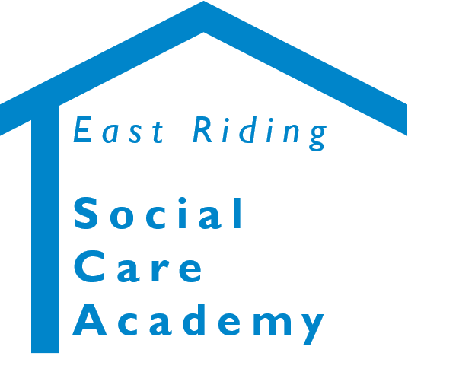

**Learning Disability Awareness for Social Care Providers** © 2020 – East Riding Social Care Academy (East Riding of Yorkshire Council)

All rights reserved. No part of this document may be reproduced, distributed, or transmitted in any form or by any means, including photocopying, recording, or other electronic or mechanical methods, without the prior written permission of the copyright holder.