Learner Resource Book

Working in a Person Centred Way

Version 2.1 – 10/2020

Contents
The Learner Resource 1
Introduction 1
Structure and Layout 1
Latest Version 2
Your morning routine 3
Activity 1 3
Person Centred Features 4
Case study 5
Activity 2 5
Communication Charts 6
Activity 3 6
One Page Profile 7
Activity 4 7
Information 8

The Learner Resource

Introduction
Welcome to the Working in a Person Centred Way module. This module aims to introduce learners to a person centred and strengths-based approach in adult social care.

This learner resource is to be used as part of the leaning process. Within this learner resource you will find information, activities and direction to further help or information.

Structure and Layout
Each guide has a common structure and layout that helps ensure consistency and maintains the quality of the materials.

The following symbols are used to highlight key information or actions:

Information
This symbol highlights information on a particular point, topic or area.
Key Point
This symbol highlights a key point on a particular topic or area.
Question
This symbol indicates a question.
Activity
This symbol indicates a activity.
Scenario
This symbol indicates a scenario or case study.
Tag
This symbol highlights where you can find more information, help, support or a resource.

Latest Version
Always check you have the latest version of the learner resource. The issue number and date appear on the cover page.

If you have been given this learner resource by your Line Manager, Supervisor or Learning and Development Champion – they will have checked it is the current version. Learning and Development only provide copies of the current version of any learner resource.

Your morning routine

Activity 1

Take 10 minutes to think about and write down what you did this morning from the moment you woke up to getting to work.

Please only write what you feel comfortable in writing…. We don’t need all the details!!

………………………………………………………………………………………………………………………………………………………………………………………………………………………………………………………………………………………………………………………………………………………………………………………………………………………………………………………………………………………………………………………………………………………………………………………………………………………………………………………………………………………………………………………………………………………………………………………………………………………………………………………………………………………………………………………………………………………………………………………………………………………………………………………………………………………………………………………………………………………………………………………………………………………………………………………………………………………………………………………………………………………………………………………………………………………………………………………………………………………………………………………………………………………………………………………………………………………………………………………………………………………………………………………

Person Centred Features

Information

- The Person is at the centre of any work undertaken

- No work is undertaken in isolation

- The work shows what is important to the person now, in the future and what support they need

- The work helps individuals to become part of their community and not just services

- It is part of a process of continual learning not a finished product

Case study

Activity 2
This is Pierre, he is currently in his last year of studying a degree in Music at University. Here are some basic facts about Pierre:

- Born in France and can Speak English
- Moved to England to Study Music
- He is the top of his class and is liked by everyone
- Suffers with depression
- Loves to play the piano and write songs
- Struggles with being in large groups of people he doesn’t know

He has recently been struggling with his mental health and as a result of this, he is now behind on his studies. Because Pierre’s mood is low he feels he can’t see how or if he wants to complete his final year of his degree. Pierre is a very talented piano player and has always dreamed of teaching music.

How can you help Pierre?

………………………………………………………………………………………………………………………………………………………………………………………………………………………………………………………………………………………………………………………………………………………………………………………………………………………………………………………………………………………………………………………………………………………………………………………………………………………………………………………………………………………………………………………………………………………………………………………………………………………………………………………………………………………………………………………………………………………………………………………………………………………………………………………………………………………………………………………

Communication Charts

Activity 3
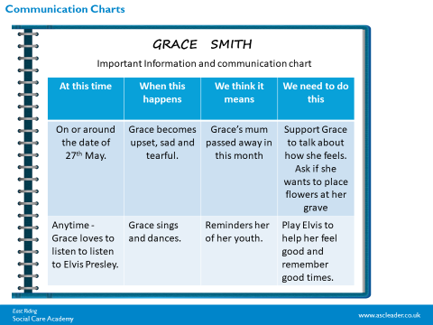

In the chart below think about a service user you support or someone you know. Complete the communication chart, Please do not write any names but do write key information that would help other staff members to be aware of regarding that individual.

At his time | When this happens | We think this means | We need to do this

One Page Profile

Activity 4

Profile

What people like and admire about me…

How best to Support me..
What’s important to me…

THIS IS ME …

Information
Information

For information on any of the topics we have discussed today or any further information on Working in a Person Centred Way please follow these links.

For any information on person centred care follow Helen Sanderson Associates website:
http://helensandersonassociates.co.uk/

Information on working in a person centred way can also be found at Scie:
https://www.scie.org.uk/prevention/choice/person-centred-care?gclid=EAIaIQobChMI1rXJrdHj6gIVRrDtCh3GYAdNEAAYAiAAEgLTkvD_BwE

To see how this material relates to The Care Certificate: https://www.skillsforcare.org.uk/Documents/Learning-and-development/Care-Certificate/Standard-5.pdf

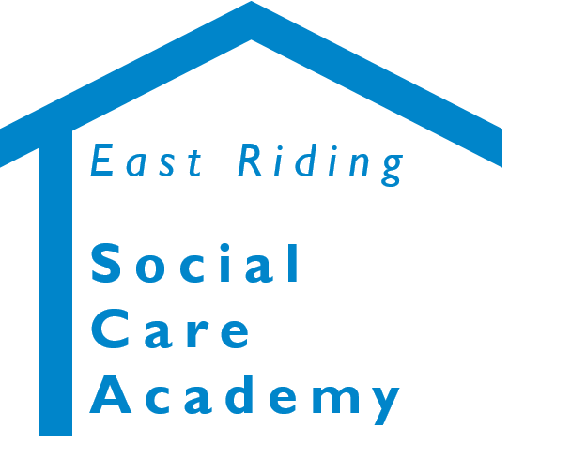

Working in a person Centred Way
© 2020 – East Riding Social Care Academy (East Riding of Yorkshire Council)

All rights reserved. No part of this document may be reproduced, distributed, or transmitted in any form or by any means, including photocopying, recording, or other electronic or mechanical methods, without the prior written permission of the copyright holder.

