 | Learner Resource
Modern Slavery

Version 1.1 October 2024

Contents
What we do in the East Riding 1
Local resources 2
County Lines-------------------------------------------------------------------------------------------------------------------3
Workplace resource ---------------------------------------------------------------------------------------------------------5
NRM------------------------------------------------------------------------------------------------------------6
Steps to follow------------ -----------------------------------------------------------------------------------7
Further resources--------------------------------------------------------------------------------------------8

What do we do in the East Riding?

 | As we are ‘transparent’ in our care role , businesses can help prevent modern slavery by being transparent- being upfront about where their employees come from, a robust recruitment procedure, etc.  The Modern Slavery Act 2015 (Section 54) requires every organisation and business within the UK (with a total turnover of £36m or more) to produce a slavery and human trafficking statement for each financial year.  Smaller companies may wish to produce a similar statement on a voluntary basis.  ERYC does not have an obligation to publish a modern slavery statement but has chosen to do so. It can be viewed on the intranet.  Follow the link below or scan the QR code for the council's first Modern Slavery annual report 2023-2024  https://downloads.eastriding.org.uk/ersab/Modern%20Slavery%20Annual%20Report%202023-24.pdf  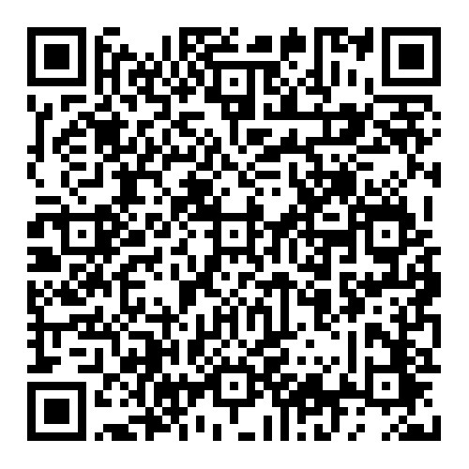

Local resources
Information

 | Humber Modern Slavery Partnership  We are committed to tackling Modern Slavery in all its forms across Humberside by working in partnership to disrupt organised crime, bring perpetrators to justice and protect vulnerable people.  Our Mission  To generate a coordinated, efficient and proactive response to Modern Slavery across all four local authority areas in Humberside. To have a victim-focused approach that sees improved identification and support for victims as well as improved knowledge among the public and professionals. To make Humberside a hostile environment for perpetrators.  Follow the link below or scan the QR code to view the Humber Modern Slavery Partnership strategy and resources and the Wilberforce Institute,Hull.  https://humberantislave.co.uk/  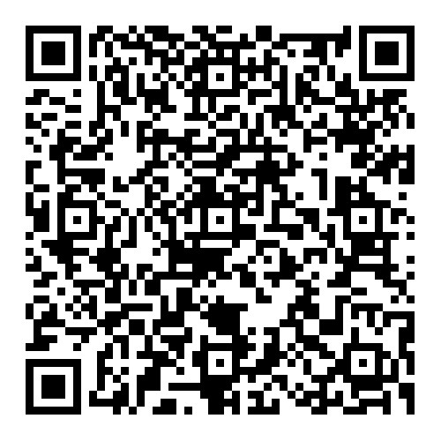  https://www.hull.ac.uk/research/institutes/wilberforce  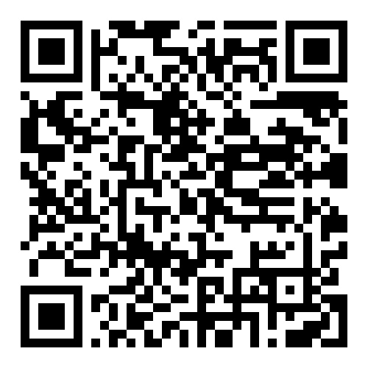

County Lines
Local and national

 | Humberside Police are working hard to increase awareness within the community about the signs of County Lines exploitation and encourage reporting. Public cooperation is vital in tackling this issue.  Chief Inspector Mark Skelton said  “ let us focus our efforts to combat the scourge of County Lines drug distribution. Each operation we disrupt, each individual we save from exploitation, is a significant victory in our ongoing battle against organised crime.  The fight against County Lines is not just about law enforcement; it's about protecting our most vulnerable from exploitation and dismantling networks that sow discord in our communities. Your dedication, vigilance, and proactive approach are key to our success.  Please disseminate through your respective networks, and encourage partners to submit intelligence through the Community Intelligence Portal using the link or scan the QR code below.  https://www.humberside.police.uk/partners/partner-services/community-partner-intelligence/community-partnership-intelligence/ (for professionals)  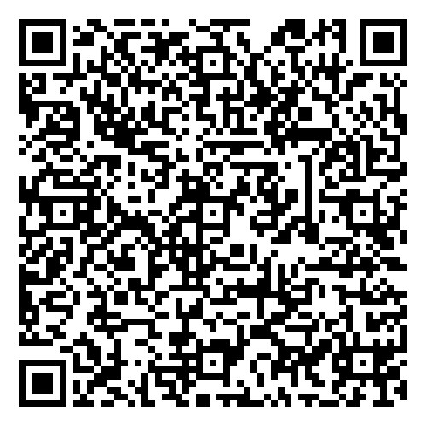  Below is the link for a resource on slang words used in County Lines and a QR to scan.  https://ivisontrust.org.uk/criminalexploitation/county-lines- slang/  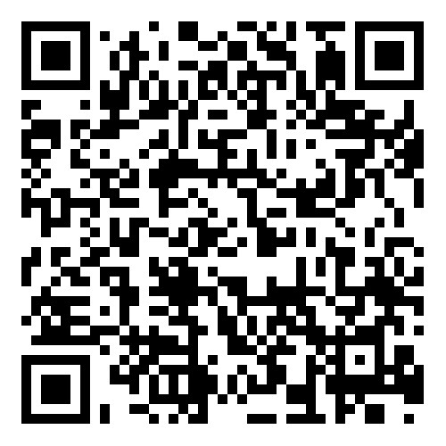  https://www.gov.uk/government/publications/criminal-exploitation-of-children-and-vulnerable-adults-county-lines/criminal-exploitation-of-children-and-vulnerable-adults-county-lines  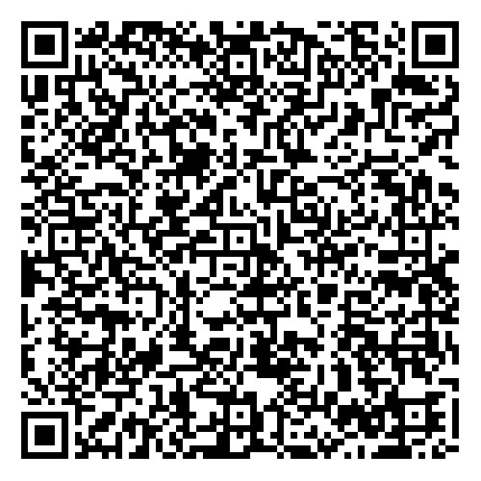

Workplace resource
Use the link or scan the QR code below for a poster for your workplace.
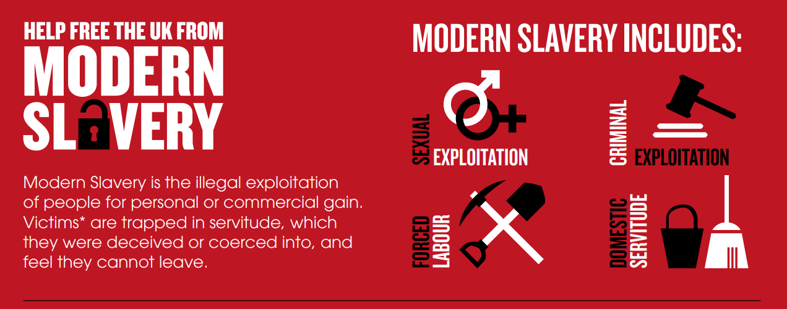

https://assets.publishing.service.gov.uk/government/uploads/system/uploads/attachment_data/file/640349/UK_slavery_infographic_v3.pdf
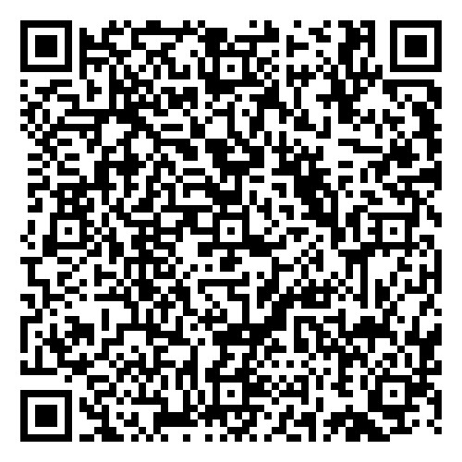

National Referral Mechanism
NRM
 | The National Referral Mechanism (NRM) was introduced in 2009, a framework for identifying and referring victims of human trafficking or modern slavery and ensuring they receive the appropriate support including safe accommodation.  Adults need to consent to entering the NRM. Consent should be sought prior to any interview after you have explained the process and benefits.  If an adult does not consent to a referral into the NRM you should submit a Duty to Notify only (DTN). This is the same digital form and the adult does not need to be present. Please click on the link below or scan the QR code to access the form.  https://www.modernslavery.gov.uk/start  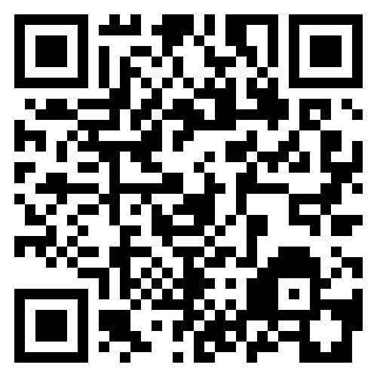  Please find a link below or scan the QR |code for a guide on how to fill out the form for adults or children.  https://downloads.eastriding.org.uk/ersab/whats-new/modern-slavery-update-july-2023/A-guide-to-making-an-effective-NRM-referral.pdf  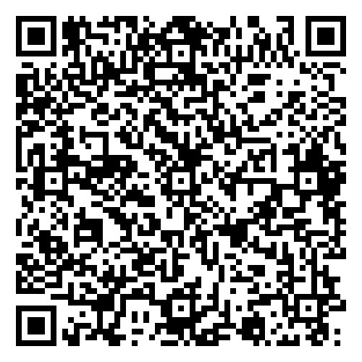

Steps to follow

Below find a link to the ERSAB ‘What if’ on Modern Slavery. Follow the steps and information in the card.

https://downloads.eastriding.org.uk/ersab/policy-and-guidance/what-if-cards/What_if_-_Modern_Slavery.pdf

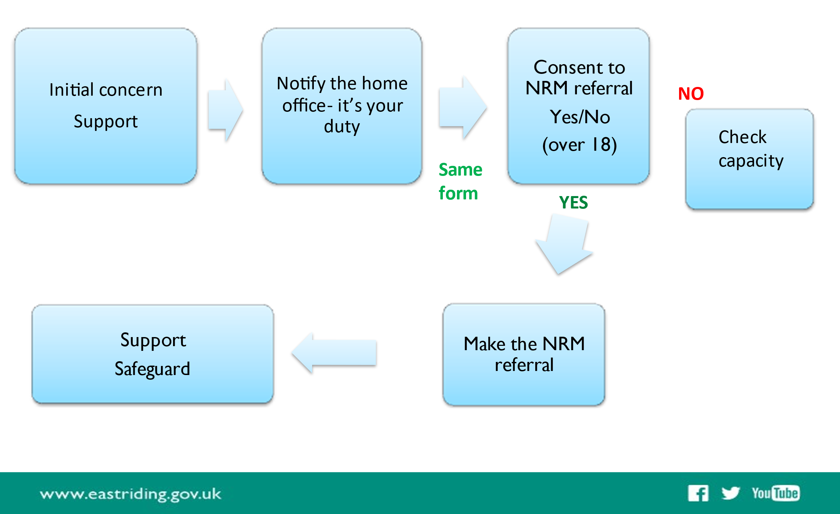

Further links and resources
Below are three apps for your mobile phone.


https://www.unseenuk.org/about-modern-slavery/download-the-app/

https://theclewerinitiative.org/campaigns/safe-car-wash

https://theclewerinitiative.org/blog/farm-work-welfare-app

Further resources:
Sexual assault referral centre
https://casasuite.org/

Trauma informed code of conduct
https://www.helenbamber.org/sites/default/files/2022-01/HBF%20Trauma%20Informed%20Code%20of%20Conduct%202nd%20Edition.pdf

Children’s support
https://www.ecpat.org.uk/

