|  |  |
| --- | --- |
|  | ***Learner Resource*** |
| **Understanding Dementia**  **Level 2** | |

|  |  |
| --- | --- |
|  |  |
|  |  |

Version 1.0 – 03/2023

**Contents**

Activity 1 1

Behaviours 1

Unmet needs 1

Activity 2 2

What do you take…? 2

Activity 3 3

Interaction 3

Scenario 4

Charlie 4

Information 5

Flow Model 5

Sensory Items 6

Quiz 7

Dementia Poem 9

Useful information 11

# Activity 1

## Behaviours

|  |  |
| --- | --- |
|  | Activity  Think about the individuals that you support, what are the behaviours that they can sometimes present with? |

## Unmet needs

|  |  |
| --- | --- |
|  | Activity  Thinking about the above answers, what could be the reason for these behaviours? |

# Activity 2

## What do you take…?

|  |  |
| --- | --- |
|  | Activity  Walking home from a very stressful day at work you stumble across an old rusty lamp and as you rub it to take a better look a Genie appears…  The Genie thanks you for releasing him from the lamp and rewards you with a wish. You think long and hard about this and you ask to go to a desert island to get away from all the stresses of everything and have time to relax. The Genie accepts this but will only grant this on one condition, that you will arrive in only your underwear and you will only be able to take 8 items with you.  You think about how stressed you have been and the difficult times that you are having at work and even though you think that this is a strange condition for the wish you agree.  What 8 things do you take with you and why?   1. _____________________________________________   _____________________________________________   1. _____________________________________________   _____________________________________________   1. _____________________________________________   _____________________________________________   1. _____________________________________________   _____________________________________________   1. _____________________________________________   _____________________________________________   1. _____________________________________________   _____________________________________________   1. _____________________________________________   _____________________________________________   1. _____________________________________________   ______________________________________________________ |

# Activity 3

## Interaction

|  |  |
| --- | --- |
|  | Activity  **How and in what ways do we generally interact and communicate with other people?**  **How may someone with mid/late stages of dementia interact?**  What are the differences between our interactions with people in general and those who have dementia? |

# Scenario

## Charlie

|  |  |
| --- | --- |
|  | Scenario  You arrive at your Charlie’s house and a family member lets you in. You walk into the living room where Charlie is sat looking out the window in his favourite chair. Charlie doesn’t respond to you as you enter the room, as this is often the case with Charlie as his dementia is progressing and he is becoming less and less engaging with people around him.  How do you approach Charlie and try to get him to engage in any form of conversation? |

# Information

## Flow Model

|  |  |
| --- | --- |
|  | Information    The Flow Model – founded by Professor Mihaly Csikszentmihalyi  His theory showed that people are happiest when they are in a state of flow, a state of concentration or complete absorption with the activity at hand and the situation. It is a state in which people are so involved in an activity that nothing else seems to matter. The idea of flow is identical to the feeling of being in the zone or in the groove. The flow state is an optimal state of intrinsic motivation, where the person is fully immersed in what they are doing. This is a feeling everyone has at times, characterised by a feeling of great absorption, engagement, fulfilment, and skill during which temporal concerns (time, food, ego-self, etc.) are typically ignored. |

# Sensory Items

Below are some suggested sensory items that can be used. These types of items can be found online at such places as Amazon and also Alzheimer’s Online shop.

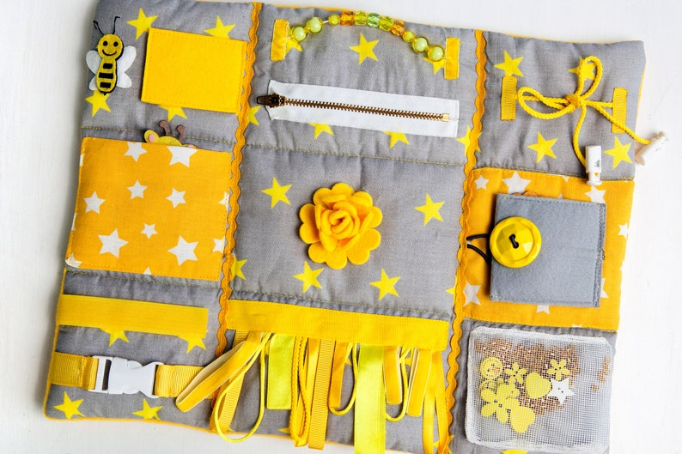

Sensory Blanket

# 

Fiddle Muff

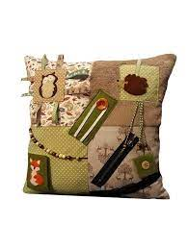

Sensory Cushion

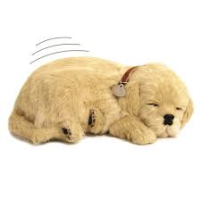

Simulation Pets

# Quiz

|  |  |
| --- | --- |
|  | Logo  Description automatically generated   1. ***Name three types of Dementia…*** 2. ***What are 5 signs and symptoms of dementia?*** 3. ***What are three stages of dementia?*** 4. ***What links behaviours to unmet needs?*** 5. ***Name three fundamental needs?*** 6. ***Why are activities important? Please circle those that apply***   Improve physical fitness.  Reduce falls.  Greater engagement  Something to do.  Because my manager says so.  Reduce anxiety and improve mood.   1. ***Name three therapeutic activities?*** 2. ***What is validation?*** 3. ***Name three ways which you can find out about a person’s past / history and why is this important?***   ***10.Why is planning for end of life care important?***  Ensure the right care is given.  Tick box exercise  Ensure you carry out the persons wishes  Advanced planning |

# Dementia Poem

|  |  |
| --- | --- |
|  | When I wander  don’t tell me to come and sit down.  Wander with me.  It may be because I am hungry, thirsty, need the toilet.  Or maybe I just need to stretch my legs.  When I call for my mother  (even though I’m ninety!)  don’t tell me she has died.  Reassure me, cuddle me, ask me about her.  It may be that I am looking for the security  that my mother once gave me.  When I shout out  please don’t ask me to be quiet…or walk by.  I am trying to tell you something,  but have difficulty in telling you what.  Be patient. Try to find out.  I may be in pain.  When I become agitated or appear angry,  please don’t reach for the drugs first.  I am trying to tell you something.  It may be too hot, too bright, too noisy.  Or maybe it’s because I miss my loved ones.  Try to find out first.  When I don’t eat my dinner or drink my tea  it may be because I’ve forgotten how to.  Show me what to do, remind me.  It may be that I just need to hold my knife and fork  I may know what to do then.  When I push you away  while you’re trying to help me wash or get dressed,  maybe it’s because I have forgotten what you have said.  Keep telling me what you are doing  over and over and over.  Maybe others will think  you’re the one that needs the help!  With all my thoughts and maybes,  perhaps it will be you  who reaches my thoughts,  understands my fears,  and will make me feel safe.  Maybe it will be you  who I need to thank.  If only I knew how.  Source: Caregiver's Voice |

# Useful information

|  |  |
| --- | --- |
|  | Information  **For help, support, or further information with all aspects of dementia care:**  🖰 [Find support near you | Alzheimer's Society](https://www.alzheimers.org.uk/find-support-near-you) – link  www.alzheimers.org.uk/find-support-near-you  **Carers Trust**  🖂 [info@carers.org](mailto:info@carers.org)  🖰 [www.carers.org](http://www.carers.org)  **Carers UK**  🖂 [info@carersuk.org](mailto:info@carersuk.org) 🖰 [www.carersuk.org](http://www.carersuk.org) 🖰 [www.carersuk.org/forum](http://www.carersuk.org/forum) (online discussion forum)  **Citizens Advice**  [www.citizensadvice.org.uk](http://www.citizensadvice.org.uk)  **Cruse Bereavement Care**  🖂 [helpline@cruse.org.uk](mailto:helpline@cruse.org.uk)  🖰 [www.cruse.org.uk](http://www.cruse.org.uk)  **Dying Matters**  🖰 [www.dyingmatters.org](http://www.dyingmatters.org) 🖰 [www.dyingmatters.org/contact](http://www.dyingmatters.org/contact) (web form)  **The National Council for Palliative Care (NCPC)**  🖂 [enquiries@ncpc.org.uk](mailto:enquiries@ncpc.org.uk) 🖰 [www.ncpc.org.uk](http://www.ncpc.org.uk)  **Dove House Hospice**  🖰<https://www.dovehouse.org.uk/?gclid=CjwKCAiAp8iMBhAqEiwAJb94z0GxlgF0L1RvqwueUFuMH3qEgc8RXx87w28YsZ2HGRfx2MIo5eNukxoCICsQAvD_BwE>    **Therapeutic Activities:**  **Therapy Dogs Nationwide**  🖰 <http://tdn.org.uk/>  **Online activity ideas – Alzheimer’s Society**  🖰 <https://www.alzheimers.org.uk/blog/5-online-activity-ideas-people-living-dementia>  **Skills for Care – Activity Provisions Self Audit Tools**  🖰 <https://www.skillsforcare.org.uk/Learning-development/ongoing-learning-and-development/activity-provision/Activity-provision-self-assessment-tool.aspx>  **The Dementia Statements**  🖰 <https://www.alzheimers.org.uk/about-us/policy-and-influencing/what-we-think/dementia-statements-and-rights>  🖰 <https://www.dementiaaction.org.uk/>  **Government’s Implementation plan**  🖰 <https://www.gov.uk/government/publications/challenge-on-dementia-2020-implementation-plan> |