Learner Resource

Dementia Awareness

Version 1.0 – 09/2020

Contents
About Self-Study Guides 1
Introduction 1
Structure and Layout 1
Latest Version 2
Types of Dementia 3
Activity 1 3
Dementia, Delirium and Depression 4
Information 4
Activity 2 6
Kitwood’s Equation 6
Activity 3 8
Kitwood’s Flower 8
Activity 4 11
Scenario 11
The Bookcase Analogy 14
Information 14
The Herbert Protocol 16
Information 16
Further information 17
Additional Resources 17

About Self-Study Guides

Introduction
Welcome to the Dementia Awareness module. This module enables you to develop your knowledge, understanding and skills with individuals who have dementia.

This learner resource is to be used as part of the leaning process. Within this learner resource you will find information, activities and direction to further help or information.

Structure and Layout
Each guide has a common structure and layout that helps ensure consistency and maintains the quality of the materials.

The following symbols are used to highlight key information or actions:

Information
This symbol highlights information on a particular point, topic or area.
Key Point
This symbol highlights a key point on a particular topic or area.
Question
This symbol indicates a question.
Activity
This symbol indicates a activity.
Scenario
This symbol indicates a scenario or case study.
Tag
This symbol highlights where you can find more information, help, support or a resource.

Latest Version
Always check you have the latest version of the learner resource. The issue number and date appear on the cover page.

If you have been given this learner resource by your Line Manager, Supervisor or Learning and Development Champion – they will have checked it is the current version. Learning and Development only provide copies of the current version of any learner resource.

Types of Dementia

Activity 1

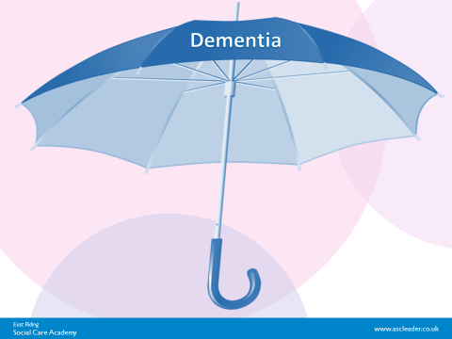

The most common types of Dementia are:

- ....................................................................................................
- ………………………………………………………....
- …………………………………………………………
- …………………………………………………………
- …………………………………………………………
- …………………………………………………………
- …………………………………………………………

Dementia, Delirium and Depression

Information
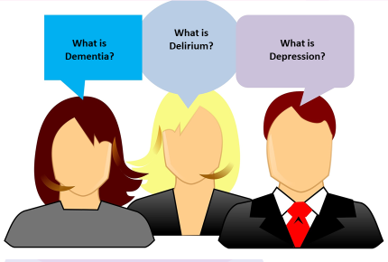

Dementia is… a chronic or persistent disorder of the mental processes caused by brain disease or injury.

Symptoms include:
Memory lapses/loss
Confusion
Disorientation
Problems with speech/language, concentrating, planning, organising, orientation
Behaviour that are out of character – restlessness, pacing, calling out, repeating the same question, disturbed sleep, reacting aggressively
Difficulty with understanding and being understood
Difficulty completing everyday tasks
Difficulty with recognition
Difficulty with perception/ Visuospatial skills
Mood changes
Anxiousness
Irritability
Loss of confidence
Withdrawal
Changes in appetite
Loss of interest in activities
Delusions (believing things that are untrue)
Hallucinations (seeing or hearing things that are not there

Delirium is…an acute state of confusion, often caused by an underlying health problem such as an infection or illness or caused by the effect of medication on a person’s body. It can develop quickly but is treatable and someone should be appropriately assessed, treated and monitored if they are experiencing symptoms that can be distressing for the person and those involved.

Symptoms include:
Temporary memory problems
Confusion
Disorientation
Incoherent speech
Changes in sleeping patterns
Restlessness
Anxiety
Agitation
Hallucinations
Delusions

Depression is…a disorder with more severe symptoms than feeling ‘a bit fed up’ as people sometimes say they feel. Symptoms of depression will often have a significant impact on how people interact with others and function on a daily basis and can lead to people having thoughts of self-harm or suicide. It can occur alongside dementia.

Symptoms include:
Temporary memory problems
Confusion
Disorientation
Low mood
Tearfulness
Loss of motivation, energy, interest in activities
Anxiety
Changes in appetite
Changes in sleeping pattern
Physical aches and pains
Loss of confidence
Poor concentration

Kitwood’s Equation

Information
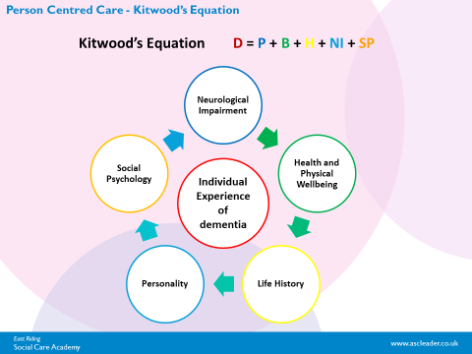

Personhood

Tom Kitwood understood this idea well, calling it Personhood; “it implies recognition, respect and trust” (Kitwood, 1997).

Personhood can be massively undermined when people are not considered according to their individual needs. By treating the people in our care as patients and tasks, we can easily lose the recognition, respect and trust we all deserve.

The real challenge is how we put this into practice. Kitwood came up with a model to help us think outside the “task” and the “patient” and give more positive experiences to the people we are caring for

1. Neurological Impairment
This includes the decline of cognitive abilities that comes with dementia – memory loss, slower processing, language difficulties, loss of abstract thinking, reduced planning and sequencing, behaviour, and more!

2. Health and Physical Well-being
A person with dementia may also have other illness, temporary or long standing, which will impact their functional ability and how they are experiencing their time in our care. These may include pain, sensory impairments, chest infections, UTIs, wounds or trauma, pressure ulcers, long term conditions (diabetes/blood pressure or heart conditions), and mental state.

3 & 4. Life History and Personality
A key way in which we make sense of the ‘here and now’ is through reference to past experience. This doesn’t change for somebody with dementia.

It’s so important to learn about their past relationships, occupation, hobbies and experiences for 2 main reasons:

- It builds our respect for them, enhancing their personhood, and,
- It gives us an idea of how they might perceive a current situat
Talk to them, talk to their family, use the “This is Me” or “Life History” documents to try and find out about the person under your care.

5. Social Psychology
People and their experiences are moulded by their sense of self, relationships, interactions and the environment. Our relationship and interactions with the people we are caring for have the potential to be extremely positive or extremely damaging.

Kitwood’s Flower

Information

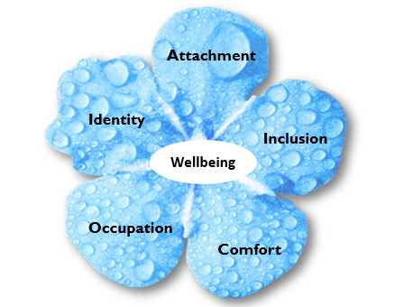

Tom Kitwood described five overlapping psychological needs that people with dementia have, which come together in a central need for love.

Ensuring these needs are met helps a human being feel relaxed, secure, at ease, valued and of use:

Comfort is about the provision of tenderness, closeness and soothing. It promotes security and decreases anxiety. It helps people relax. Comfort can be provided through physical touch, or through comforting words or gestures.

Identity relates to knowing who a person is and to having a sense of continuity with the past, whilst valuing that person. It’s about having a life story maintained either by the person with dementia, or for them by others.

Attachment relates to bonding, connection, nurture, trust and relationships. It also relates to security in relationships and feeling that one has trusted others whom they can turn to in times of trouble or need. When people are anxious they may need to feel attached to someone or something familiar.

Occupation relates to being involved in activity in a way that is personally meaningful. It also relates to having a sense of agency, which is about feeling one has control over the world and can make things happen. It is about feeling that you can have an effect and impact on what is done and how.

Inclusion is about being bought into the social world, either physically or verbally. It relates to facilitating engagement where there would otherwise be none and making a person feel they are part of a group and are welcomed and accepted. Recognising people’s worth, including them in discussions and activities emphasising a sense of belonging and having fun together all support the need for people to feel included.

Activity 2

Scenario
I would like you to imagine you are new to adult social care. It is your first day as a care assistant in a care home and the manager is showing you around.

The manager says - pointing to two people slumped in chairs:

“We’ve got 5 ‘dementias’ in this home. Three cause very little trouble, especially the one that’s bedfast but this one can be very aggressive and she sometimes attacks the other residents. The other one over there is a smearer and I’m not sure whether we’ll be able to keep her here for much longer”.

Questions

If you were the new care assistant, how might you be feeling about these two residents?

How do they feel about what has been said?

What might this tell us about these individuals?

How might this affect your behaviour towards the people with dementia if you were providing personal care?

NOTES: …………………………………………………………………………………………………………………………………………………………………………………………………………………………………………………………………………………………………………………………………………………………………………………………………………………………………………………………………………………………………………………………………………………………………………………………………………………………………………………………………………………………………………………………………………………………………………………………………………………………………………………………………………………………………………………………………………………………………………………………………………………………………………………………………………………………………………………………………………………………………………………………………………………………

Discuss your answers within the group

More background information…Ruth

Ruth had a long career as a teacher and had been a deputy head at a primary school. Her husband had been a telecommunications engineer. They had two children, a girl and a boy but their marriage had largely been a formality for the sake of the children. Ruth’s husband had affairs with other women during their frequent periods of separation when he travelled abroad on business. Their son, after a promising start in life, had become addicted to alcohol, his marriage collapsed and he lost his home and his business. Ruth’s husband died and their daughter distanced herself from the family, leaving Ruth alone. Much of Ruth’s life had been filled with similar disappointments and sadness.

Questions

Why do you think Ruth might express herself in an aggressive manner?

What clues in her background are there to her behaviour?

What do you think Ruth might be feeling?

What might Ruth need?

What difference does this make to how you view Ruth?

What impact might this have on your interactions with Ruth?

NOTES………………………………………………………………………………………………………………………………………………………………………………………………………………………………………………………………………………………………………………………………………………………………………………………………………………………………………………………………………………………………………………………………………………………………………………………………………………………………………………………………………………………………………………………………………………………………………………………………………………………………………………………………………………………………………………………………………………………………………………………………………………………………………

Discuss your answers within your group

Let me tell you about Fran…

She lost her mother at age 15. She had a short marriage of 4 years. Her husband, her son age 3 and her daughter age 2 were all killed in a road traffic collision. Fran had always lived with a low income, she worked as a cleaner. Fran met a new man in middle age but he died after only 2 years together. A couple of years later Fran met another man who sexually abused her.

Questions

Why do you think Fran might smear her faeces? Clinical term is Scatolia.

What do you think to Fran’s label of being a ‘smearer’?

What do you think Fran might be feeling?

What might Fran need from you to help her?

How might Fran’s life history influence her behaviour today?

How might this change how you feel about Fran?

What might we learn from this?

NOTES……………………………………………………………………………………………………………………………………………………………………………………………………………………………………………………………………………………………………………………………………………………………………………………………………………………………………………………………………………………………………………………………………………………………………………………………………………………………………………………………………………………………………………………………………………………………………………………………………………………………………………………………………………………………………………………………………………………………………………………………………………………………………………………………………………………………………………………………………………………………………………………………………………………………………………………………………………………………………………………………………………………………………………………………………………………………………………………………………………………………………………………………………………………………………………………………………………………………………

Discuss your answers within your group

The Bookcase Analogy

Information

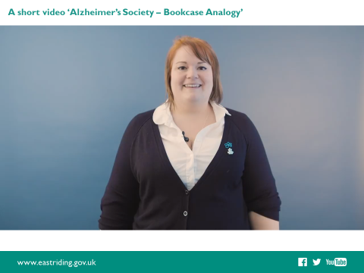
The following information is to support the YouTube video found at https://www.youtube.com/watch?v=WQ9uSR22qkI

Imagine two very different bookshelves within our memory bank, one for our factual information (hippocampus) and one for our feelings and emotions (amygdala). Every experience we have in life will be stored on both bookshelves.

The memories are stored as experiences occur. So earliest memories will be on the lower shelves with those most recent on the top. For many, the earliest memory such as the first day at school, is probably saved on the second or third shelf of our bookshelves. Factual information such as the building’s appearance, teacher’s name and uniform will be stored on our hippocampus bookshelf, but how we felt about those very first days at school will be on our amygdala bookshelf – were we scared, worried, lonely or were we excited and happy?

As we grow older, our memories are stored in this manner in time order. When a person has dementia, the factual (hippocampus) bookshelf will start to wobble. At first there may be no significant damage but it might take a little longer to recall the information. As further damage occurs in the brain, some of the information may fall from a different shelf, so more details are forgotten.

Someone in the early stages of dementia may, in a similar way to which we can all experience challenges with our memories, remember some aspects of a holiday quite clearly, perhaps the name of the hotel or the resort but become confused with the year the holiday took place. In the early stages of dementia someone can probably function quite well with little support.

The difference between the type of memory loss we can all experience and that caused by the physical changes in the brain, is that for someone with dementia, the damage is progressive. As further cells are damaged, some memories will be lost completely, so the person may eventually not remember ever having experienced the holiday. If the information cannot be recalled then it will seem like it never happened.

This can be very distressing for family members who might try to remind the person, perhaps by going over the details and insisting that it did happen but if the person with dementia has no knowledge of this memory they might feel confused, upset or perhaps frightened.

We know that the most recent memories are usually damaged first so the top shelves will be the first to collapse, this can result in the person with dementia believing they are much younger than they are. If their strongest memories are from 20 years ago, because their ability to apply logic and reason is damaged, the person may believe their life is as it was at that time. They may feel they must go to work, or find their children or parents from that time in their life. This is the reason people with dementia may sometimes mistake family members or care staff for someone else.

For example ‘If my memory is telling me I am only 45 years old, then my husband couldn’t possibly be the 85-year-old you are telling me he is, therefore I must use my emotional memory bank to make some sense of who this person might be. If they ‘feel’ like someone I feel safe with and know well, they ‘must’ be my father?’

In time most factual memories will be destroyed, and the person with dementia will rely very much on their emotional responses to make sense of the world around them. Without logic and reason this information is concentrated, therefore it is impossible and impractical to then apply logic and reason to a situation we may find difficult. For example if the person with dementia assumes you are their mother, this may not be that they think you are actually their mother but more that you ‘feel’ like a mother figure as you are kind and caring and the person feels safe with you.

‘Bookcase – an explanation of memory from Alzheimer’s Society’, has been produced by the Learning and Development team at the East Riding of Yorkshire Council, using latest information published on You Tube on 14 May 2018.

The Herbert Protocol

Information
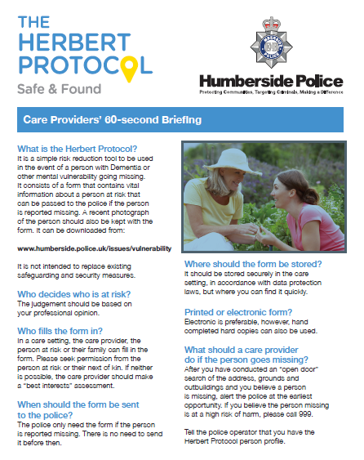
Here is Humberside Police’s outline guide on what The Herbert Protocol. A link to this website and also to the form can be found in the further information additional resources section in this booklet.

Further information

For further support you can contact:

Alzheimer’s Society – The UK’s largest Dementia Charity
https://www.alzheimers.org.uk/

Dementia UK
https://www.dementiauk.org/

Dementia Friends
https://www.dementiafriends.org.uk/

Carers UK
https://www.carersuk.org/help-and-advice/get-support?gclid=EAIaIQobChMI6eHWraLh6wIVxYjVCh29FwWzEAAYASAAEgI-avD_BwE

Carers Support
https://www.eastriding.gov.uk/living/care-and-support-for-adults/carers/support-for-carers/

East Riding Services and Support (Assessment Process) Alzheimer’s Society
https://dementiaeastriding.org.uk/east-riding-dementia-services- and-support/

Please contact your manager for any concerns you may have with any individual service users.

Additional Resources

The Herbert Protocol – Safe and Found
https://www.humberside.police.uk/herbert-protocol

A Good Life with Dementia - East Riding 2023
Age Well | Healthy & Active Communities | Resources | VCSE news & resources East Riding
The resource can be downloaded from the VCSE website.

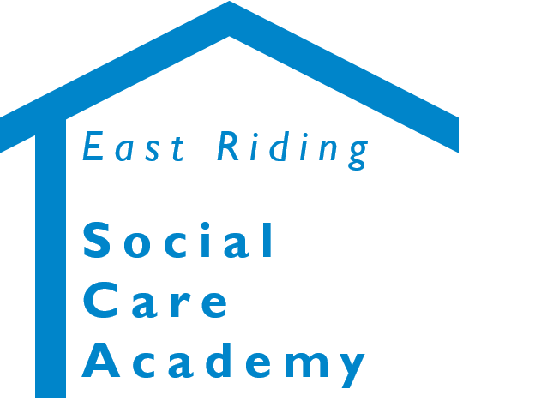

Dementia Awareness - Learner Resource Book
© 2020 – East Riding Social Care Academy (East Riding of Yorkshire Council)

All rights reserved. No part of this document may be reproduced, distributed, or transmitted in any form or by any means, including photocopying, recording, or other electronic or mechanical methods, without the prior written permission of the copyright holder.

