Version 1.0 – 02/2024

Strengths Based Approach in Adult Social Care

Learner Resource

Contents
Your Strengths and Challenges… 1
Why Strengths Based…? 2
What else does the Care Act say… 2
What makes a good conversation...? 3
The SOLAR Model 4
Video Scenario 5
The ROPES Model 6
Mapping Tool 7
Case Example – Aripta 9
One Page Profile 11
Helen Sanderson, Good Day / Bad Day 12
Helen Sanderson, what’s working, what’s not working…? 13
The Happy, Safe Grid… 14
Case Study 1 - Mary 15
Case Study 2 – Tom 17
Case Study 3 - Jun 19
Useful links and resources 21

Your Strengths and Challenges…

Please take a couple of minutes to think about anything that you feel you are good at… this could be something that makes you feel alive, good, energised, engaged this could be organising, listening, creativity, anything that you enjoy doing.

Strength 1

Strength 2

Now can you identify a couple of challenges. These would be things that you don’t like doing, that you feel you are not very good at. These could make you feel demotivated, unhappy, they could drag, they might require some additional energy you feel you don’t want to give.

Challenge 1

Challenge 2

What was easier to write down, your strengths or your challenges? Why do you think this is?

Why Strengths Based…?
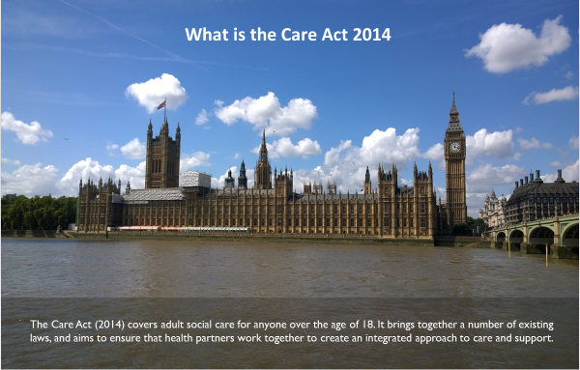
Rational: Why do we need training on the strengths-based approach?

Prior to the 2014 Care Act, social care was primarily focussed on identifying the needs or ‘deficits’ of individuals. ​

Social care professionals were encouraged to think about what ‘was missing’ for people in their lives.​

The Care Act 2014 is the law that sets out how adult social care in England should be provided. It requires local authorities to make sure that people who live in their areas: receive services that prevent their care needs from becoming more serious or delay the impact of their needs. The Care act stipulates throughout that the person receiving the care should be involved at every stage, they should be placed at the centre of all planning and decisions- Person centred care.

What else does the Care Act say…
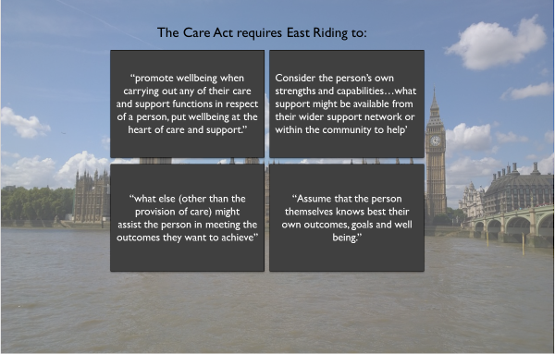

What makes a good conversation...?

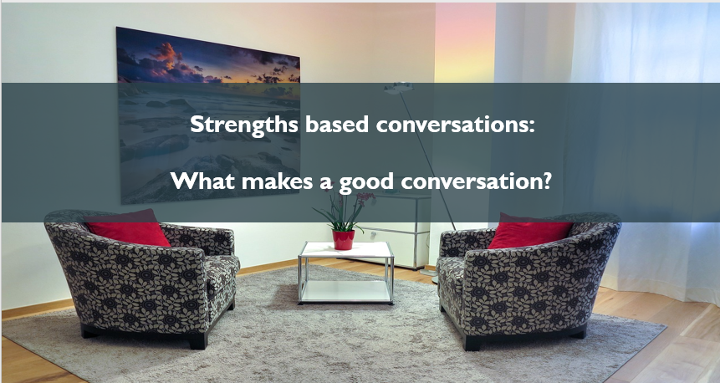

Thinking about what makes a good conversation, please make some notes.
Ask yourself:

- What are you doing already?

- What happened during recent conversations?

- How do you structure a conversation?

- What's your environment like, and does the environment matter?

- What information do you have already?

- Do you use this?

The SOLAR Model

Gerard Egan created the SOLAR Model (1975) as an aid for teaching and learning about non-verbal communication. This is a model that can help and support communication with individuals to ensure that good positive actions are used to help get the most from your interaction.

S
L
O
E
R

Remaining relatively relaxed.
Effective eye contact without staring.
Open posture. Arms and legs uncrossed.
Leaning forward from time to time. Looking genuinely interested. Listening attentively

Sitting at a comfortable angle and distance

Think about your body language when talking to other people. Do you do any of the above already, or is this something that you could try in the future?

Video Scenario
Can you identify the positives and negatives within the video and write them below.

Approach A –

Approach B -

The ROPES Model

R When we think about resources, we need to ask ourselves what can the individual access here and now, consider relationships– family, friends, role models, social environment – groups, clubs, hobbies interests, religious involvement, Community– community spaces, community involvement, organisational
O Present focus, we need to focus on what’s available, what are the choices, what can be accessed, what hasn’t been tried yet?
P (glass half full concept / looking at potential; how can I prepare for the future?) Think about the Future, what will that look like? Be creative and imaginative explore ideas and possibilities, is there something they would like to try. Vision of the future (when problem has been solved what will this look like?) What have you thought of trying but haven’t tried yet? Exceptions (to the problem)
E Thinking about the past (reflection) has there been any problems, what's happened previously and how have you overcome this. What has helped build resilience before?
S What’s working now? how is it working? What do you want to continue to do - If it’s not broke do we need to fix it, let’s use this to create additional positive outcomes. The solution often isn’t related to the problem. Solutions are person-led; focus on constructing solutions, not solving problems. Build on those successes.
You could ask: What if a miracle happened? (De Shazer, 1985) What can you do now to
create a piece of the miracle?

Mapping Tool

About Strengths and Asset Mapping
The Strengths-Based Approach in Social Care focusses on what a person can do rather than what they cannot. This includes identifying the strengths of the person and the assets available to support their needs.

Assets, such as; family, friends, community groups, etc., can vary from person to person and area to area. However, a key goal of the Strengths-Based Approach in Social care is to deliver support that is personalised to individual needs.

Strengths and Asset Mapping has 2 key elements:
- Identifying the Strengths and Assets available to people within a particular area / community.
- Identifying the Strengths and Assets available to a particular person before, during and after an assessment.

It is essential to maintain an active register of strengths and assets available within East Riding to apply the Strengths-Based Approach effectively, i.e. Connect to Support.

Mapping and the Care and Support Assessment Process
Each Strengths and Asset Group within the Hexagon links to areas within the Care and Support Assessment Form, as follows:
Home and Housing:
- Being able to make use of the home safely
- Maintaining a habitable home environment
- Your mobility
- Additional information about Support, Needs and Risks
Health and Care:
- Managing and maintain nutrition
- Maintaining personal hygiene
- Managing toilet needs
- Being appropriately clothed
- Carrying out any caring responsibilities the adult has for a child
- My medication and symptoms
- Your mobility
- Additional information about Support, Needs and Risks
Social, Spiritual, Community and Transport:
- Developing and maintaining family or other personal relationships
- Making use of necessary facilities or services in the local community including public transport and recreational facilities or services
- Your mobility
- Additional information about Support, Needs and Risks
Additional Support:
- All areas in relation to any form of additional support requirements
- About You
Work and Education:
- Accessing and engaging in work, training, education or volunteering
- Additional information about Support, Needs and Risks
Assets of individuals
These are the skills, knowledge, networks, time, interest and passions of the Service User and those close to them, i.e. family and friends.

Assets of associations
This is formal and informal community organisations, faith groups or voluntary groups. It includes all informal networks and ways that people come together, e.g. football teams, allotments, etc.

Assets of organisations
This includes services organisations delivery local and ones they manage or control, e.g. parks, leisure centres, health centres, libraries, etc.

Mapping Type
Individual / Community

PID

What do we know about the person?

What is important to the person?

What are the person’s strengths?
e.g. skills, interests, hobbies, etc.

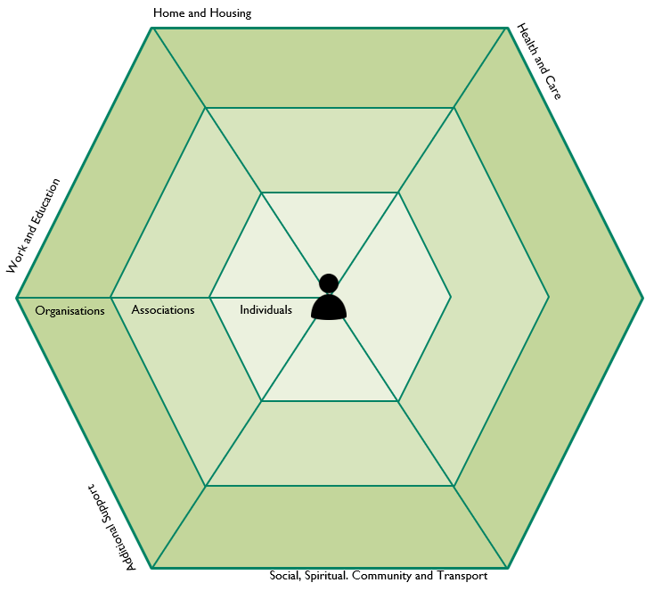

Case Example – Aripta
Assessment in the community: Arpita's story Arpita is an 81-year-old lady who has perhaps the largest supply of books I have ever seen. She loves to read. You could call it a passion but that would probably be an understatement. I have read many reports about Arpita but they tend to focus on her wheelchair or her ‘complex’ and ‘challenging behaviour’. I ask myself wouldn’t I be challenging if someone asked me, even politely, to get rid of my prized possessions because they were ‘prohibiting free movement around my house’. I did not see Arpita’s love of books as a problem with hording but instead as a potential library.

Arpita spends most of her days in her home, rarely going out due to the lack of wheelchair accessible areas in her local community. My work with Arpita challenged me to first look closely at her inner circle. Arpita had lost touch with her family and had no friends or at least none that she spoke of. After several conversations I learnt that the roots of Arpita’s disconnection from her family was that they were scattered across England. Furthermore, she did not want them to see her in her current state as she does not like to be pitied.
We explored ways in which she could possibly regain these connections without focusing on the changes that she had experienced over the past few years.

Reaching out in to the community I wanted to explore whether the local library had the means to start a book club. Unfortunately, they informed me that whilst they could potentially house the club and offer some resources, budget cuts meant that they could not coordinate it. I was however aware that there were several requests for book clubs in my office. One of which was willing to facilitate anyone else who wished to join and welcomed the use of the library.

Now that the foundations were laid I started to mention this club to Arpita during our conversations. I first asked whether she would be willing to loan out some of her books to the club. Arpita welcomed the idea. We first focused on the books in the front hallway. Together we were able to identify 50 amazing books that would be perfect for the club. Regrettably, looking through the books we realised that some were damaged and unreadable. We both agreed that it was probably pointless keeping these if they couldn’t be of benefit to her or the club. It took a couple of months before Arpita was willing to join the book club herself.

At first, she joined out of curiosity. One of the members of the club kindly volunteered to help Arpita to get to the library. On her way out of the door on the first day, Arpita commented that it was so much easier to get around her home without the books blocking the way. Furthermore, she was pleased that her books were bringing joy to the group.

Arpita soon became a core member of the book club. Her insight into the books was a breath of fresh air to some of the group members who had found that the group was becoming a bit stale. During the club Arpita opened up about how she felt. She explained that social workers often made her feel useless and labelled her as a hoarder. Sure, they never called her a hoarder, but she knew that’s what they were implying when they talked about the ‘clutter’. They focused on her missing legs and not on her mind that was still alive with creativity.

Every time they visited, usually annually, they convinced her of all the support she needed. They tried to offer her day centres – which she found boring – and introduced carers to her home. Whilst the help was appreciated, their judgements were not. This was the first time she felt that she had something to offer others.

Speaking to the group largely made up of social workers and occupational therapists she learnt that she could be a bit more creative with the way she managed her care. She did not know for instance that there were devices to help her around the home such as robot vacuums. This felt a bit like something out of one of her science fiction novels but thought it would be amazing. This experience had been so liberating for Arpita. She felt valued and a positive impact of sharing her books with the club is that her property was now clutter free. As word travelled of the success of the group it started to grow, attracting people from all walks of life.

Why is this intervention strengths based?

Is there anything that is less Strengths based?

One Page Profile

A one-page profile can help social care professionals provide better person-centered care and support. It is a simple summary of what is important to someone and how they want to be supported. Below can you create your own One Page Profile about yourself.

How to support me …
What people like and admire about me …
What’s important to me …

Helen Sanderson, Good Day / Bad Day
Bad day
Good day

What will it take to have more good days than bad days?

Helen Sanderson, what’s working, what’s not working…?
The Person
What`s not working?
What`s working?

Family

Staff

What needs to happen to build on what’s working and change what is not working?

The Happy, Safe Grid…

Happy

What can we do to make sure the person keeps safe?

Where we want to be

Safe
Unsafe
What can we do to increase the person’s happiness?

Don’t go here!

Unhappy

Please remember that we are aiming for people to be in the top left corner…

NOTES:

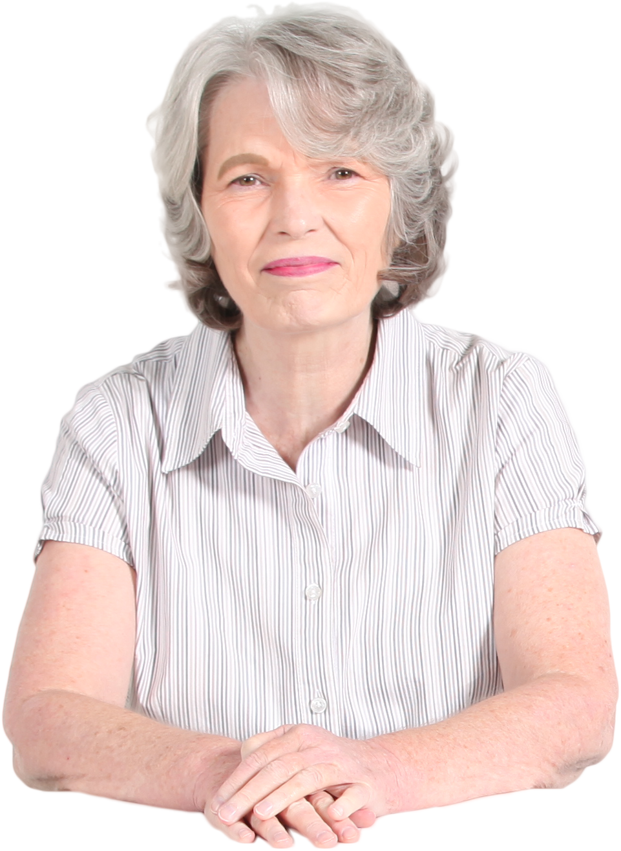
Case Study 1 - Mary

Case study: Mary Smith
Age: 75
Gender: Female
Ethnicity: White British
Location: East Yorkshire
Family: Son, Samuel, husband died 2 years ago.
Conditions: Arthritis, diabetes, high blood pressure, depression, and anxiety.

Mary is a 75-year-old woman who lives alone in a flat in a small East Yorkshire town. She used to be a teacher in a primary school and continues to enjoy reading and light gardening. She has arthritis, diabetes, and high blood pressure. She also suffers from depression and anxiety. She has a son who lives nearby, but he works full-time and has his own family including a child with autism. He is worried that he does not have the time to care for her if she requires further help.

Mary feels lonely and isolated, and often worries about her health and finances. She has some difficulty managing her daily activities, such as cleaning, shopping and some cooking. She has a home care worker who visits her twice a week, but she feels that the service is not meeting her needs and preferences. The home care worker is concerned that Mary sometimes mixes up her tablets.

Mary was referred to a social worker by her GP, who noticed that her mental and physical health was deteriorating, and she had told the GP she was lonely. The social worker contacted Mary and arranged a visit to her home. The social worker used a strengths-based approach to assess Mary’s situation and to explore her goals and aspirations.

Task: In groups choose one of the approaches below that we have discussed and create your ‘answers’

1: ROPES
What did you find out using (ROPES)
Resources, Personal, Family, Social environment, organisational, community
Options, Present focus, choice, what can be accessed now, what is available that hasn’t been tried?
Possibilities (glass half full concept / looking at potential; how can I prepare for the future?) Future focus, Imagination, Creativity, Vision of the future (when problem has been solved what will this look like?) What have you thought of trying but haven’t tried yet?
Exceptions (to the problem), when is the problem not happening, when is the problem different?
Solutions (person-led; focus on constructing solutions, not
solving problems)

2: Helen Sanderson tool
What does a good day/bad day look like?
What would need to change to have more good days?

3: Helen Sanderson tool
What is working / not working for the person and the family.
What needs to happen next to build on what is working and change what is not working?

NOTES:

Case Study 2 – Tom

Case study: Tom Kilkenny
Age: 28
Gender: Male
Ethnicity: Mixed, Irish
Location: East Yorkshire
Family: Mum, and two sisters
Conditions: Learning disability, autism, communication difficulties, anxiety

Tom is a 28-year-old man who has a learning disability and autism. He lives in a supported living scheme in Beverley, where he has his own flat and receives 24-hour support from staff. Tom has a history of challenging behaviour, such as aggression, self-injury, and property damage.

He also has sensory issues, communication difficulties and anxiety. He has been excluded from several day services and activities due to his behaviour. He has a care coordinator from the community learning disability team, who monitors his mental and physical health and coordinates his care and support.

Tom was referred to his care coordinator, who wanted to explore alternative ways of supporting Tom to have a better life. The care coordinator used a strengths-based approach to assess Tom’s situation and to explore his goals and aspirations.

Task: In groups choose one of the approaches below that we have discussed and create your ‘answers’

1: ROPES
What did you find out using (ROPES)

Resources, Personal, Family, Social environment, organisational, community
Options, Present focus, choice, what can be accessed now, what is available that hasn’t been tried?
Possibilities (glass half full concept / looking at potential; how can I prepare for the future?) Future focus, Imagination, Creativity, Vision of the future (when problem has been solved what will this look like?) What have you thought of trying but haven’t tried yet?
Exceptions (to the problem), when is the problem not happening, when is the problem different?
Solutions (person-led; focus on constructing solutions, not
solving problems)

2: Helen Sanderson tools:
What does a good day/bad day look like?
What would need to change to have more good days?

3: Helen Sanderson tools:
What is working / not working for the person and the family.
What needs to happen next to build on what is working and change what is not working?

NOTES:

Case Study 3 - Jun

Case study Three: Jun Zhang
Age: 52
Gender: Male
Ethnicity: Chinese
Location: East Yorkshire
Family: Mum, Ling and one estranged brother.
Conditions: Learning disability, depression

Jun is a 52-year-old man with a learning disability and some history of depression. He moved to the UK when he was 6 years old with his mum, who is 80 years old, and they continue to live together in Hornsea.

Ling, his mum, supports Jun to take his medication and complete daily tasks such as cooking and finance. Jun attends a work link programme 2 days a week and until recently had a private carer who took him out 1 day a week. Jun and his mum have travelled the world, with holidays on cruise ships, weekends away and a shared love of the theatre and music. Jun and his mum have a really close relationship as Jun’s dad had never been around.

Work link had noticed that Jun was acting differently, he wasn’t his usual chatty self, and his movements were slow. He was picking his skin and was making comments about not being well and also his mother being 80. At the same time, Jun’s mum rang a respite home, somewhere Jun had been in the past to ask if he could come in for a night. Jun’s social worker went to the home to talk to Jun and his mum, and she arranged a GP review after she was informed that Jun had a constant upset stomach, and he was talking about his life not having any worth.

Task: In groups choose one of the approaches below that we have discussed and create your ‘answers’

1: ROPES
What did you find out using (ROPES)
Resources, Personal, Family, Social environment, organisational, community
Options, Present focus, choice, what can be accessed now, what is available that hasn’t been tried?
Possibilities (glass half full concept / looking at potential; how can I prepare for the future?) Future focus, Imagination, Creativity, Vision of the future (when problem has been solved what will this look like?) What have you thought of trying but haven’t tried yet?
Exceptions (to the problem), when is the problem not happening, when is the problem different?
Solutions (person-led; focus on constructing solutions, not
solving problems)

2: Helen Sanderson tools:
What does a good day/bad day look like?
What would need to change to have more good days?

3: Helen Sanderson tools:
What is working / not working for the person and the family?
What needs to happen next to build on what is working and change what is not working?

NOTES:

Useful links and resources

East Riding Council Your Life Your Way
https://www.yourlifeyourway.uk/care-and-support-service-costs/

SCIE
https://www.scie.org.uk/strengths-based-approaches

Strengths-based social work: practice framework and handbook
https://www.gov.uk/government/publications/strengths-based-social-work-practice-framework-and-handbook

Using communities' strengths to foster social networks
https://www.nationalvoices.org.uk/blogs/using-communities-strengths-foster-social-networks

How motivational interviewing works
https://www.rcn.org.uk/clinical-topics/supporting-behaviour-change/motivational-interviewing

Building community capacity https://www.thinklocalactpersonal.org.uk/_assets/Resources/TLAP/BCC/TLAPChangingSWCulture.pdf

Developing a wellbeing and strengths-based approach to social work practice:
changing culture
https://www.thinklocalactpersonal.org.uk/Latest/Developing-aWellbeing-and-Strengths-based-Approach-to-Social-Work-Practice-ChangingCulture/

50 Strength-Based questions:
https://www.changedlivesnewjourneys.com/50-first-strength-based-questions/

Recovery Model:
https://www.mentalhealth.org.uk/explore-mental-health/a-z-topics/recovery

Description of a motivational interview:
https://www.ncbi.nlm.nih.gov/books/NBK64964/

CQC Assessment Framework for Local Authority Assurance
Assessment framework for local authority assurance - Care Quality Commission (cqc.org.uk)

Top Tips for Strengths Based Conversations
https://www.skillsforcare.org.uk/resources/documents/Support-for-leaders-and-managers/Managing-a-service/Community-Asset-and-strength-based-approaches/Person-centred-and-community-based-working-a-mini-guide-strength-based-approaches.pdf

Ask – Listen – Do
https://www.england.nhs.uk/learning-disabilities/about/ask-listen-do/

Conversational Assessment
https://www.skillsforcare.org.uk/resources/documents/Support-for-leaders-and-managers/Managing-a-service/Community-Asset-and-strength-based-approaches/Using-conversations-to-assess-and-plan-peoples-care-and-support.pdf

Helen Sanderson
http://helensandersonassociates.co.uk/about/how-can-we-help-you/our-courses/person-centred-thinking/

