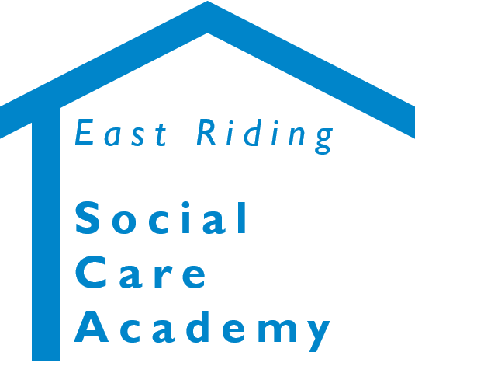
Adult Social Care
Apprenticeship Application

About this Form
- This Form is used to apply to complete an Adult Social Care Apprenticeship Programme.
- The information provided is used to consider your application, made a decision, assist in securing funding and (if approved) refer you to a provider that can deliver the Qualification or Apprenticeship Programme.
- Please complete all pages of this form otherwise your application will be delayed or rejected.

About You

Surname:
Forename(s):
Title:
Date of birth:
National Insurance Number:
Home address:
Home postcode:
Personal email address:
Personal telephone number:

About the Pathway / Apprenticeship You Want to Complete

Name of the Pathway / Apprenticeship:
Please explain why you want to complete this Pathway / Apprenticeship:

Do you have any special requirements or need support to take part in a Pathway / Apprenticeship? (e.g. Dyslexia).

Please tell us about how you intend to use the learning gained from Apprenticeship:

About the Care Certificate

Do you hold a Care Certificate?
If so:
- When did you do it?
- Where did you do it?
- Please provide your Certificate?
- Do you still have your Portfolio / Workbooks?

About Your Current Job

Job Role and Grade
Contracted weekly hours
Start date with the Council
Team and Service:
Work Base / Location:
Work Email address:
Work Telephone Number:
Manager’s Name:
Manager’s Email Address:
Manager’s Telephone Number:

About Your Previous Jobs

We need to know about your job history, as this helps us decide if you are able to complete the Level requested.

Employer | Job Title and Nature of Work | How long in job

About Your Existing Qualifications

We need to know about the Qualifications you already hold, as this helps us decide if you are able to complete the Level requested.

Qualification | Grade / Result | Date Achieved | Provider

Agreement

Learner:
I confirm that:
- I wish to complete the Pathway / Apprenticeship noted on this Application Form.
- The details on this form are correct, including information about my existing Qualifications.
- I agree to commit to completing the learning materials and assessments, i.e. Portfolios, tests, exams, etc. to achieve the Apprenticeship, which includes committing personal time outside of work.
- I understand my Manager will be advised of my progress to ensure I am on track for completing the Apprenticeship and Care Certificate.

Manager:
I confirm that:
- I have discussed the completion of the Pathway / Apprenticeship with the learner and agreed that it is appropriate and relevant for their role and / or future career development in line with Service and Corporate Policies and Procedures.
- The completion of the Pathway / Apprenticeship has been noted as a learning and development need on their Performance Review and / or Supervision Records.
- I will release the learner to attend Study Days, assessments, exams, etc. in line with the Apprenticeship requirements.
- In the case of Apprenticeships, there is a requirement to receive 20% off-the-job training. This allocation can include statutory and mandatory training that a learner may already complete where it is relevant to the Apprenticeship.
- I will ensure that the learner is provided with the relevant 20% off-the-job training and Functional Skills study time (if applicable) in line with the Qualified Care Workforce Pathways Guidance.

Note:
- All information provided on this application will be held securely in line with Corporate and Legal requirements for the protection of personal data.
- Information will only be shared with appropriate parties involved in the delivery of the Apprenticeship and Care Certificate.

Learner – Signature
Learner – Date

Manager – Signature
Manager – Date

Once completed, a signed and scanned copy should be emailed to ascleader@eastriding.gov.uk

