Learner Resource

Recording Skills

Version 1.1 – 10/2020

Contents
About Self-Study Guides 1
Introduction 1
Structure and Layout 1
Latest Version 2
General Principles of Recording 3
Activity 1 3
Objective and Subjective 4
Fact and Opinion 5
Activity 2 5
Retentive Memory 7
Activity 3 7
Involving Service Users in Recording 8
Activity 4 8
Abbreviations and Acronyms 9
Activity 5 9
Video - Neil and Barbara 10
Activity 6 10
Notes 10
Observation 11
Helpful Resources and Information 12
Grammar and Vocabulary 12
For further guidance and assistance with any issues regarding record keeping, please contact your line manager/supervisor. 13

About Self-Study Guides

Introduction
Welcome to the recording skills module. This module enables you to develop your knowledge and skills to ensure everyday good practice relating to record keeping and case recording procedures for Adult Services are upheld.

This learner resource is to be used as part of the leaning process. Within this learner resource you will find information, activities and direction to further help or information.

Structure and Layout
Each guide has a common structure and layout that helps ensure consistency and maintains the quality of the materials.

The following symbols are used to highlight key information or actions:

Information
This symbol highlights information on a particular point, topic or area.
Key Point
This symbol highlights a key point on a particular topic or area.
Question
This symbol indicates a question.
Activity
This symbol indicates a activity.
Scenario
This symbol indicates a scenario or case study.
Tag
This symbol highlights where you can find more information, help, support or a resource.

Latest Version
Always check you have the latest version of the learner resource. The issue number and date appear on the cover page.

If you have been given this learner resource by your Line Manager, Supervisor or Learning and Development Champion – they will have checked it is the current version. Learning and Development only provide copies of the current version of any learner resource.

General Principles of Recording

Activity 1

Legislation & Procedures we are governed by? | Activity  Write down the reasons why we keep records, what type or reports and records we generate and also the legislation and procedures we are governed by.  Why do we keep Records?  Reports & Records we produce?

Objective and Subjective

Information
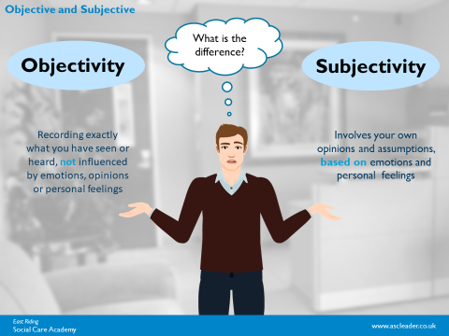

- Objective = unbiased
- Subjective = risk of bias

Information
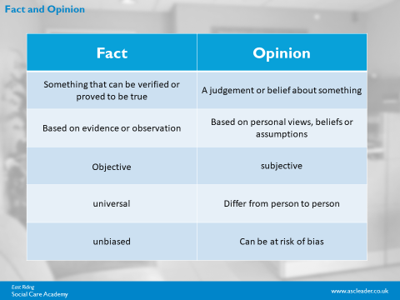

The difference between Fact and Opinion.

Fact and Opinion

Activity 2

Activity
Distinguishing Fact and Opinion
Consider each of the statements below. For each one decide whether it is a Fact or an Opinion.

Then have a go at rewriting each statement that you feel contains an opinion in a way that makes the difference between fact and opinion clear.

When rewriting the statements, think about (and give examples of) how you might substantiate your professional judgement/opinion.

Statement | Fact or Opinion?
- Being alone at home is depressing Jim.
- Alan said his daughter slapped him.
- On the last visit the living room was not safe for Mrs Smith and she is at a high risk of falls.
- Jenny is very contented.
- Pat has an unusual appetite (she has two Kit Kats with her breakfast every day).
- George has suffered skin breakdown.
- Harry has poor mobility
- There are no current concerns regarding Anna’s weight.
- Stuart has had multiple falls.
- Joyce wants to manage her own medications.

Retentive Memory

Activity 3

Activity
You have a minute to write down as many of the images you can remember from the slide at the beginning of this course… No cheating, wait for the start prompt from your tutor!

Involving Service Users in Recording

Activity 4

Activity
How do we involve service users and carers in recording?
How do we ensure that the wishes and feelings of service users and carers are recorded?

Please write down all the ways in which you can involve service users in all aspects of their care.

Abbreviations and Acronyms

Activity 5

Activity
Write what you think these abbreviations or acronyms are.

DN
HV
T/C
MCA
CA
MH
SW
SWIT
AMHP
CWT
VARM
PIP
DLA
LD
NFA
DP
CQC
PEA
DOLS
BIM
OPG
COP
KLOE
AA
LPA
SALT
EOL

Video - Neil and Barbara

Activity 6

You will now watch a short video about Neil and Barbara. Please write down everything that you observe below.

You can make notes while watching the video and then on the next page write a full account of what you have observed.

The video is around 3 minutes and you will have around 5 minutes to write up your observation. We will then discuss this in the group.

Notes

Observation

Helpful Resources and Information

Information

Grammar and Vocabulary
- Verbs HAS to agree with their subjects.
- And don't start a sentence with a conjunction.
- Avoid clichés like the plague. (They're old hat.)
- Also, always avoid annoying alliteration.
- Be more or less specific.
- Parenthetical remarks (however relevant) are (usually) unnecessary.
- Also too, never, ever use repetitive redundancies endlessly over and over again.
- No sentence fragments.
- Foreign words and phrases are not always apropos.
- Do not be redundant; do not use more words than necessary; it's highly superfluous and can be excessive.
- All generalizations are bad.
- Comparisons are as bad as clichés.
- Don't use no double negatives.
- Avoid excessive use of ampersands & abbrevs., etc.
- One-word sentences? Eliminate.
- Eliminate commas, that are, not necessary. Parenthetical words, however, should be enclosed in commas.
- Never use a big word when substituting a diminutive one would suffice.
- Don't overuse exclamation points!!!
- Use words correctly, irregardless of how others use them.
- Use the apostrophe in it's proper place and omit it when its not needed and use it correctly with words' that show possession.
- If you've heard it once, you've heard it a billion times: Resist hyperbole; not one writer in a million can use it correctly. Besides, hyperbole is always overdone, anyway.
- Puns are for children, not groan readers.
- Go around the barn at high noon to avoid colloquialisms.
- Who needs rhetorical questions? However, what if there were no rhetorical questions?
- Exaggeration is a billion times worse than understatement.
- Avoid "buzz-words" or jargon; such integrated transitional scenarios complicate simplistic matters.
- People don't spell "a lot" correctly alot of the time.
- Each person should use their possessive pronouns correctly.
- Proofread carefully to see if you any words out.
- The dash - a sometimes useful punctuation mark - can often be overused - even though it's a helpful tool some of the time.
- Proofread carefully to make sure you don't repeat repeat any words.

For further guidance and assistance with any issues regarding record keeping, please contact your line manager/supervisor.

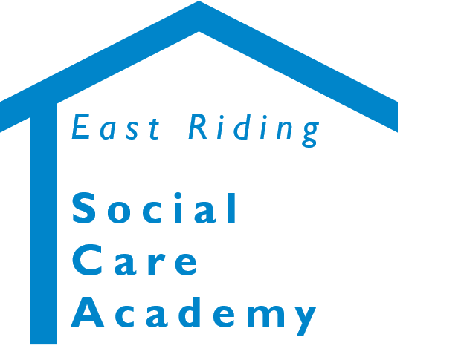

Recording Skills Learner Resource
© 2020 – East Riding Social Care Academy (East Riding of Yorkshire Council)

All rights reserved. No part of this document may be reproduced, distributed, or transmitted in any form or by any means, including photocopying, recording, or other electronic or mechanical methods, without the prior written permission of the copyright holder.

