Learner Resource

Nutrition Hydration and Dysphagia Support in Social Care

Version 2.0 – 07/2020

Contents
The Learner Resource 1
Introduction 1
Structure and Layout 1
Latest Version 2
Quiz 3
Activity 1 6
Information 7
Religious/Cultural Diets 7
Eatwell Guide 8
Activity 2 9
Activity 3 10
IDDSI – Food and Drinks Classification and Testing 11
CHCP Mealtime Checklist 12
Activity 4 13
CHCP Nutrition and Dietetics Referral Form 15
Additional information resources 16

The Learner Resource

Introduction
Welcome to the fluid and nutrition module. This module enables you to develop your knowledge and skills in the fluid and nutrition needs of service users.

This learner resource is to be used as part of the leaning process. Within this learner resource you will find information, activities and direction to further help or information.

Structure and Layout
Each guide has a common structure and layout that helps ensure consistency and maintains the quality of the materials.

The following symbols are used to highlight key information or actions:

Information
This symbol highlights information on a particular point, topic or area.
Key Point
This symbol highlights a key point on a particular topic or area.
Question
This symbol indicates a question.
Activity
This symbol indicates a activity.
Scenario
This symbol indicates a scenario or case study.
Tag
This symbol highlights where you can find more information, help, support or a resource.

Latest Version
Always check you have the latest version of the learner resource. The issue number and date appear on the cover page.

If you have been given this learner resource by your Line Manager, Supervisor or Learning and Development Champion – they will have checked it is the current version. The Social Care Academy will only provide copies of the current version of any learner resource.

Quiz

Someone’s diet is:
- What they eat to lose weight.
- What they eat
- What they weigh

Water is important for your body because
- It is a source of fibre
- It is a source of energy
- It can dissolve substances.

Our bodies need food as a fuel for:
- Nutrition
- Excretion
- Respiration

Good sources of protein are:
- Meat, fish and nuts.
- Pasta, potatoes and rice.
- Fruits and vegetables.

You have a balanced diet when:
- The mass of the food eaten is the same today as tomorrow
- You eat foods with the right amounts of all the nutrients.
- You only eat fish on Fridays

What are nutrients?
- The chemical process which your body breaks down food
- Sugars
- Substances that the body needs to regulate bodily functions

What is the "fuel" to your body?
- Food
- Water

True or False: Nutrients and Foods are very important for your body and health.
- False
- True

Which mineral helps build strong bones and teeth?
- Magnesium
- Calcium
- Iron

Vegetables are important in a person's diet because they are high in
- Protein
- Fats
- Vitamins

What percentage of the Eatwell plate is fruit and vegetables?
- 33%
- 45%
- 25%

Which mineral do people with anaemia lack?
- Zinc
- Iron
- Potassium

Fluid is essential to assist our bodies to function correctly
- True
- False

Which vitamin is good for eyesight?
- Vitamin A
- Vitamin B
- Vitamin C
- Vitamin D

Malnutrition refers to...
- Overnutrition
- Undernutrition
- Both over- and under-nutrition

Which of the following increases the risk of malnutrition?
- Famine
- Having higher nutrient requirements
- Having a lack of income
- All of the above

What is dysphagia?
- Difficulty swallowing
- Obstructed airway
- Impaired speech
- Shortness of breath

Malnutrition and frailty occur more common in older adults
- True
- False

Frailty impacts more than one's physical health.
- True
- False

What does fortify food mean?
- Adding high energy foods to meals to increase the calories
- Adding more fruit and vegetables to your diet
- Eating anything you want

Activity 1
Activity

There are various pieces of legislation, policies, internal processes that you are required to adhered to when supporting someone with their nutritional needs when working in social care settings.

Can you list as many legislations, polices and processes that relate to fluids and nutrition?

Information

Religious/Cultural Diets

Below is a guide to what certain cultures and religions may or may not eat.
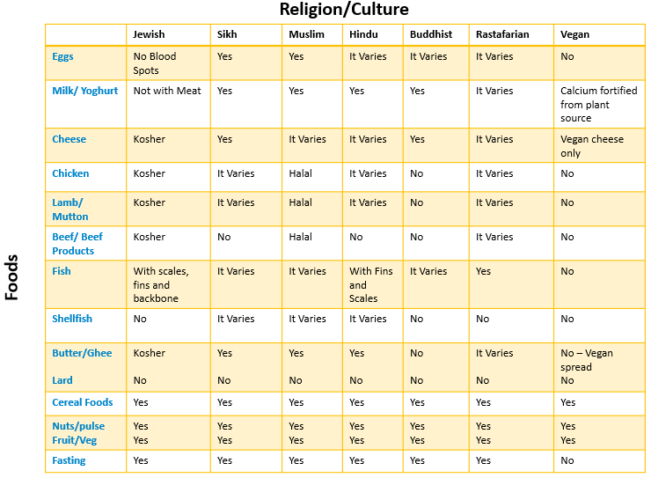

Eatwell Guide
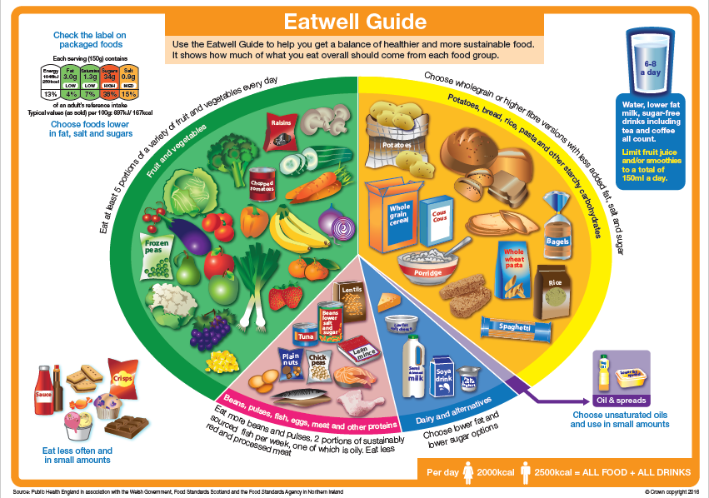

Activity 2

Activity
Did you know that water can be found in food?

You will find pictures of the top ten foods that contain a high percentage of water. Can you guess the percentage of water content in each of the following?

% | % | %
% | % | %
% | % | %
 | %

Activity 3
Poor nutrition can impair our daily health and wellbeing and reduce our ability to lead an enjoyable and active life. In the short term poor nutrition can contribute to stress, tiredness and our capacity to work. Over time it can contribute to the risk of developing illness and other health problems

Activity
Think about the various health problems that occur through a poor diet.

What could they be?
What are the signs to look for?
What actions would you take if you noticed these?

Problems | Signs | Actions

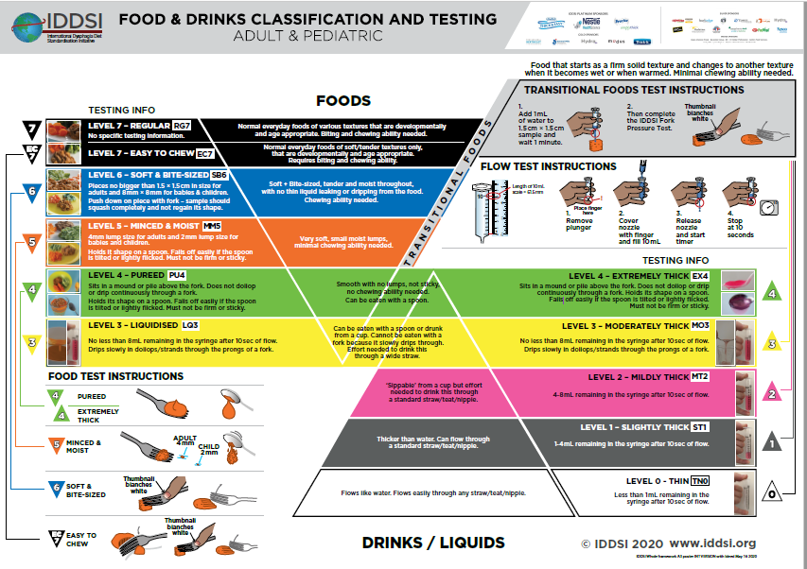
IDDSI – Food and Drinks Classification and Testing

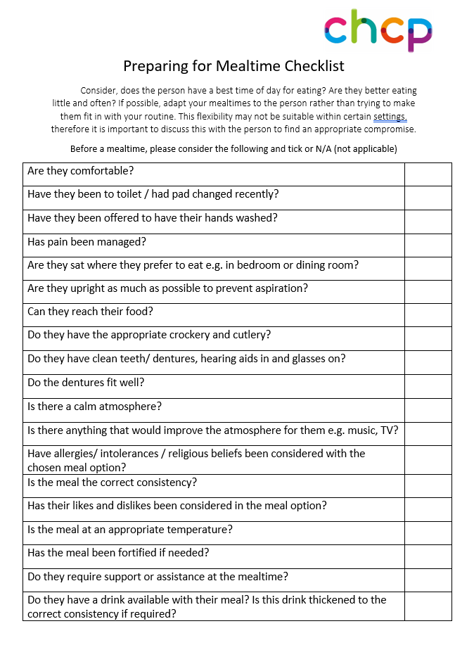
CHCP Mealtime Checklist

Activity 4
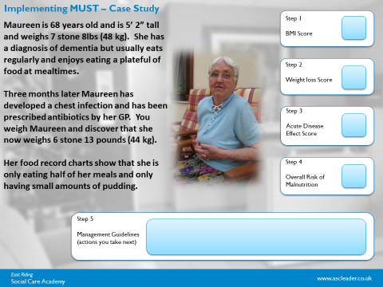

Key Point
For a referral to a dietetic practitioner you will need to do the following:
- Fully fill in the referral form
- Apply the pre-assessment checklist
- Copy of the food and fluid charts for the person for a minimum of three days
- List of all medications (MARS Chart)
- Copy of any hospital discharge letters (if applicable)
- Any Speech and Language Therapy (SALT) recommendations.

CHCP Nutrition and Dietetics Referral Form

Below is a copy of the Hull and East Riding referral form for nutrition and dietetics. Please note that all referrals made must be done via email and sent to chcp.247111@hns.net
All boxes must be completed with up to date information and where possible consent must be given from the individual for the referral to be made.

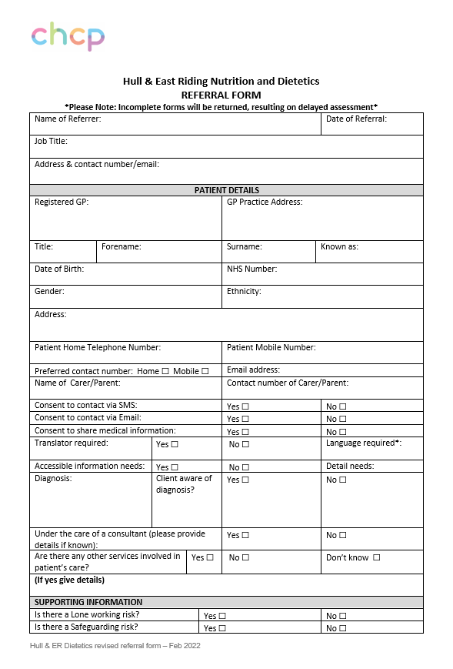

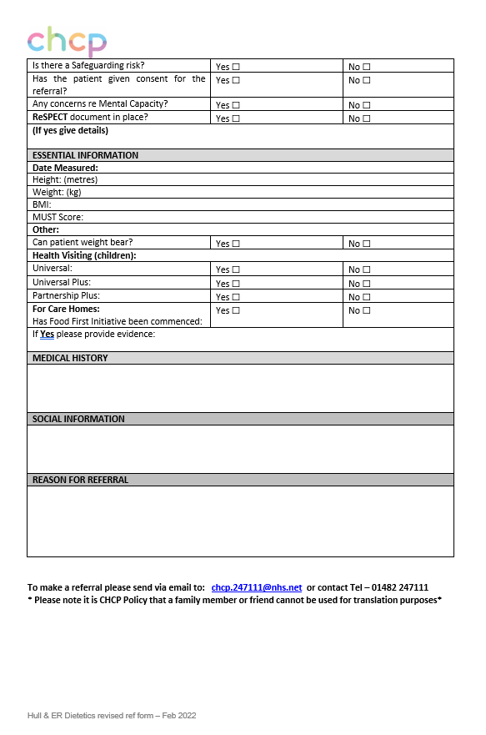

Additional information resources

Information

Information for the topics we have spoken about today are available from the following:

For more information on the Eatwell Plate please follow the link for more guidance and information:
https://www.nhs.uk/live-well/eat-well/the-eatwell-guide/

Dysphagia information can be found on the NHS website:
https://www.nhs.uk/conditions/swallowing-problems-dysphagia/

IDDSI website:
https://iddsi.org/
IDDSI Framework Handout:
https://ftp.iddsi.org/Documents/Consumer_Handouts_for_Adults_All_Levels.pdf

Death by Indifference Report:
https://www.mencap.org.uk/sites/default/files/2016-08/Death%20by%20Indifference%20-%2074%20deaths%20and%20counting.pdf

Care certificate:
https://www.skillsforcare.org.uk/Learning-development/inducting-staff/care-certificate/Care-Certificate.aspx

Fortified Recipe Ideas:
https://www.nhsglos.nhs.uk/wp-content/uploads/2022/01/PrescQipp-Fortified-Diet-Recipe-Booklet.pdf

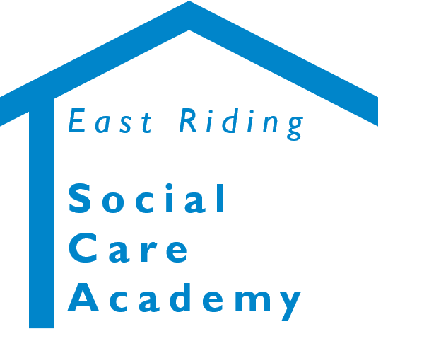

Nutrition and Hydration Support in Social Care Settings
© 2020 – East Riding Social Care Academy (East Riding of Yorkshire Council)

All rights reserved. No part of this document may be reproduced, distributed, or transmitted in any form or by any means, including photocopying, recording, or other electronic or mechanical methods, without the prior written permission of the copyright holder.

