 | Learner Resource
Mental Capacity Act
Level 2

Version 1.2 March 2025

Contents

What is capacity? | 1
Knowledge recap | 2
Adulthood | 2
Decisions | 3
What if-practitioner support | 4
Causative Nexus | 5
Case Study-Doris | 6
Less restrictive | 7
Legislation | 7
Tips for capacity assessments | 7
Resources | 9

What is capacity?

 | What is capacity? Please write down your thoughts.    https://www.communitycare.co.uk/2024/01/23/safeguarding-adults-enquiries-do-you-need-consent/

Adulthood

 | When did you consider yourself to be an adult?  What would you say was your first ‘adult’ decision?  

Is there a decision to be made?

What decisions do not apply to the MCA?

1
2
3

Time and specific decisions

 | A mental capacity assessment relates to a specific decision that has to be made and is not about a general ability to make decisions. For example, a person may not have the mental capacity to make complex investment decisions but may have sufficient mental capacity to pay their household bills.

Daily Decisions



- Describe a situation where you have had to make a decision for one of the individuals you support?

- How did you know that they were not capable of making the decisions for themselves?

Practitioner support

 | Find the ‘what if’ capacity assessment practitioners guides via Teams on the ASCH Quality Practice Framework.  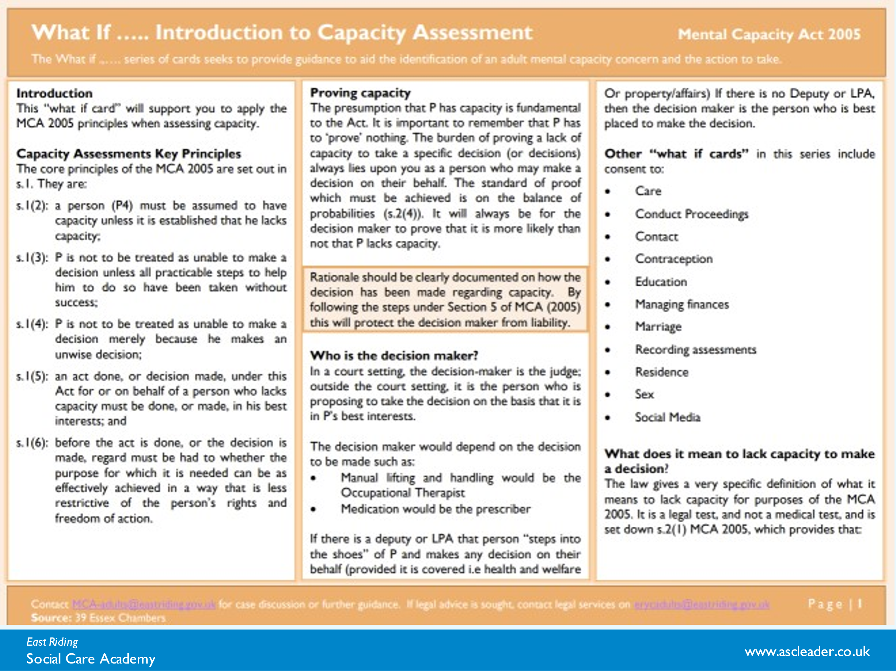  Find the MCA and best Interests practitioner factsheet at ASCH Framework Teams channel.  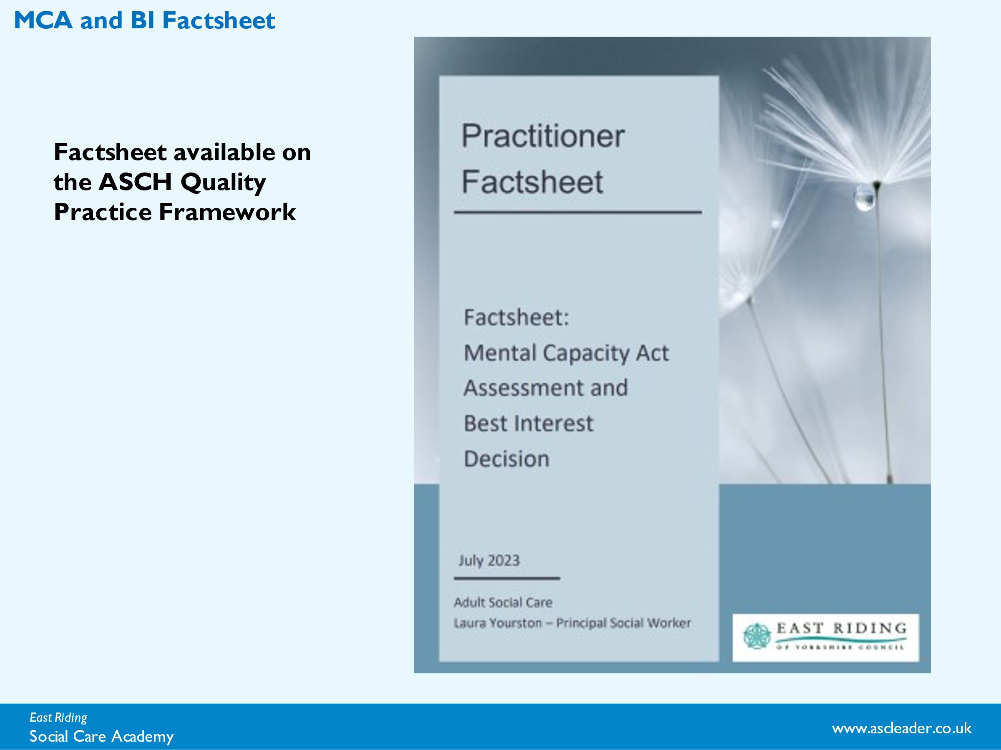

Causative Nexus
 | Causative nexus refers to the direct relationship between an individual's mental impairment or a disturbance in the functioning of the mind or brain and their inability to make a specific decision at a particular time. In simpler terms, there must be a cause-and-effect relationship between the person's mental condition and their incapacity to make a decision.  P’s diagnosis of dementia impacts her cognitive ability to make informed capacitated decisions. She is unable to understand information, retain the information or use and weigh up the information for the purposes of making specific decisions related to her health and wellbeing, care and support needs or her accommodation. P was not aware of her cognitive impairment and that if she does not have the appropriate level of care and support, she is at risk of self-neglect and would be extremely vulnerable. It is very unlikely that P will regain mental capacity to make decisions in relation to her care and treatment. I have also taken into consideration P’s care records, the views of the care staff, which confirms that her mental disorders impacts her ability to make the decision around her care and treatment”

Case Study Doris
Doris is an 80-year-old woman who has until recently been living at home with her husband, Harold. They have been married for 60 years. They have one daughter called Catherine, who doesn’t live close by. Doris was a nurse and now both her and Harold enjoy their garden and their Scottie dog called Pip. Doris loves Tom Jones music, listening to radio 2 and choosing her smart clothes and jewellery to wear. They both love their hometown of Bridlington and enjoy the sea views from their bungalow. Harold has been Doris’s main carer as she was given a diagnosis of Mixed Dementia 6 years ago. Doris is able to make some daily decisions, but Harold has supported and cared for her, with the help of 2 visits from paid carers. Doris has an advanced statement that says she would like to stay in Bridlington.
More recently Harold has been unwell, and he has been assessed as no longer being able to care for Doris. Doris is very confused about the situation, her living arrangements and care and where her husband is. Doris has moved into a care home as an emergency, but a decision now needs to be made as to her long-term future.

What is the decision to be made?

How would you put the principles of the MCA to practice?
Presumption of capacity
Support
What would be your practicable steps (principle 2 – support Doris to understand)
H- Hour

E- Environment

L-Language/communications

P- People

E- Equipment

D- Diagnosis

Unwise decision?

Best interests and least restrictive

adults_pt_mca_web.pdf ( Helped tool)

Less restrictive
Whenever you make a decision or implement a decision under the Mental Capacity Act you are required to achieve the required outcome by acting in a way that is least restrictive of the person's rights and freedoms.

Any thoughts as to possible barriers for taking a least restrictive approach?

Legislation

 | Take 3 mins to note down what law’s, legislation, procedures and frameworks we should be aware of in line with the Mental Capacity Act 2005

Tips for Capacity Assessments
 | Tip 1: Develop a Profile of the Person  •Read the referral and gather some background information about the individual.  •Contact the Referrer to obtain their views on the situation and how to best support the individual during the assessment.  •Consider their communication needs.  Tip 2: Consider What Triggered the Assessment  •What are the reasons for carrying out this assessment.  •Am I carrying out this assessment because the person’s behaviour or circumstances causes doubt as to whether they have the capacity to make a specific decision?  Tip 3: What is the Specific Decision to be made?  •Break down the decision and make it as specific as possible.  •The individual may have the capacity around certain aspects of the decision to be made and can have autonomy in this area.  Tip 4: Consider the Practical Steps  •Bear in mind the assumption of capacity and that an unwise decision is not necessarily an incapacitated decision.  •That the burden of proof lies on yourself, as the assessor, and that the standard of proof is the balance of probabilities.  Tip 5: Allow enough time to carry out the assessment.  •This will depend on the complexity of the decision needed to be made  •Give a comprehensive explanation as to why a Mental Capacity Assessment is needed to the person being assessed and try to gain consent.  •Ensure you have detailed information to hand to ensure that the service user or client is sufficiently supported with their decision making.  •Ensure you can adequately explain options and consequences of decisions.  Tip 6: Set the Threshold of Understanding and include a Section for Analysis  •Include a section on ‘analysis’ to evidence professional views and judgement under the functional areas (understand, retain, use/weigh, or communicate).  •State the practical steps which have been taken to enable and support the individual to improve their ability to participate in the decision-making process including their verbal and non verbal responses.  •Consider whether to reassess the individual or return to the assessment at a better time, whether to carry out the assessment at a time when the person is most relaxed, whether to use an assistive technology/communication tool or support from a professional, advocate, friend or carer.  Tip 7: Establish the causative nexus.  •A causative nexus between the impairment of mind and the inability to make a decision is required to displace the presumption of capacity under s1 (2) MCA 2005.  •You should always explain how the impairment of, or disturbance in the functioning of the mind or the brain causes the person to be unable to make the decision. This only needs to be a couple of lines. Avoid jargon and write in plain English  Source: https://socialworkhaven.com/mental-capacity-assessments-report-writing/

Skill Set
Supporting MCA Assessments
Skills that we need to develop to support with MCA Assessments:

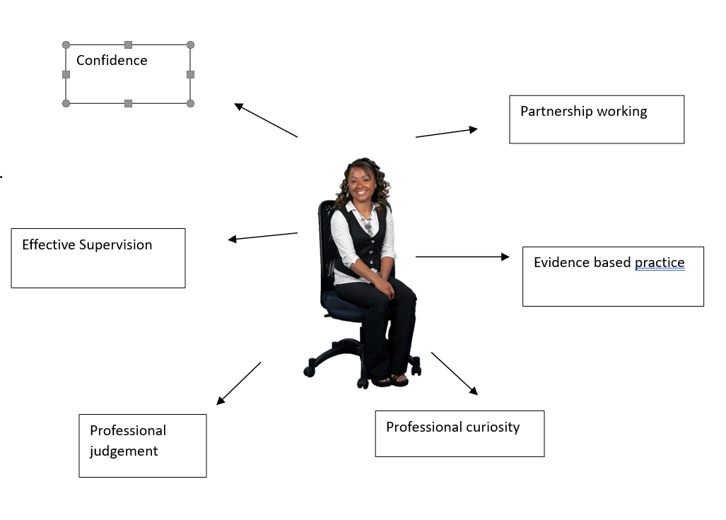

Resources and links
Useful websites include:

The MCA Code of Practice can be downloaded from www.gov.uk/government/publications

39 Essex Chambers
http://www.39essex.com/resources-and-training/mental-capacity-law
Database of guidance notes (including as to capacity assessment) case summaries and case comments from the monthly 39 Essex Chambers Mental Capacity Law Report, to which a free subscription can be obtained by emailing marketing@39essex.com.
http://www.mclap.org.uk/
Website set up by Alex with forums, papers and other resources with a view to enabling professionals of all hues to ‘do’ the MCA 2005 better.
http://www.capacityguide.org.uk/
Website which draws upon both this guidance and research conducted by the Mental Health and Justice project to give further assistance to those thinking about capacity, especially in more difficult situations.
http://www.lpslaw.co.uk /
Website set up by Neil which includes videos, papers and other materials (much of them free) relating both to the Liberty Protection Safeguards and the MCA 2005 more widely;
http://www.mentalhealthlawonline.co.uk/
Extensive site containing legislation, case transcripts and other useful material relating to both the Mental Capacity Act 2005 and Mental Health Act 1983.
It has transcripts for more Court of Protection cases than any other site (including subscription only sites), as well as an extremely useful discussion list.
http://www.scie.org.uk/mca-directory
The Social Care Institute of Excellence database of materials relating to the MCA.
I and We statements:
https://making itreal.org.uk/using-making-it-real/
Factsheet available on the
ASCH Quality Practice Framework
https://eryc.sharepoint.com/:b:/r/sites/ASCHQualityPracticeFramework/Shared%20Documents/General/Quality%20Practice%20Framework/03%20-%20Practitioner%20Factsheets/14-%20Factsheet%20MCA%20-%20BIA%20-%20DoLS.pdf?csf=1&web=1&e=NL74ZO
Lorraine Currie
https://www.mentalcapacitylawandpolicy.org.uk/living-the-mca-in-practice-in-conversation-with-lorraine-currie
Human Rights video link
https://www.youtube.com/watch?v=BOc-fpC1bak
Tim Farmer’s The Assessor's Notebook
Tim Farmer - The Assessor's Notebook - YouTube

Guidance on out-of-date code of practice
https://www.39essex.com/information-hub/insight/mental-capacity-act-dols-codes-practice-update

