 | Learner Resource
Reviews in adult social care

Version 1.March 2024

Contents
Types of review 1
The process 2
The unplanned review -------------------------------------------------------------------------------------------------------2
The requested review--------------------------------------------------------------------------------------------------------3
Substantial difficulty------------------------------------------------------------------------------------------4
Advocacy --------------------- -------------------------------------------------------------------------------4
Strengths-based approach ---------------------------------------------------------------------------------4
Accessible information standards ------------------------------------------------------------------------5
Crib sheet -------------------------- -------------------------------------------------------------------------5
Positive behaviour support---------- ----------------------------------------------------------------------7
Reviewing 1-1 -----------------------------------------------------------------------------------------7
Questions and resources-----------------------------------------------------------------------------------8

Types of review

 | Different types of reviews-Notes  1.  2.  3.  4.  ---------------------------------------------------------------------------------------  ---------------------------------------------------------------------------------------

The Process
Information

 | 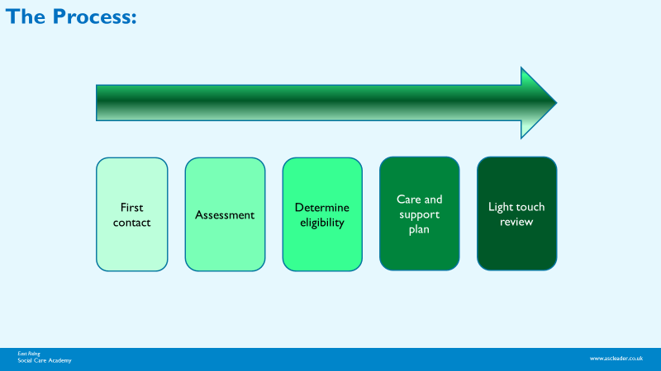

The unplanned review

 | Questions  1. Can you think of any occasions when an unplanned review would be required?  ----------------------------------------------------------------------------------------  2. What are some of the issues with an unplanned review?

The requested review


You receive an email from a relative of an older person receiving care and support at home. The email informs you that the person’s condition is deteriorating and supplies evidence from the GP of recent visits.

- Would you offer a review and why?

-------------------------------------------------------------------------------

Substantial difficulty
 |   Activity:  What is meant by substantial difficulty?

Advocacy

What is advocacy?
“Advocacy is taking action to help people say what they want, secure their rights, represent their interests, and obtain services they need. Advocacy promotes social inclusion, equality, and social justice. “
(The Advocacy Charter, 2018).

https://www.voiceability.org/about-advocacy/types-of-advocacy/care-act-advocacy

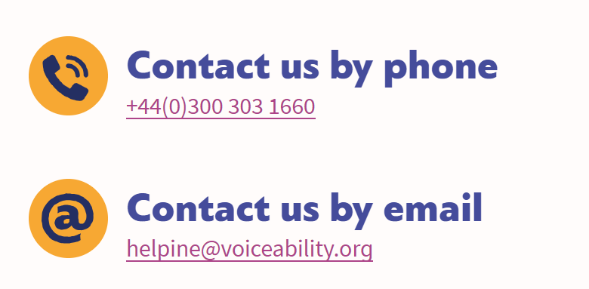

Strengths-based approach
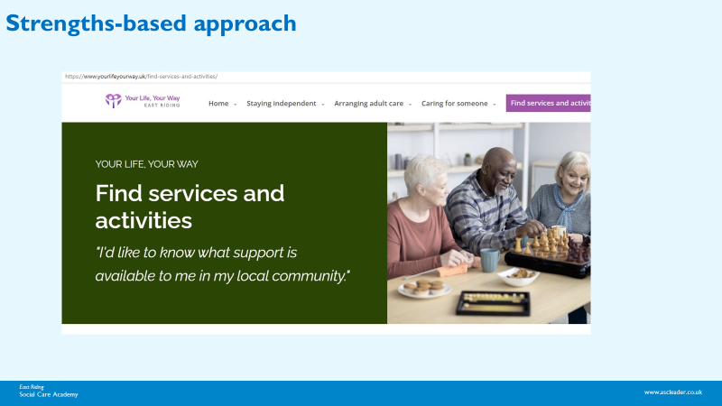

https://www.yourlifeyourway.uk/

Accessible information standards
Communication

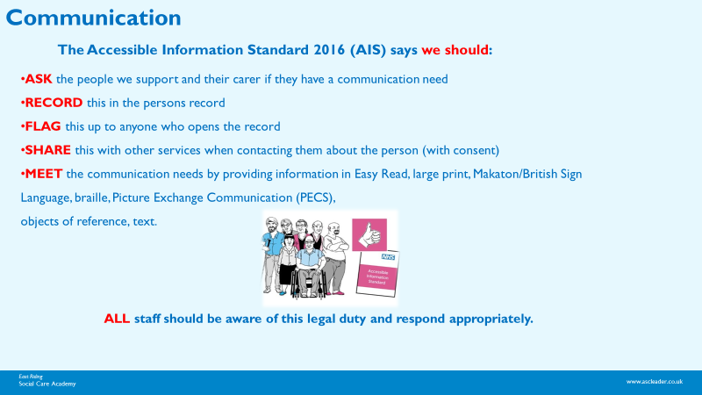

An e-learning course is available via elfh (NHS England) Accessible Information Standard – e-learning for healthcare (e-lfh.org.uk)

(More info https://www.england.nhs.uk/about/equality/equality-hub/patient-equalities-programme/equality-frameworks-and-information-standards/accessibleinfo/ )

Crib sheet
Activity
Activity: Reflecting on all the information you have seen so far and your own experiences please work together in groups to devise your own ‘crib sheet’- a tick list for you to refer to when carrying out a review. It may help to use the three columns suggested in your learner resource: Prior, During, and After. You have 15 minutes for this task.
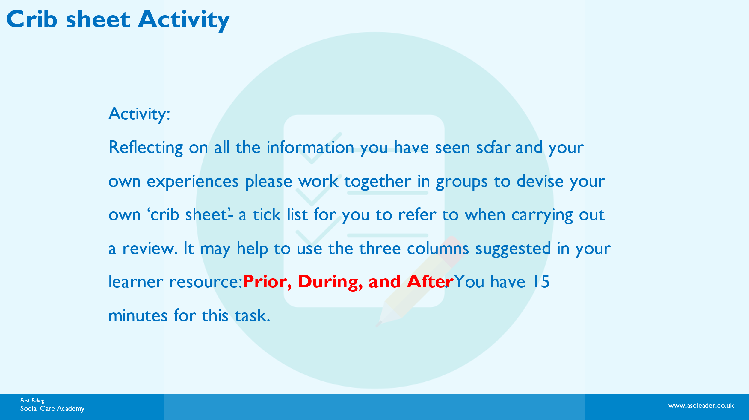

Prior | During | After

Positive behaviour support
 | 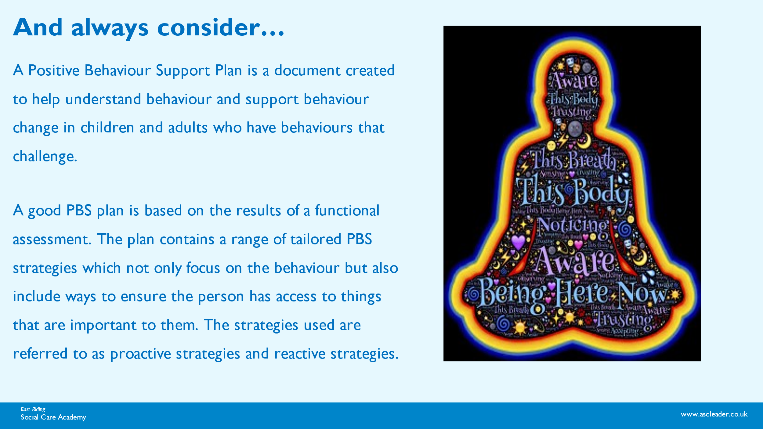  https://www.challengingbehaviour.org.uk/wp-content/uploads/2021/02/003-Positive-Behaviour-Support-Planning-Part-3.pdf

Reviewing 1-1
 |   What are the benefits of reviewing 1-1 care and support?  ----------------------------------------------------------------------------------------

Any questions and resources

 |   https://www.voiceability.org/about-advocacy/types-of-advocacy/care-act-advocacy  http://helensandersonassociates.co.uk/about/how-can-we-help-you/our-courses/person-centred-thinking/  https://www.england.nhs.uk/about/equality/equality-hub/patient-equalities-programme/equality-frameworks-and-information-standards/accessibleinfo/  