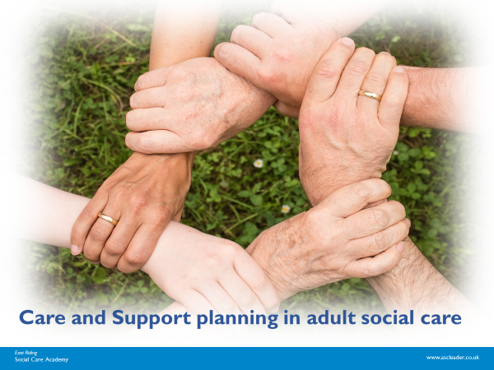 | Learner Resource
Care and support planning in adult social care

Version 1.3 October 2024

Contents
The Process- how it fits in 1
What are care and support Plans 1
Human Rights -------------------------------------------------------------------------------------------------------------------2
One page profile -------------------------------------------------------------------------------------------------------------- 3
Person-centred-----------------------------------------------------------------------------------------------4
Advocacy --------------------- -------------------------------------------------------------------------------4
Capture their voice ----------------------------------------------------------------------------------------4
Key quality standards -------------------------------------------------------------------------------------- 5
Risk -------------------------- ------------------------------------------------------------------------------- -5
Wellbeing---------- ------------------------------------------------------------------------------------------6
Mental Capacity Act-----------------------------------------------------------------------------------------7
Outcomes-----------------------------------------------------------------------------------------------------8
What needs to be in a Care and Support plan--------------------------------------------------------8

The process

How it fits in

 | 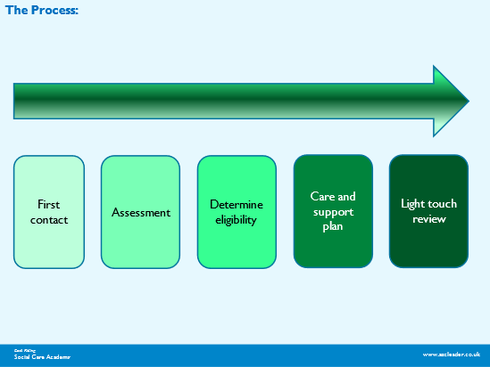

What are care and Support plans

Activity
 | Activity  In groups discuss:  What are care and Support plans?  ---------------------------------------------------------------------------------------  ---------------------------------------------------------------------------------------  Why do we have them?  ---------------------------------------------------------------------------------------  --------------------------------------------------------------------------------------

Human Rights

The FREDA principles
 |   Fairness  Respect  Equality  Dignity  Autonomy (choice and control).

One page profiles
https://helensandersonassociates.com/person-centered-thinking-tools/

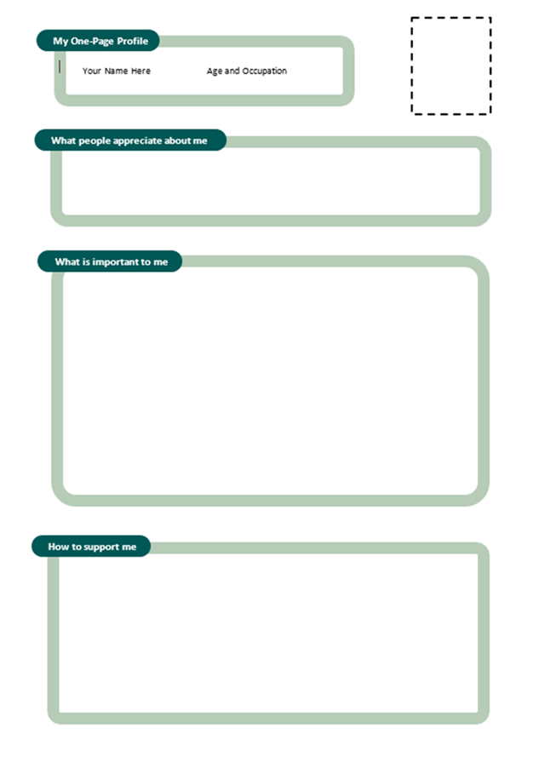

Person-centred
Activity
 | Activity:  Discuss ways in which you can make sure a care and support plan is person-centred, can you give any examples of things you have tried?  ----------------------------------------------------------------------------------------

What is advocacy?
 | What is advocacy?  “Advocacy is taking action to help people say what they want, secure their rights, represent their interests, and obtain services they need. Advocacy promotes social inclusion, equality, and social justice. “  (The Advocacy Charter, 2018).

Capture their voice.
What can we do as professionals to make sure every effort has been made to communicate with them and to ensure they are the active owners of their care plan? Discuss answers.

More info https://www.england.nhs.uk/about/equality/equality-hub/patient-equalities-programme/equality-frameworks-and-information-standards/accessibleinfo

http://www.helensandersonassociates.co.uk/wp-content/uploads/2015/02/Commchartmetoyou.pdf

Key quality standards:
I statements- using First person

Activity

Using the case note below please complete the boxes ‘ Your situation and outcomes’ and ‘the plan for achieving the outcomes’ using a strengths-based and First person format.

Joe has moved into an Independent Supported Living flat 3 months ago and uses the phone to speak to his mum and brother when his support worker dials the number for him. He does this twice a week but he has expressed that he would like to do this more and he would feel more grown up if he could do it on his own. He likes to talk to them about his day and ask about his dog. Joe ‘s best friend goes to the football most Saturday’s but he cannot get there as his support worker doesn’t have the car. This makes him feel lonely. Joe enjoys animals and would like to work with them, but he doesn’t know what he needs to do for this. Joe’s medication needs to go out with him in the community, but he can administer it himself and has a Fuller’s in place.

Your situation and outcomes:

The plan for achieving your outcomes:

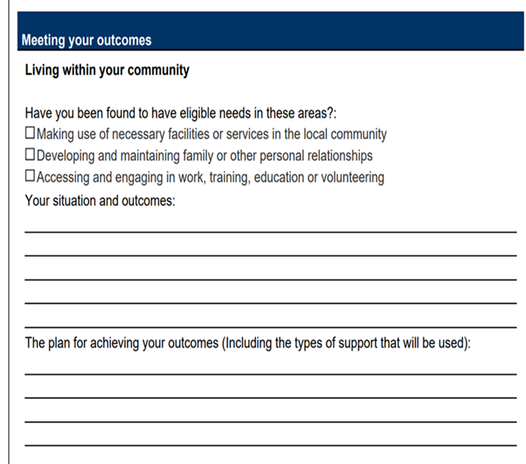

Risk Activity
 | Activity: : Am I risk averse?  In your own lives how do you approach risk?  ----------------------------------------------------------------------------------------  Do I prefer actions that help me to feel safe? Do I consider the potential benefits for others on taking risks?  ----------------------------------------------------------------------------------------

Well-being
 | Activity:  Write down as many areas of well-being that you can think of…

Mental Capacity Act
Notes on the Mental Capacity Act 20205

Outcomes

Activity: Identify the personal outcome statements from the given ones 1-24.
Circle the statements that you think are outcomes.

1. I can’t get out and about anymore because I’m unsteady on my feet.
2. To have a better social life by being part of a sewing club and not feel lonely.
3. I want to control my drinking, so I can rebuild the relationship with my daughter and get to read my grandson a bedtime story.
4. Provision of information about local singing groups.
5. I want to have more confidence to go to town on my own so that I don’t have to rely on my family.
6. When Mum feels low she stays in bed all day.
7. To have home cooked meals that I enjoy at a time that suits me.
8 We want to have a clean and tidy enough home, so we feel happier and can invite friends around sometimes.
9. Referral for an assessment at the Community Mental Health Team
10. To be able to walk safely in my garden without being afraid of falling.
11. Best Interests Meeting to be arranged.
12. I have care workers calling three times a day to help with personal care.e
13. Dad is getting very forgetful, he wants a memory clock.
14. I want Mum to sit with me and help me with my homework.
15. I go to the memory clinic once a month.
16. I want to be able to get out and do the things I love. I love to go singing and see shows. I don’t ever want to feel like I’m trapped in my home.
17. I am registered blind.
18. I will have come to terms with the loss and the sadness, and I will be focusing more on the positives.
19. Mum needs homecare.
20. Respite care is needed for Mrs Jones when her husband is admitted to hospital for treatment.
21. Going to a carers’ support group.
22. I can reduce the stress on my daughter and stay at home while maintaining a link with my friend.
23. I want to be able to use a toilet rather than doing my business in a pad. It’s not very comfortable to be laying in it and it’s embarrassing having the carers change me.
24. I’m having supervised contact with my dad.

Key quality standards:

What needs to be in a Care and support plan?
 | NOTES 

Resources and links

Resources and Links

https://www.voiceability.org/about-advocacy/types-of-advocacy/care-act-advocacy

http://www.gov.uk/government/publications/care-act-statutory-guidance/care-and-support-statutory-guidance

http://helensandersonassociates.co.uk/about/how-can-we-help-you/our-courses/person-centred-thinking/

htps://www.thinklocalactpersonal.org.uk/_assets/Resources/Personalisation/Personalisation_advice/A_Person_Centred_Approach_to_Risk.pdf

https://www.england.nhs.uk/about/equality/equality-hub/patient-equalities-programme/equality-frameworks-and-information-standards/accessibleinfo/

http://www.helensandersonassociates.co.uk/wp-content/uploads/2015/01/careandsupportselfassessmenthandout.pdf

Fire safety tool
https://www.safelincs.co.uk/hfsc/

Cultural and identity resources

https://www.skillsforcare.org.uk/resources/documents/Developing-your-workforce/Care-topics/Culturally-appropriate-care/Culturally-appropriate-care-guide.pdf

https://www.cqc.org.uk/guidance-providers/adult-social-care/examples-culturally-appropriate-care

