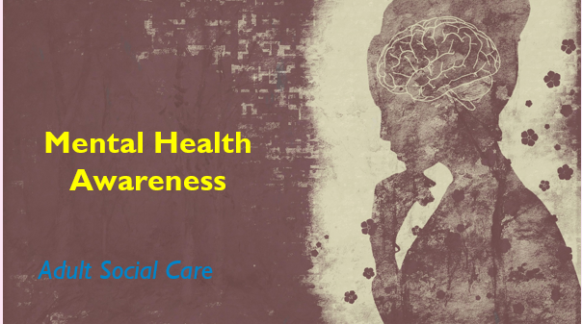 | Learner Resource
Mental Health Awareness

Version 1.0 – 03/2022

Content
Mental Health Conditions 1
Activity 1 1
Signs and Symptoms 2
Activity 2 2
Information 4
5 Ways to Well being 4
The Stress Container 5
Activity 3 5
Information 7

Mental Health Conditions

Activity 1

Activity

What Mental health conditions can you think of?

Below list all the mental health conditions that you are aware of.

Signs and Symptoms

Activity 2

Activity

Below can you identify the signs and symptoms of these 9 most common mental health conditions.

Depression:
……………………………………………………………………….
……………………………………………………………………….
……………………………………………………………………….

Obsessive Compulsive
Disorder:
……………………………………………………………………….
……………………………………………………………………….
……………………………………………………………………….

Panic Disorder:
………………………………………………………………………
………………………………………………………………………
………………………………………………………………………

Psychosis
……………………………………………………………………….
……………………………………………………………………….
……………………………………………………………………….

Generalised Anxiety
Disorder:
………………………………………………………………………..
……………………………………………………………………….
……………………………………………………………………….

Post-Traumatic Stress
Disorder (PTSD):

………………………………………………………………………..
………………………………………………………………………..
………………………………………………………………………..

Personality Disorder
………………………………………………………………………………………………………………………………………………………………………………………………………………………

Bipolar
……………………………………………………………………………………………………………………………………………………………………………………………………………………….

Schizophrenia
………………………………………………………………………………………………………………………………………………………………………………………………………………………

Information

5 Ways to Well being

Activity
Evidence suggests there are 5 ways you can improve your mental health and wellbeing. Trying these things could help you feel more positive and able to get the most out of life. For this activity I would like you to write what you could do to put this into practice.

Connect
…………………………………………………………………...
…………………………………………………………………...
…………………………………………………………………...

Be Active
…………………………………………………………………...
…………………………………………………………………...
…………………………………………………………………...

Take Notice
…………………………………………………………………...
…………………………………………………………………...
…………………………………………………………………...

Keep Learning

…………………………………………………………………..
…………………………………………………………………...
……………………………………………………….

Give

…………………………………………………………………...
…………………………………………………………………...
…………………………………………………………………...

The Stress Container

Activity 3
Activity

Below is you will find your own stress container.

Please write down all the factors that you feel causes you stress or worry within your life. This can be anything from work issues, family issues, or anything that is happening around you.

…………………………………………
…………………………………………
…………………………………………
…………………………………………
…………………………………………
…………………………………………
…………………………………………
…………………………………………

When we feel that all our stresses are getting to much then we need to make sure that we are releasing that stress, so our container doesn’t overflow.

Please write down ideas that you can do which can help relieve that stress or make you feel less stressed.

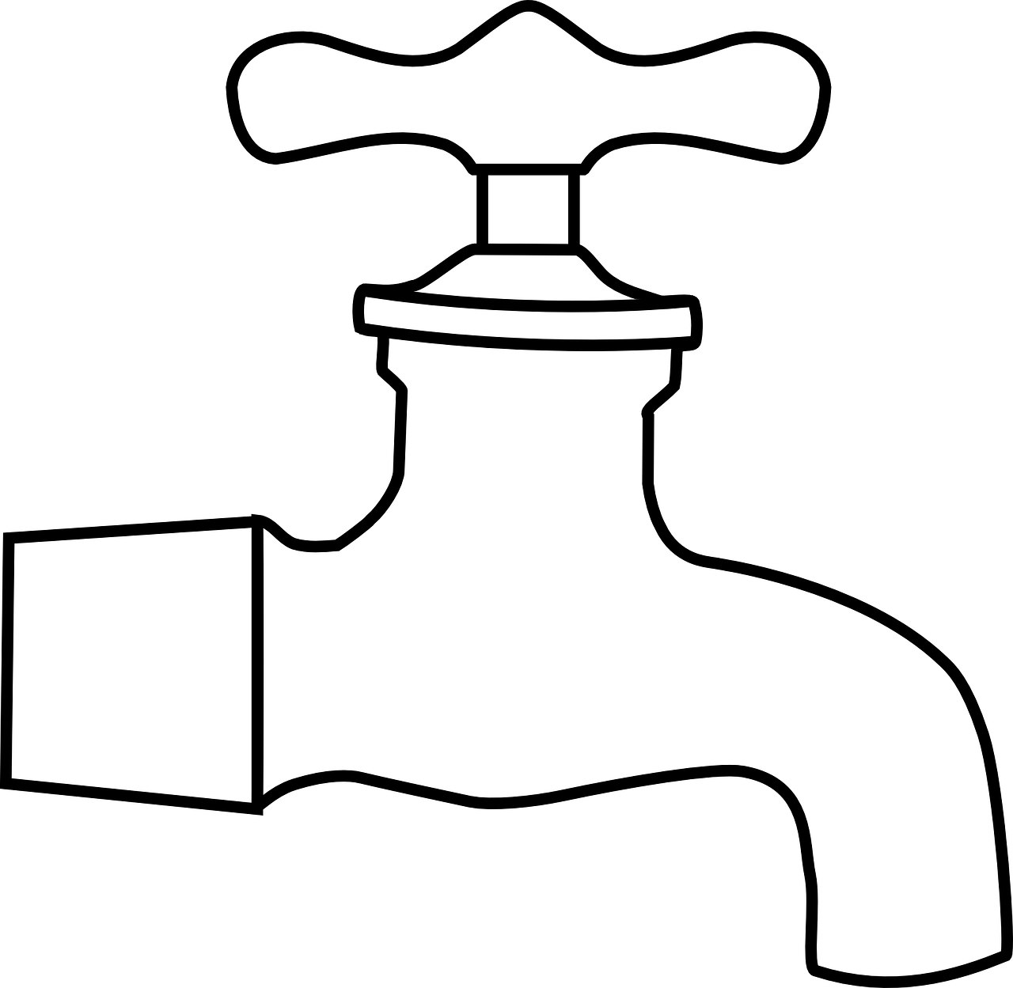
……………………………………………………
…………………………………………………..
……………………………………………………
………………………………………………..
………………………………………………..
…………………………………………………
……………………………………………………

To help you turn the tap to empty it better, answer these following questions:

1. What can I change or manage differently?

2. What can’t I change and need to accept?

3. What needs my urgent attention?

4. Can anyone help me?

5. What are some of my unhelpful ways that I try to cope?

6. What are some of the useful ways that I use to try to cope? What else could I do?

Information

Information

Useful websites

East Riding Health and Wellbeing - https://eastridinghealthandwellbeing.co.uk/home/
Created by the East Riding of Yorkshire Council Public Health team to support the social prescribing project and make sure everyone has access to reliable wellbeing information and local services.

Community Mental Health Services for Adults - https://www.humber.nhs.uk/Services/community-mental-health-services-for-adults-in-the-east-riding.htm
The service is provided in partnership with the East Riding of Yorkshire Council and Humber Teaching NHS Foundation Trust in conjunction with other internal mental health services. The team works closely with service users and carers, their families, primary care services, and other local statutory and non-statutory agencies. The team is multi-disciplinary consisting of a wide range of health and social care professionals supported by administration staff.

East Riding Emotional Wellbeing Service - https://humberews.co.uk/
The service offers a number of different therapies to help support you with your emotional wellbeing.

Andy’s Man Club - https://andysmanclub.co.uk/
Email: info@amdysmanclub.co.uk
9 locations within East Yorkshire & Humber

House of Light - https://pndsupport.co.uk/
Phone: 01482 580499
Freephone: 0800 043 2031
Email: help@houseoflight.org.uk
Helpline is open mon-fri 9am-5pm

Men’s Sheds Association - https://menssheds.org.uk/
Phone: 0300 772 9626
Email: admin@ukmsa.org.uk

Hull and East Yorkshire Mind - https://www.heymind.org.uk/
Phone: 01482 240200
Email: info@heymind.org.uk

Your life Your way - https://www.yourlifeyourway.uk/caring-for-someone/
Your Life, Your Way aims to help our residents live active and independent lives. If you have any care needs, we'll help you get the right care and support at the right time.

Rethink - https://www.rethink.org/
Advice line: 0808 801 0525
Mon – Fri 09:30 – 16:00

No Health without Health – Government Strategy
https://assets.publishing.service.gov.uk/government/uploads/system/uploads/attachment_data/file/213761/dh_124058.pdf

PAPYRUS - Papyrus UK Suicide Prevention | Prevention of Young Suicide (papyrus-uk.org)
HOPELINE: 0800 068 4141
Text: 07860039967
24 hours, 7 days a week

Young Minds - YoungMinds | Mental Health Charity For Children And Young People | YoungMinds
Parents Advice Line: 0808 802 5544
Mon – Fri 09:30 – 16:00

Anxiety UK
Phone: 03444 775 774

No Panic - Home - NoPanic
Helpline: 0300 772 9844
10am – 10pm everyday

Shout - Support with self-harm | Shout 85258 (giveusashout.org)
Text: 85258
24/7 free confidential support service

Videos

I had a dog, and his name was depression - https://www.youtube.com/watch?v=XiCrniLQGYc
Duration 4:19 mins

Five Ways to Wellbeing –
https://www.youtube.com/watch?v=bsc2QkCC3uI
Duration: 2:42 mins

How to talk to your friends about mental health (MECC) - https://youtu.be/AOucXkCAV7c?list=PLfKvBIIJ5Z8v3Jb4T7qbVe2R8tF_zpnYB
Duration 1:18 mins

