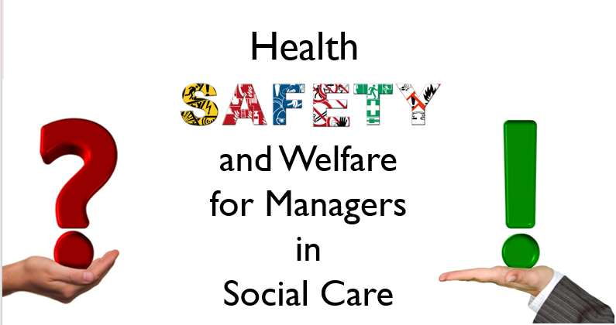 | Learner Resource
Health, Safety and Welfare for Managers in Social Care

Version 1.1 – 05/2024

Contents
The Learner Resource 1
Introduction 1
Structure and Layout 1
Latest Version 2
Activity 1: Good and Poor Health and Safety 3
HSE key facts … 4
Activity 2: “What’s Your Thoughts?” 5
Activity 3: “Start the Conversation” 6
The What, Why and How Framework 7
Control of Substances Hazardous to Health Safety Guidance 8
Health and Safety Arrangements Document 9
Wellbeing Information 10

The Learner Resource

Introduction
Welcome to the Health, Safety and Welfare for Managers in Social Care. This module enables you to develop essential knowledge of Health, Safety and Welfare for in Social Care and how to keep yourselves, colleagues, service users and visitors safe

This learner resource is to be used as part of the leaning process. Within this learner resource you will find information, activities, tools and direction to further help or information.

Structure and Layout
Each guide has a common structure and layout that helps ensure consistency and maintains the quality of the materials.

The following symbols are used to highlight key information or actions:

 | Information  This symbol highlights information on a particular point, topic or area.
 | Key Point  This symbol highlights a key point on a particular topic or area.
 | Question  This symbol indicates a question.
 | Activity  This symbol indicates a activity.
 | Scenario  This symbol indicates a scenario or case study.
 | Tag  This symbol highlights where you can find more information, help, support or a resource.

Latest Version
Always check you have the latest version of the Learner Resource. The issue number and date appear on the cover page.

If you have been given this learner resource by your Line Manager, Supervisor or Learning and Development Champion – they will have checked it is the current version. Learning and Development only provide copies of the current version of any learner resource.

Activity 1: Good and Poor Health and Safety

Activity
Think about and jot down what you feel the benefits of good health and safety are and what you think the costs of poor health and safety are:
Benefits

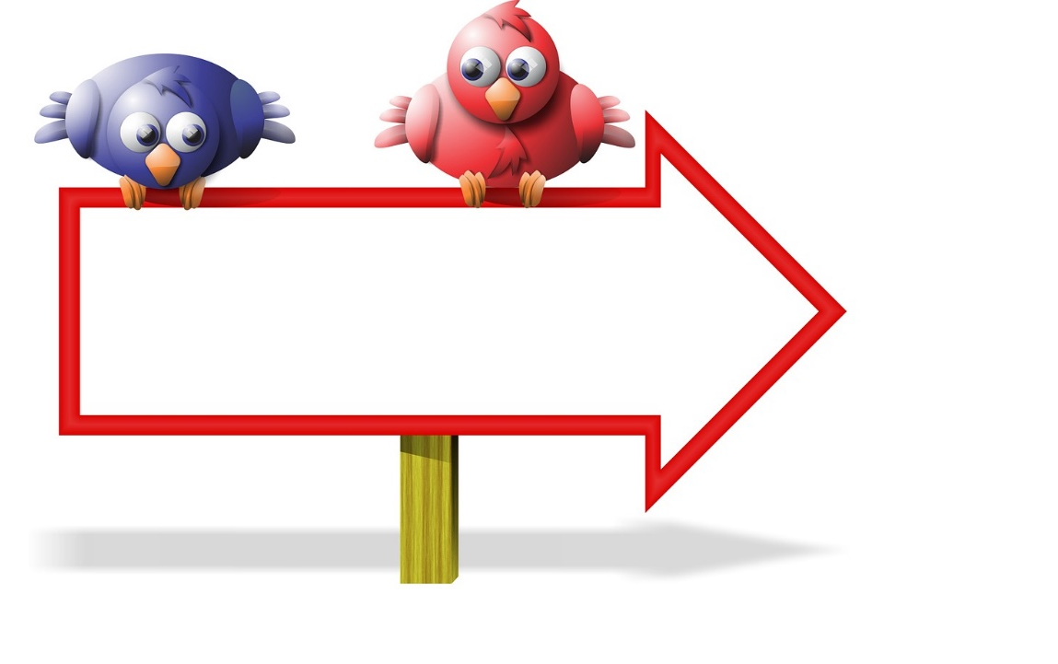
Good Health and Safety

Costs


Poor Health and Safety

HSE key facts …

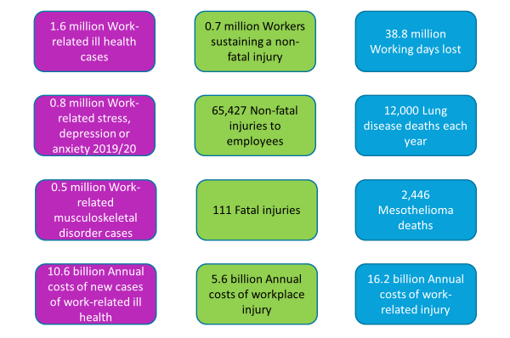

Key figures for England 2019/2020 from the Health and Safety Executive

Activity 2: “What’s Your Thoughts?”

Activity
Please note down what you think is the meaning of responsibility and accountability?
Responsibility
……………………………………….
……………………………………….
……………………………………….
……………………………………….

………………………………………..
Accountability
………………………………………..
………………………………………..
………………………………………..

The Corporate Health and Safety Policy is the overarching policy for the council, a failure to comply may result in disciplinary action being taken.

The corporate policy outlines our general organisation of, and arrangements for, effective health and safety management. More service-specific information can be found in individual directorate health and safety policies.

These health and safety policies can be found under the relevant Health and Safety section of your directorates Insight page, accessible from the homepage.

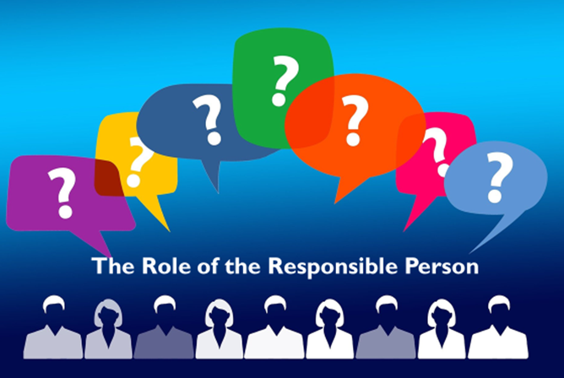
Safety at work (eastriding.gov.uk)

Activity 3: “Start the Conversation”
Activity
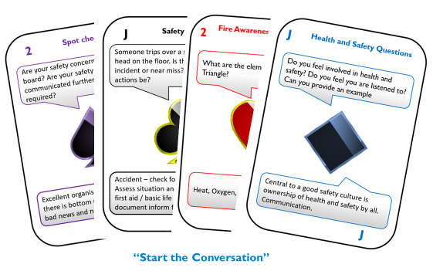
Safety cards can be used as a tool to aid discussions about health and safety. Raising awareness and addressing concerns ensuring compliance and commitment to health and safety.

The Card Deck is separated into 4 categories:
- Diamonds – questions
- Clubs – safety discussion/scenarios
- Hearts – fire awareness and evacuation
- Spades – spot check, show and tell

You can use the cards when talking to staff, managers, supervisors … in fact anyone about safety. Ask the question to start the conversation about health and safety.

The purpose of the safety cards are to raise awareness of health and safety matters.

You can use these as:
- An icebreaker
- On a Managers walk about
- As part of a focus group
- As part of training
- During a team briefing
- During Supervision

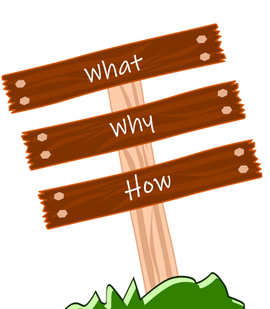
The What, Why and How Framework
The what, why and how framework has recently been introduced by many as a strategic thinking tool and it has been used in supervision for decades however it can also support good practice in terms of good health and safety.

By using it as a tool to support Health and Safety conversations we can ask ourselves:

- What do we want to achieve?

- Why do we need to achieve this?

- How can we do this?

Be careful though, don’t loose sight of the Why… as this will change the whole concept. Why allows us to drill down and look further at root causes especially when things go wrong.

Control of Substances Hazardous to Health Safety Guidance

Substance assessment flow chart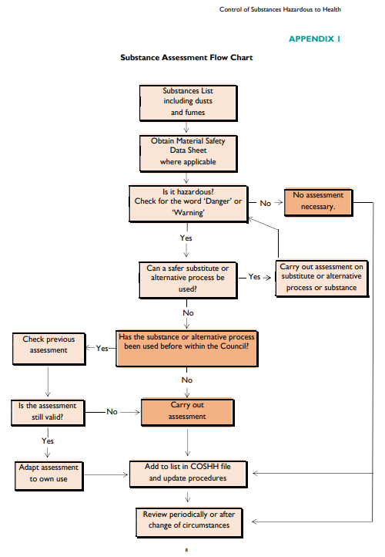

Health and Safety Arrangements Document
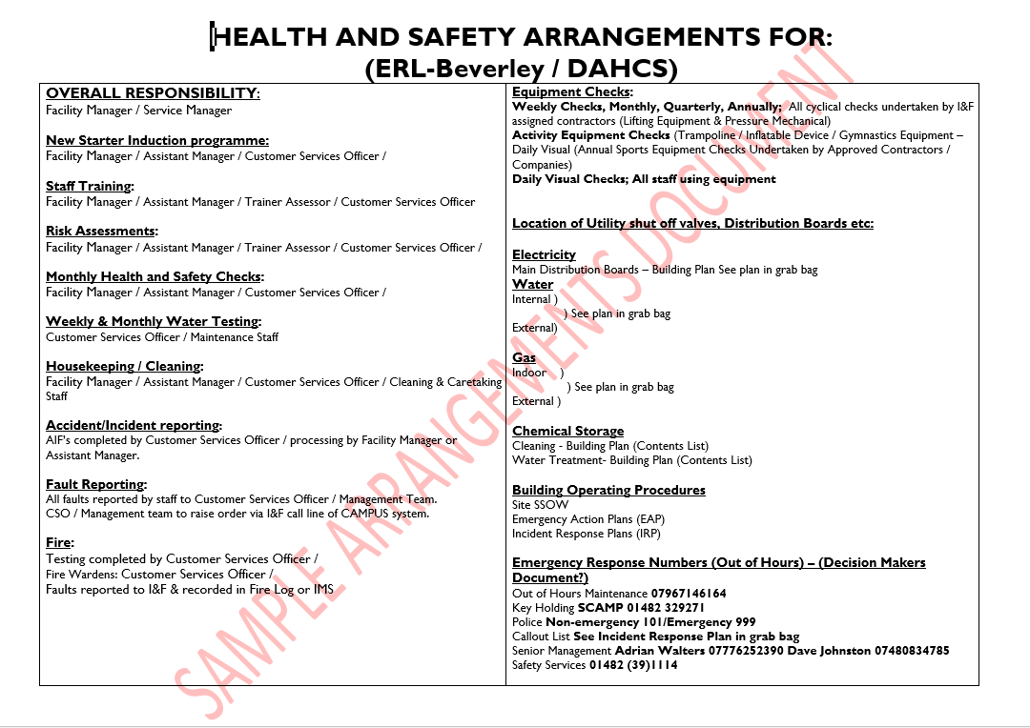Visitors and Contractors

Question
Why is it important that you know who is visiting the premise?

What precautions would you take when signing a contractor or visitor in / out of the building?

What would you do if you saw a contractor and or visitor working/ acting unsafely?

Wellbeing Information

Tag
Lets talk, think SHOUT - free confidential 24/7 text messaging support service for anyone who is struggling to cope.
https://giveusashout.org/about-us/about-shout/

The East Riding of Yorkshire Council Public Health team have created a website to support access to reliable wellbeing information and local services. The categories used within this include be active, take notice, connect, learn and give, taken from the Five Ways to Wellbeing created by Mind.
https://eastridinghealthandwellbeing.co.uk/

In addition to this the East Riding of Yorkshire Council has a dedicated webpage, on the intranet, for health and wellbeing providing you with top tips to staying well both physically and mentally. From activities such as meditation and mindfulness to guidance for keeping a healthy mind. It provides information about the reading well scheme, including reading well for mental health providing helpful information and support for managing common mental health conditions, or dealing with difficult feelings and experiences.
1. Health and wellbeing (eastriding.gov.uk)

The Live Well Work Well Scheme has recently been launched and promotes mental, physical and emotional wellbeing for East Riding employees. They offer a variety of advice and support consultations such as:
- improve your mental wellbeing
- stop smoking
- take more regular exercise
- reduce your alcohol intake
- eat healthier
- lose weight
- find useful resources to help during coronavirus

About Live Well Work Well consultations (eastriding.gov.uk)

Health and Wellbeing Champions are members of staff who promote health and wellbeing within the council and work closely with the live well work well team. They are volunteers who: have an enthusiasm and interest in health and wellbeing, are approachable and helpful, have a basic understanding of healthy lifestyles. They will support their colleagues in the workplace with health and wellbeing issues and signpost accordingly.
http://insight.eastriding.gov.uk/health-and-wellbeing/health-and-wellbeing-champions/

We also have an Employee Assistance Programme, through which you can speak to a counsellor at any time, day or night, to discuss any issues concerning you. Including legal, financial or medical advice, This service is free to council employees by calling 0800 107 6145 http://insight.eastriding.gov.uk/health-and-wellbeing/

Occupational Health Our occupational health service seeks to promote and maintain the health and wellbeing of all our employees.
Intranet - Occupational health (eastriding.gov.uk)

Humber, Coast and Vale Staff Resilience Hub. Provide access to support and advice, available to all health and care workers and their families, living or working in the Humber, Coast and Vale region, who have worked through the Covid 19 pandemic. You can find out more by visiting their website: https://www.hcvresiliencehub.nhs.uk/

Hub of Hope is an online support tool which brings local, national, peer, community charity, private and NHS mental health support and services together is one place. It is there to support everyone not just in times of crisis but when we may feel we are beginning to struggle a little or feel a little bit of support is what we need.
https://hubofhope.co.uk/

Health and Safety Executive stress resources https://www.hse.gov.uk/stress/

Other resources to support service area delivery:
Social Care Institute of excellence have developed preventative approaches which promote independence and wellbeing and are pivotal in supporting the delivery of services. For further information visit https://www.scie.org.uk/prevention

