 | Learner Resource
Recording Skills for Care Workers in Adult Social Care

Version 1.4 – 02/2026

Contents
About Self-Study Guides 1
Introduction 1
Structure and Layout 1
Latest Version 2
General Principles of Recording 3
Activity 1 3
Objective and Subjective 4
Fact and Opinion 5
Activity 2 5
Retentive Memory 6
Activity 3 6
PARTNERSHIP Model 7
Abbreviations and Acronyms 8
Activity 4 8
Lessons Learnt following an Incident … for Adult Provider Services 9
Activity 5 10
Good and Bad Recording 10
Helpful Resources and Information 11
Grammar and Vocabulary 11
Websites 12

About Self-Study Guides

Introduction
Welcome to the recording skills module. This module enables you to develop your knowledge and skills to ensure everyday good practice relating to record keeping and case recording procedures for Adult Services are upheld.

This learner resource is to be used as part of the leaning process. Within this learner resource you will find information, activities and direction to further help or information.

Latest Version
Always check you have the latest version of the learner resource. The issue number and date appear on the cover page.

If you have been given this learner resource by your Line Manager, Supervisor or Learning and Development Champion – they will have checked it is the current version. Learning and Development only provide copies of the current version of any learner resource.

General Principles of Recording

Activity 1

  Legislation & Procedures we are governed by? | Activity  Write down the reasons why we keep records, what type or reports and records we generate and also the legislation and procedures we are governed by.  Why do we keep Records?  Reports & Records we produce?

Objective and Subjective

 | Information  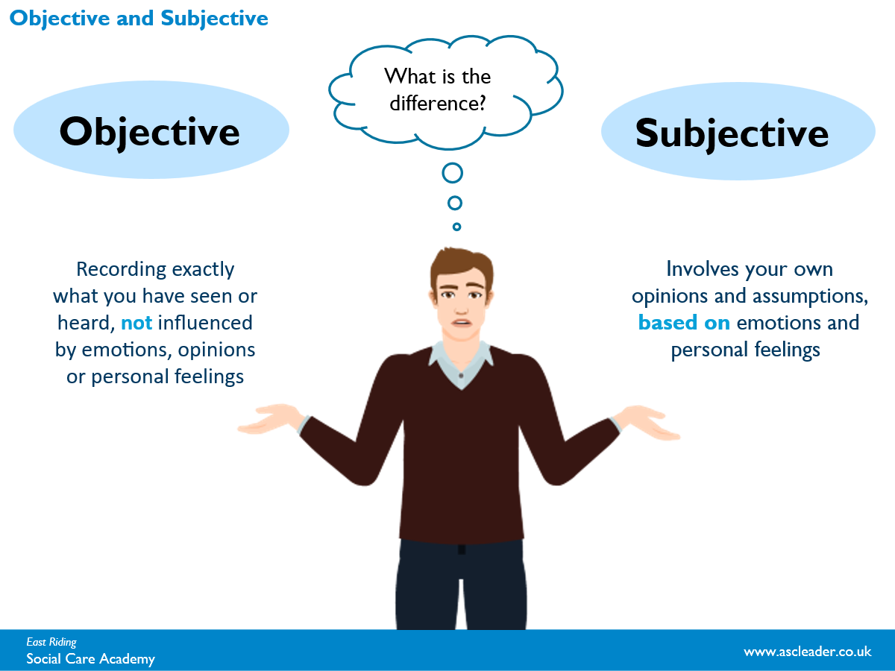  - Objective = unbiased  - Subjective = risk of bias

Information
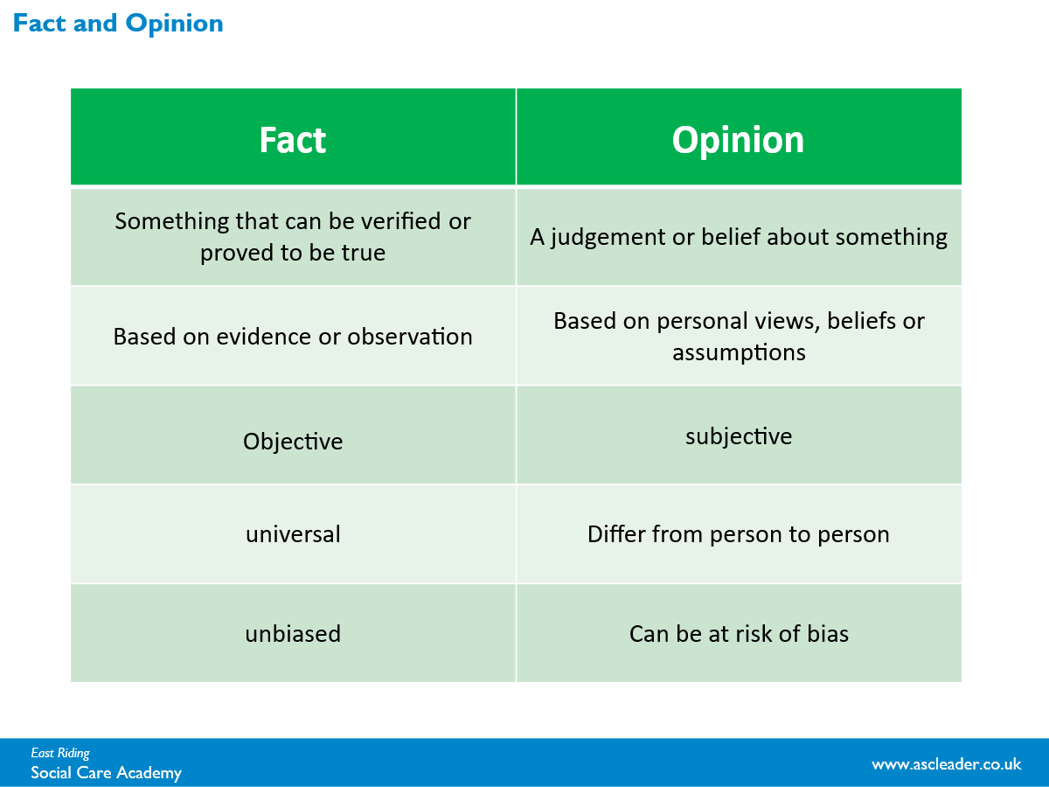

The difference between Fact and Opinion.

Fact and Opinion

Activity 2
Statements | Fact or Opinion
- Being alone at home is depressing Jim.

- Alan said his daughter slapped him.

- On the last visit the living room was not safe for Mrs Smith and she is at a high risk of falls.

- Jenny is very contented.

- Pat has an unusual appetite (she has two Kit Kats with her breakfast every day).

- George has suffered skin breakdown.

- Harry has poor mobility.

- There are no current concerns regarding Anna’s weight.

- Stuart has had multiple falls.

- Joyce wants to manage her own medication.

Read through the 10 statements below and decide if each statement is a ‘fact’ or an ‘opinion’. Your trainer will then facilitate discussions and your thoughts within the group

Retentive Memory

Activity 3


Activity
You have a minute to write down as many of the images you can remember from the slide at the beginning of this course… No cheating, wait for the start prompt from your tutor!

PARTNERSHIP Model
This is a tool that can help support you with your recording skills.

P – Person centred. Try to make your recording as person centred as any other part of your practice.
A – Accurate. Be clear what you are recording using accurate language that will not be misinterpreted.
R – Real. Record the positives and the negatives in a appropriate way.
T – Timely. Ensure that recording is done as soon as possible to avoid missing any details.
N – No jargon. Keep it simple with no abbreviations. It may seem quicker but they can be interpreted into anything.
E – Evidence based. Ensure what your writing is factual with supporting evidence such as observations.
R – Reading the previous record. Understanding what has previously been recorded can help support you with the individual.
S – Succinct. As recording is ongoing, make sure that you detail the correct information well, this will save repeated recordings.
H – Holistic. There will be many different professionals that may need to read what you have written. Ensure all information is in the same place for easy to read and access of reports, assessments etc.
I – IT complaint. Nearly all services us digital platforms to record information, it is important that you are able to use them appropriately.
P – Professional. We all do a profession job no matter where you work and your recording is a reflection of this.

Abbreviations and Acronyms

Activity 4
As a group activity, can we guess what each one could mean…?
DN
HV
T/C
MCA
CA
MH
SW
SWS
AMHP
CWT
VARM
PIP
DLA
LD
NFA
DP
CQC
PEA
DOLS
BIM
OPG
COP
KLOE
AA
LPA
SALT
EOL

Lessons Learnt following an Incident … for Adult Provider Services

Date 17 July 2024
Topic / Area Information Governance – email sent to an incorrect email address

1 Background

A regular update of care arrangements is shared by email with the service user and their family. The latest information was prepared, but the predictive text function in the MS Outlook To field inserted a similar email address that had been used before whilst the sender was typing the details. The incorrect email address was not identified at the time of sending, and the incorrect recipient responded to query if they had received the information by mistake. The incorrect recipient was a health professional and deleted the email after notifying the sender.

2 Impact

The information was shared with the incorrect recipient and raised as a data breach with the Information Governance and Feedback Team. The email had minimal content but did refer to the service user’s first name. The service user was informed of the incident.

3 Outcome

On this occasion, the incorrect recipient was a health professional and aware of data protection requirements. They notified the sender of the error and ensured the information was deleted. The service user was informed of the incident, and an apology provided. Although the information was shared with a health professional, it was not intended for them. Therefore, a data breach occurred.

4 Lessons learnt / recommendations

Enhancements to functionality to MS Outlook provides many benefits, such as predicting an email address as the user types in the To field. However, this can lead to accidently selecting an incorrect recipient. It is essential that the To field is checked before sending the email to ensure it will be sent to the correct recipient.

Activity 5

Good and Bad Recording
Written Record | Good or bad recording? | Is there anything you would change or add to make it better?
Mary had problems using the toilet today. Got dressed and then did an activity in the lounge.

Joe ate his lunch today but looked like he was struggling with it.
Doreen’s house is a mess and needs tidying up as it is a trip hazard.

George can be sexually inappropriate with female staff and they need to be watch themselves.

Spoken to William’s family member and they said they will visit later.

Read each of the 5 records and decide if you think they are a good or bad written account. In the third column write down anything you feel would make the recording better.

Remember the key aspects of good recording should always be: Factual, Non-judgemental, person centred, use supporting evidence where possible, clear to understand, professional, no abbreviations.

Helpful Resources and Information

Information

Grammar and Vocabulary
- Verbs HAS to agree with their subjects.
- And don't start a sentence with a conjunction.
- Avoid clichés like the plague. (They're old hat.)
- Also, always avoid annoying alliteration.
- Be more or less specific.
- Parenthetical remarks (however relevant) are (usually) unnecessary.
- Also too, never, ever use repetitive redundancies endlessly over and over again.
- No sentence fragments.
- Foreign words and phrases are not always apropos.
- Do not be redundant; do not use more words than necessary; it's highly superfluous and can be excessive.
- All generalizations are bad.
- Comparisons are as bad as clichés.
- Don't use no double negatives.
- Avoid excessive use of ampersands & abbrevs., etc.
- One-word sentences? Eliminate.
- Eliminate commas, that are, not necessary. Parenthetical words, however, should be enclosed in commas.
- Never use a big word when substituting a diminutive one would suffice.
- Don't overuse exclamation points!!!
- Use words correctly, irregardless of how others use them.
- Use the apostrophe in it's proper place and omit it when its not needed and use it correctly with words' that show possession.
- If you've heard it once, you've heard it a billion times: Resist hyperbole; not one writer in a million can use it correctly. Besides, hyperbole is always overdone, anyway.
- Puns are for children, not groan readers.
- Go around the barn at high noon to avoid colloquialisms.
- Who needs rhetorical questions? However, what if there were no rhetorical questions?
- Exaggeration is a billion times worse than understatement.
- Avoid "buzz-words" or jargon; such integrated transitional scenarios complicate simplistic matters.
- People don't spell "a lot" correctly alot of the time.
- Each person should use their possessive pronouns correctly.
- Proofread carefully to see if you any words out.
- The dash - a sometimes useful punctuation mark - can often be overused - even though it's a helpful tool some of the time.
- Proofread carefully to make sure you don't repeat repeat any words.

Websites

Clutter Image Ratings - Hoarding Disorders UK
Hording Disorders UK – Shows Clutter image ratings.

Social care recording - SCIE
Social Care Institute for Excellence website

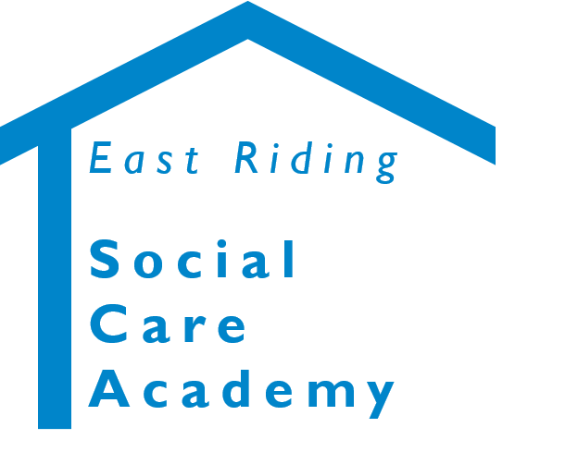

Recording Skills Learner Resource
© 2020 – East Riding Social Care Academy (East Riding of Yorkshire Council)

All rights reserved. No part of this document may be reproduced, distributed, or transmitted in any form or by any means, including photocopying, recording, or other electronic or mechanical methods, without the prior written permission of the copyright holder.

